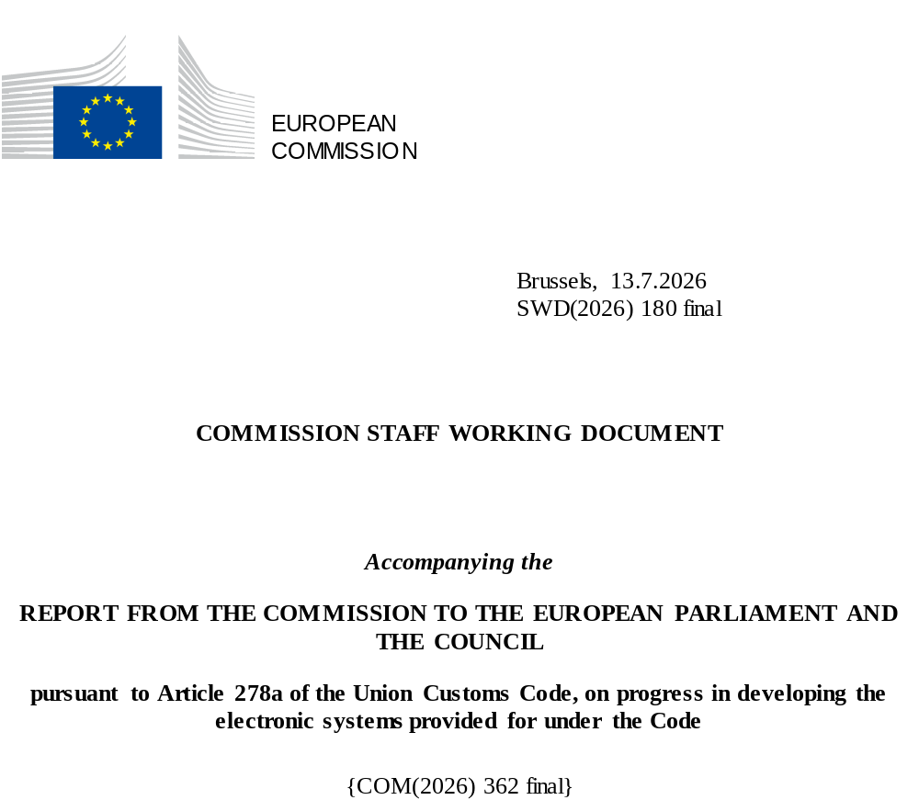

Table of Contents
1. Introduction 5
1.1 Background 6
1.2 Lessons Learnt and Support from the Commission 7
1.3 Structure of the document 8
2. Completed Projects 9
2.1 UCC Registered Exporter System (REX) 10
2.2 UCC Customs Decisions 11
2.3 UCC Direct Trader Access to the European Information Systems (UUM&DS) 12
2.4 UCC Economic Operator Registration and Identification System Upgrade (EORI2) 13
2.5 UCC Surveillance 3 (SURV3) 14
2.6 UCC Binding Tariff Information (BTI) 16
2.7 UCC Authorised EOs (AEO) Upgrade 17
2.8 UCC Information Sheets (INF) for Special Procedures 18
2.9 UCC Import Control System 2 (ICS2) – Release 1 & 2 19
2.10 UCC Guarantee Management (GUM) – Component 1 20
2.11 UCC Proof of Union Status (PoUS) – Phase 1 21
2.12 UCC New Computerised Transit System (NCTS) Upgrade – Component 1 23
3. Ongoing Projects 24
3.1 UCC Notification of Arrival (AN), Presentation Notification (PN) and Temporary Storage (TS) 25
3.2 UCC National Import System (NIS) Upgrade 47
3.3 UCC Special Procedures – Component 1 (SP EXP) 53
3.4 UCC Special Procedures – Component 2 (SP IMP) 58
3.5 UCC Guarantee Management (GUM) – Component 2 63
3.6 UCC Centralised Clearance for Import (CCI) 68
3.7 UCC New Computerised Transit System (NCTS) Upgrade – Component 2 79
3.8 UCC Automated Export System (AES) 86
3.9 UCC Import Control System 2 (ICS2) – Release 3 101
3.10 UCC Proof of Union Status (PoUS) – Phase 2 109
4. Annex 1 – Planning Overview – UCC Work Programme Projects 111
5. Annex 2 – Acronyms, Abbreviations & Key Terms 112
6. Annex 3 – Definition of formats, legal base and legal deadline for Surveillance3 113

Table of Figures
Figure 1: Overview of completed projects 9
Figure 2: Statistical information – REX 10
Figure 3: Statistical information – CDS 11
Figure 4: Statistical information – UUM&DS 12
Figure 5: Statistical information – EORI2 13
Figure 6 : Statistical information – SURV3 15
Figure 7: Statistical information – BTI 16
Figure 8: Statistical information – AEO upgrade 17
Figure 9: Statistical information – INF for SP 18
Figure 10: Statistical information – ICS2 – Release 1 and 2 19
Figure 11: Statistical information – PoUS – Phase 1 22
Figure 12: Overview of projects to be completed by the end of 2025 24
Figure 13: Project progress and status per milestone – AN 28
Figure 14: Project progress and status per milestone – PN 31
Figure 15: Project progress and status per milestone – TS 35
Figure 16: Actual/Planned dates per milestone – AN – Air transport 37
Figure 17: Actual/Planned dates per milestone – AN – Maritime transport 38
Figure 18: Actual/Planned dates per milestone – PN – Air transport 40
Figure 19: Actual/Planned dates per milestone – PN – Maritime transport 41
Figure 20: Actual/Planned dates per milestone – PN – Other modes of transport 42
Figure 21: Actual/Planned dates per milestone – TS – Air transport 44
Figure 22: Actual/Planned dates per milestone – TS – Maritimes transport 45
Figure 23: Actual/Planned dates per milestone – TS – Other modes of transport 46
Figure 24: Project progress and status per milestone – NIS Upgrade 50
Figure 25: Actual/Planned dates per milestone – NIS Upgrade 52
Figure 26: Project progress and status per milestone – SP EXP 55
Figure 27: Actual/Planned dates per milestone – SP EXP 57
Figure 28: Project progress and status per milestone – SP IMP 60
Figure 29: Actual/Planned dates per milestone – SP IMP 62
Figure 30: Project progress and status per milestone – GUM-C2 65
Figure 31: Actual/Planned dates per milestone – GUM-C2 67
Figure 32: Project progress and status per milestone – CCI-P1 72
Figure 33: Project progress and status per milestone – CCI-P2 75
Figure 34: Actual/Planned dates per milestone – CCI-P1 77
Figure 35: Actual/Planned dates per milestone – CCI-P2 78
Figure 36: NCTS-P6 timeline 79
Figure 37: Project progress and status per milestone – NCTS-P6 83
Figure 38: Actual/Planned dates per milestone – NCTS-P6 85
Figure 39: Updated AES-C1 timeline 87
Figure 40: AES-C1 Member States entry into operations as of September 2025 90
Figure 41: Project progress and status per milestone – AES-C1 93
Figure 42: Project progress and status per milestone – AES-C2 96
Figure 43: Actual/Planned dates per milestone – AES-C1 99
Figure 44: Actual/Planned dates per milestone – AES-C2 100
Figure 45: Project progress and status per milestone – ICS2-R3 105
Figure 46: Actual/Planned dates per milestone – ICS2-R3 108
Figure 47: Actual/Planned dates per milestone – PoUS-P2 110
Figure 48: Planning Overview – UCC WP Projects 111

Table of Tables
Table 1: Comparison of Planned and Actual Dates – REX-R1 10
Table 2: Comparison of Planned and Actual Dates – CDS 11
Table 3: Comparison of Planned and Actual Dates – UUM&DS 12
Table 4: Comparison of Planned and Actual Dates – EORI2 13
Table 5: Comparison of Planned and Actual Dates – SURV3 15
Table 6: Comparison of Planned and Actual Dates – BTI 16
Table 7: Comparison of Planned and Actual Dates – AEO upgrade 17
Table 8: Comparison of Planned and Actual Dates – INF for SP 18
Table 9: Comparison of Planned and Actual Dates – ICS2 – Release 1 and 2 19
Table 10: Comparison of Planned and Actual Dates – GUM-C1 20
Table 11: Comparison of Planned and Actual Dates – PoUS-P1 22
Table 12:Comparison of Planned and Actual Dates – NCTS-P5 23
Table 13: Detailed responses from Member States – AN 28
Table 14: Detailed responses from Member States – PN 31
Table 15: Detailed responses from Member States – TS 34
Table 16: Detailed responses from Member States – NIS Upgrade 50
Table 17: Detailed responses from Member States – SP EXP 54
Table 18: Detailed responses from Member States – SP IMP 60
Table 19: Detailed responses from Member States – GUM-C2 65
Table 20: Detailed responses from Member States – CCI-P1 72
Table 21: Detailed responses from Member States – CCI-P2 75
Table 22: Detailed responses from Member States – NCTS-P6 83
Table 23: Detailed responses from Member States – AES-C1 93
Table 24: Detailed responses from Member States – AES-C2 95
Table 25: Detailed responses from Member States – ICS2-R3 104
Table 26: Detailed responses from Member States – PoUS-P2 110
Table 27: Abbreviations and Acronyms 113
Table 28: Definition of formats, legal base and legal deadline – SURV3 114

Introduction
The Union Customs Code (UCC) requires the European Commission and the Member States to upgrade some existing electronic systems and introduce a number of new systems for the completion of a modern and digital environment of customs formalities. In total, the UCC requires the upgrading or creation of fourteen trans-European systems and three national systems.
The UCC entered into force on 1 May 2016. Different completion deadlines were scheduled for the end of 2020, 2022, or 2025, depending on the system.
In view of the reporting requirement established by Article 278(a) of the Regulation (EU) 2019/632 amending Regulation (EU) 2013/952, the Commission is committed to provide an annual report to the European Parliament and the Council on the progress in developing the electronic systems of the UCC. The report assesses the progress of the Commission and the Member States in developing each of the electronic systems, taking particular note of the following milestones:
- The date of publication of the technical specifications for the external communication of the electronic systems;
- The period of conformance testing with Economic Operators (EOs);
- The expected and actual dates of deployment of the electronic systems.
The legal deadlines for finalising the technical specifications and for deploying the electronic systems are laid down in the UCC Work Programme (UCC WP). The detailed planning per project, containing additional milestones such as the business case, business process modelling, Vision Document (VIS), and conformance testing are defined in the Multi-Annual Strategic Plan for Customs (MASP-C).
The first, second, third, fourth, fifth and sixth UCC Annual Progress Report were published on 13/12/2019, 14/12/2020, 14/12/2021, 10/02/2023, 09/09/2024, and 02/10/2025 respectively. Details of the completed projects are limited in this report; however, additional information can be found in the previous year’s reports.
In preparation for this year’s UCC Annual Progress Report, the Commission continued with the methodology used in previous years, gathering information on the UCC projects state of play from the Member States and the Project Managers in Directorate-General for Taxation and Customs Union (DG TAXUD).
This annual report reflects the progress status achieved at the time of writing, until 30 June 2025, with more recent updates included in several cases. More detailed elements of the state of play, including progress by 31 December 2025, are presented in the Annual Progress Report 2025 and in Annex 1 to this Staff Working Document.
The main outcomes of the progress reporting exercise for 2025 are included in this Commission Staff Working Document. Reporting information that summarises the current project status, key risks, and mitigating actions is found in the Report from the Commission to the European Parliament and the Council pursuant to Article 278a of the UCC, on progress in developing the electronic systems provided for under the Code.

Background
To support the electronic transition process towards a fully digital customs environment, the UCC WP outlines seventeen electronic systems divided into three categories:
- Eleven central trans-European systems to be developed or upgraded by the Commission (often also requiring developments or upgrades of the national systems by the Member States);
- Three decentralised trans-European systems that have to be developed or upgraded by the Commission, but have a major national component to be implemented by the Member States, and;
- Three national systems that have to be developed or upgraded exclusively by the Member States.
The UCC WP and MASP-C set the baseline milestones for each electronic system, and this document provides progress updates regarding their advancement. For this purpose, the Commission oversaw the collection of additional reporting information through the following sources:
(1) National Planning that the Member States are required to provide bi-annually (January and June):
The information gathered by the Member States’ customs authorities consists of detailed national project plans that include concrete dates, status, and progress of the milestones set in the UCC WP.
(2) EU survey launched in February 2025 amongst the Member States to capture the progress:
The information gathered from the survey consists of qualitative comments regarding the assessment of risk, delays, and reasons for any such delays as well as the mitigating measures planned and/or taken in relation to the projects listed in the UCC WP. Finally, the Member States also provided information on the lessons learnt during the development of the projects.
(3) the projects’ state of play provided by the Project Managers in DG TAXUD.
(4) bilateral high-level meetings between DG TAXUD and the Member States Customs IT Directorates on the state of play of the UCC IT Implementation:
DG TAXUD conducted bilateral high-level meetings with Member States Customs IT Directorates, focusing on having a conversation with each Member State to gain the full picture of their status and to see what can be done to support them in their work, especially in light of the upcoming deadlines for several projects.
(5) outputs from the trans-European coordination and monitoring programmes:
In the framework of the Coordination Programmes, specific information was gathered from the more detailed project reporting and monitoring programmes in place since 2020 for the core decentralised trans-European systems in the area of transit, export and imports.
The progress information has been collected, analysed, and reported in this accompanying Commission Staff Working Document, which presents the detailed overview of the progress of the various individual projects as follows:
- For the trans-European systems, the analysis and reporting refer to the Commission’s activities only when it is central, while for the systems that involve national input, and even in some cases national components, the analysis refers to both the Member States’ and Commission’s activities;
- For the national systems, only Member States’ activities are reported.
The UCC is scheduled to conclude at the end of 2025. As a result, all related projects must be completed and fully operational by the end of the year to ensure compliance with the established legal framework. In view of all this, close and continuous communication has been maintained with the Member States to regularly monitor the progress of the UCC projects and to provide the necessary support in order to meet the deadlines.

Lessons Learnt and Support from the Commission
In the EU survey section focused on lessons learnt and support from the Commission, Member States shared key insights from the implementation of their projects. These reflections offer practical guidance for enhancing future system development and deployment under the UCC framework.
A commonly cited best practice was the formation of dedicated national project teams with prior UCC experience, often supported by customs officials embedded in development teams to ensure operational relevance. Many Member States reported success with Agile and in-house development approaches, which provided flexibility to adjust timelines, particularly in projects facing evolving requirements or external dependencies. Phased implementation strategies and early integration testing helped reduce complexity and manage risks during rollouts. Effective stakeholder engagement emerged as critical. Close cooperation with national IT teams, software vendors, and traders, along with clear and consistent communication (e.g. user guides, e-learning materials, and helpdesks), supported smooth transitions and minimised business disruption.
Key challenges included aligning diverse national IT systems and legacy infrastructure, managing interdependencies across parallel UCC projects, and adapting to changes in EU technical specifications. Additional issues involved tight procurement timelines, constrained budgets, and limited technical staff. Data-related obstacles, such as real-time volume processing, incomplete submissions from EOs, and cybersecurity concerns, were addressed through frequent monitoring, iterative testing cycles, and transitional data management plans.
Finally, Member States underlined the importance of the Commission’s support during development and testing. Regular coordination, including through bilateral exchanges, project group discussions, and the Electronic Customs Coordination Group (ECCG), was seen as essential to clarifying expectations and ensuring alignment throughout implementation.

Structure of the document
The report is structured as follows:
- Section 1: Introduction.
- Section 2: Completed Projects.
- Section 3: Ongoing Projects.

Completed Projects
Figure 1 provides the overview of the UCC projects that have been completed:
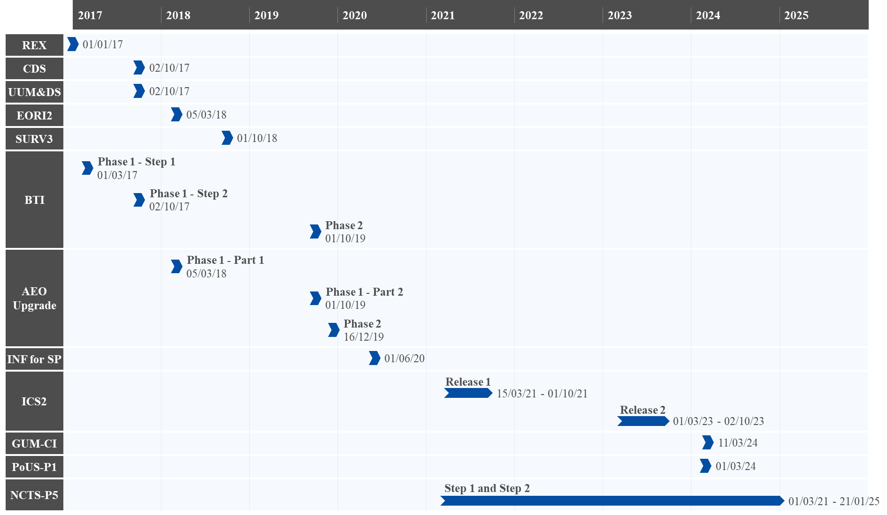
Figure 1: Overview of completed projects

UCC Registered Exporter System (REX)
Deployment | 1 January 2017
The UCC Registered Exporter System (REX) is a trans-European system that contains information both on Registered Exporters established in Generalised Scheme of Preferences (GSP) countries and on EU EOs in partner countries CH, NO, and TR exporting to GSP countries and certain other countries. The main purpose of the system is to replace the paper-based certification process by an IT-supported self-certification process. The system includes a central database that contains the registered exporters and provides the Member States with the opportunity to enhance their national systems with an automated verification of REX members.
There were three releases planned. REX – Release 1 (REX-R1) was the only release covered in the scope of the UCC WP. No risks were identified during the implementation of REX-R1 and the project was successfully completed on 1 January 2017.
Some statistical information on the use of the REX system since operations – situation as of 1 May 2025:
 | Active REX registrations
 | 84,229 | 117,302
 | Non-EU countries (REX BC) module | Member States (REX MS) module
 | Applications submitted in the REX TP by EU Traders
 | 12,911
 | Applications
Figure 2: Statistical information – REX

Overview of Project Progress
Table 1 compares the actual dates to those set in the UCC WP. Despite there being a slight delay in the finalisation of the technical specifications, REX-R1 was deployed on time.
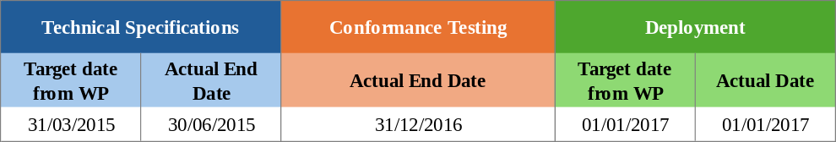
Table 1: Comparison of Planned and Actual Dates – REX-R1

UCC Customs Decisions
Deployment | 2 October 2017
The UCC Customs Decisions System (CDS) is designed to achieve harmonisation of the processes relating to the application for a customs decision, the decision taking, and the decision management. This harmonisation is put into practice via the standardisation and electronic management of the application and decision/authorisation data across the Union. The system covers all applications and decisions that may have an impact/are valid in more than one Member State. The Member States also have the right to use CDS to manage their national customs decisions if they wish to do so. The project was fully deployed on 2 October 2017.
Some statistical information on the use of CDS – situation as of 15 May 2025:
CDS Application and Decision Statistics
 | 2023 | 2024 | 2025
Number of applications submitted | 9,779 | 12,728 | 5,620
Average number of applications per working day | 44 | 58 | 69
Number of decisions taken | 6,748 | 9,345 | 4,082

Figure 3: Statistical information – CDS

Overview of Project Progress
Table 2 highlights that there were no divergences in the planning compared to the dates set in the UCC WP.
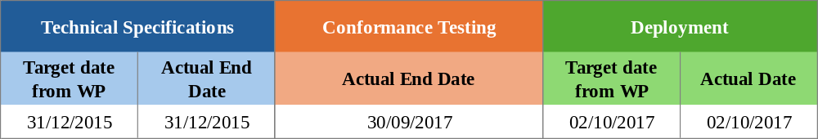
Table 2: Comparison of Planned and Actual Dates – CDS

UCC Direct Trader Access to the European Information Systems (UUM&DS)
Deployment | 2 October 2017
The Direct Trader Access to the European Information Systems comprises of Uniform User Management and Digital Signature (UUM&DS) components. The system aims to provide a service for user-to-system interfaces targeted to the electronic customs systems provided for in the UCC. In essence, the UUM&DS system facilitates a direct and EU harmonised trader access to the customs systems as stipulated in the UCC.
The first deployment of the project was completed and implemented together with CDS on 2 October 2017, as agreed in the context of the UCC WP. The system was also incorporated into other electronic projects, such as the UCC Binding Tariff Information (BTI), the UCC Authorised Economic Operators (AEO) and the Information Sheets (INF) system for Special Procedures (SP). The project further evolved to include system-to-system interfaces in view of the Import Control System 2 (ICS2) deployment and to cover the needs of other UCC and non-UCC projects, such as for the Proof of Union Status (PoUS), the Carbon Border Adjustment Mechanism (CBAM) and the Central Electronic System of Payment information (CESOP).
Some statistical information on the use of the UUM&DS system – situation until March 2025:
Number of Successful requests |  | Systems using UMM&DS
1,882,931
  System | % of Requests
  ICS2 | 35.40%
  EUCTP | 35.02%
  CBAM | 16.70%
  CD | 9.18%
  UUM&DS-ADM-EXT | 2.74%
  CESOP (Taxation) | 0.96%
Average monthly availability of UUM&DS
99.94%
Figure 4: Statistical information – UUM&DS

Overview of Project Progress
Table 3 highlights that there were no divergences in the planning compared to the dates set in the UCC WP.
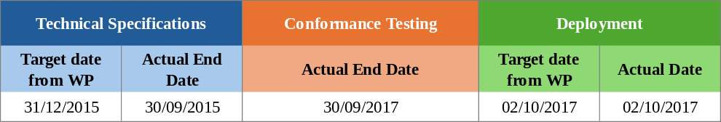
Table 3: Comparison of Planned and Actual Dates – UUM&DS

UCC Economic Operator Registration and Identification System Upgrade (EORI2)
Deployment | 5 March 2018
This system upgrade provided minor changes to the existing trans-European Economic Operator Registration and Identification (EORI) system. These changes enabled the registration and identification of EOs of the Union as well as third-country operators and persons apart from EOs. The Economic Operator Registration and Identification upgrade (EORI2) system has been in operation since 5 March 2018.
Some statistical information on the use of the EORI2 system – situation until 31 March 2025:
EORI2 Records
 | Q4 2023 | Q1 2024 | Q2 2024 | Q3 2024 | Q4 2024 | Q1 2025
Total Valid Records | 8,786,959 | 8,907,182 | 8,896,229 | 8,835,083 | 8,962,947 | 9,069,791
New Valid Records | 161,941 | 158,394 | 149,655 | 141,811 | 155,366 | 157,529
Deleted Records | 1,144 | 10,729 | 1,909 | 2,278 | 35,460 | 49,571

Figure 5: Statistical information – EORI2

Overview of Project Progress
Table 4 compares the actual dates to those set in the UCC WP. Despite there being a slight delay in the finalisation of the technical specifications, EORI2 was deployed on time.
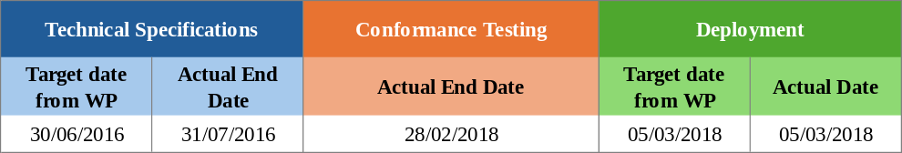
Table 4: Comparison of Planned and Actual Dates – EORI2

UCC Surveillance 3 (SURV3)
Deployment | 1 October 2018
The Surveillance 3 system (SURV3) introduces an upgrade to the standard exchange of information in the earlier Surveillance 2 system (SURV2) to align the system with UCC requirements. This database records and centralises all EU trade data (imports for free circulation and exports) that national customs authorities provide on a daily basis. The upgrade implements electronic data-processing techniques and establishes adequate functionalities needed for processing and analysing the full surveillance dataset obtained from Member States. The new system will improve the customs risk analysis, the fight against fraud, market analysis, post-clearance controls and statistical analysis.
The system was successfully deployed on 1 October 2018, with all the data being gathered in different formats via Surveillance Recap. Additionally, all national systems needed to be fully aligned to the UCC by 31/12/2022 (legal deadline for all Member States), though extended until 31/12/2023 for those Member States having been granted a derogation, thereby enabling the system to operate at its full potential.
An emphasis should be made on the need to extend the use of the system, given that for those Member States who are going to be delayed or partially delayed for the National Import System (NIS) even beyond the derogation date, it will have a direct consequence on the collection of the data via Surveillance Recap and on the functioning of the reports of the SURV3 system. Therefore, the system will have to be prolonged in use until all Member States are on board. The collection of all the required data from all Member States is essential not only for SURV3 but also for other projects such as for CBAM.
Some statistical information on the use of Surveillance data records received from January 2025 until June 2025 by format and Member State:

Use of Surveillance data records
MS | Import |  |  |  |  | Export
MS | CCIP | nUCC | Postal | UCC Full | UCC reduced | CCIP | nUCC | UCC Full | UCC reduced
AT | 100.00% |  |  |  |  | 99.99% | 0.01%
BE | 59.79% | 40.21% |  |  |  | 0.08% | 99.92%
BG |  | 99.08% | 0.92% |  |  |  | 100.00%
CY | 99.99% | 0.01% |  |  |  | 0.01% | 99.99%
CZ |  |  |  | 100.00% |  |  | 100.00%
DE |  | 100.00% |  |  |  |  | 100.00%
DK | 100.00% | 0.00% |  |  |  | 0.06% | 99.94%
EE |  | 100.00% |  |  |  |  | 100.00% |  | 0.00%
ES |  | 100.00% |  |  |  | 0.01% | 99.99%
FI |  | 100.00% |  | 0.00% |  | 0.11% | 99.89%
FR | 98.59% | 1.41% |  |  |  | 100.00%
GR |  | 100.00% |  |  |  |  |  |  | 100.00%
HR | 0.01% | 97.71% | 2.28% |  |  | 0.00% | 100.00%
HU |  | 99.28% |  |  | 0.72% |  | 28.90% |  | 71.10%
IE |  |  |  | 100.00% |  |  | 100.00%
IT |  |  |  | 99.79% | 0.21% |  | 99.82% |  | 0.18%
LT | 0.28% | 99.72% |  |  |  |  | 100.00%
LU |  | 100.00% |  |  |  |  | 100.00%
LV |  | 98.54% | 1.39% | 0.07% |  |  | 100.00% | 0.00%
MT |  |  |  | 100.00% |  |  |  | 100.00%
NL |  | 98.24% |  |  | 1.76% |  | 100.00% |  | 0.00%
PL | 0.00% | 98.77% | 1.08% | 0.15% |  | 0.05% | 99.95%
PT | 100.00% |  |  |  |  | 100.00%
RO | 100.00% |  |  |  |  | 0.00% | 100.00%
SE |  | 100.00% |  |  |  | 23.85% | 76.15%
SI | 0.00% |  |  | 100.00% |  | 0.01% | 99.99%
SK |  |  |  | 100.00% |  |  | 100.00%
XI |  |  |  |  | 100.00% |  |  |  | 100.00%

Figure 6 : Statistical information – SURV3

Overview of Project Progress
Table 5 highlights that there were no divergences in the planning compared to the dates set in the UCC WP.
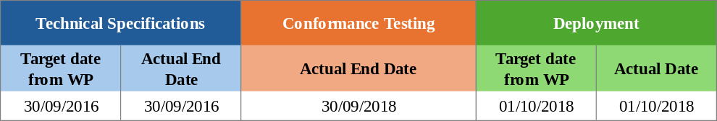
Table 5: Comparison of Planned and Actual Dates – SURV3

UCC Binding Tariff Information (BTI)
Deployment Phase 1 – Step 1 | 1 March 2017
Deployment Phase 1 – Step 2 | 2 October 2017
Deployment Phase 2 | 1 October 2019
The project for a UCC Binding Tariff Information (BTI) system aims to upgrade the existing trans-European Binding Tariff Information (EBTI-3) database containing all BTI issued by customs authorities of Member States. The customs authorities concerned are responsible for recording their decisions in the BTI database. EOs apply for binding tariff decisions to ensure legal certainty when classifying goods that it imports or exports from the EU.
Concerning the status of the project, the first phase was completed on 2 October 2017 and the second phase on 1 October 2019. The integration of the system with the European Union Customs Trader Portal (EU CTP) was also completed on 1 October 2019. Additionally, the Trader Portal (TP) (central EU or national) is used by all traders across all Member States, and all BTI applications and decisions are transmitted electronically.
Some statistical information on the use of the BTI system – situation until 19 May 2025:
BTI applications submitted by EOs |  |  | BTI decisions issued by custom authorities |  | Digitalisation Progress
242,893 | 47,075  via the EU TP |  | 226,998 |  | 8 processes digitalised  (including 20 sub-processes)
242,893 | 195,818  via the national TP |  | 226,998 |  | 8 processes digitalised  (including 20 sub-processes)
Figure 7: Statistical information – BTI

Overview of Project Progress
Table 6 compares the actual dates to those set in the UCC WP. Despite there being a slight delay of the technical specifications for Step 2, all phases were deployed on time.
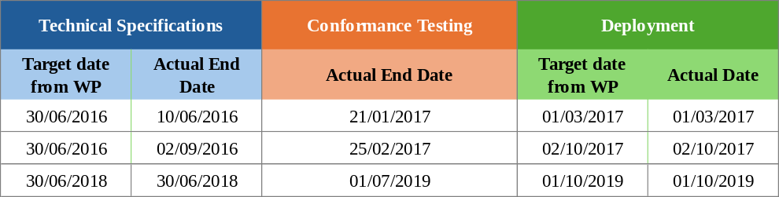
Table 6: Comparison of Planned and Actual Dates – BTI

UCC Authorised EOs (AEO) Upgrade
Deployment Phase 1 – Part 1 | 5 March 2018
Deployment Phase 1 – Part 2 | 1 October 2019
Deployment Phase 2 | 16 December 2019
Following the legal changes adopted in the UCC, the AEO upgrade aims to enhance the process of applications and authorisations for the AEO status. The project consisted of two phases. In Phase 1, significant improvements were made to the existing AEO system, in light of the harmonisation of the decision-taking procedure for customs. Phase 2 focused on implementing an electronic form to provide a harmonised interface for EOs to submit their AEO applications and receive their AEO decisions electronically.
Some statistical information on the use of the AEO system – situation until 31 March 2025:
AEO performance indicators
 |  | Q4 2024 | Q1 2025
AEO Applications | Submitted | 105 | 97
AEO Applications | New | 158 | 121
AEO Authorisations | New | 192 | 170
AEO Authorisations | Revoked | 134 | 146

Figure 8: Statistical information – AEO upgrade

Overview of Project Progress
Table 7 highlights that there were no divergences in the planning compared to the dates set in the UCC WP.
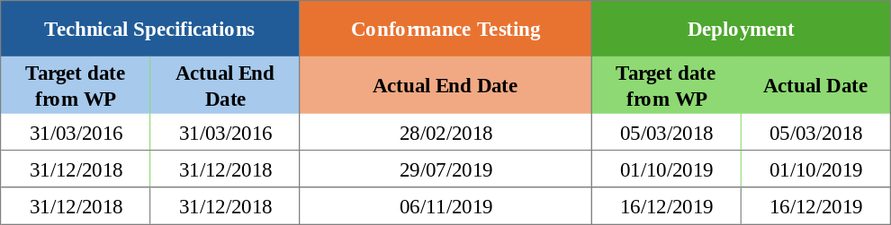
Table 7: Comparison of Planned and Actual Dates – AEO upgrade

UCC Information Sheets (INF) for Special Procedures
Deployment | 1 June 2020
The aim of the Information Sheets (INF) for the SP project is to develop a new trans-European system to support and streamline the data management processes and the electronic handling of data in the domain of SP. This harmonised the approach for the efficient management of inward and outward processing procedures and improved the monitoring and control amongst customs offices.
The INF central system was successfully deployed on 1 June 2020, and by October 2020, all Member States were actively using the system.
The INF Specific TP component was also successfully integrated into the EU CTP and deployed on 1 June 2020. The EU CTP is the single portal at Union level to provide traders unique access to a number of centralised trans-European systems (e.g. EBTI, AEO, and INF).
Currently a system-to-system interface between the INF central system and national declaration systems is being developed to automate the input and facilitate the processing of INF relevant data.
Some statistical information on the use of the INF for SP system – situation until 15 May 2025:
INF requests created by EOs |  | INFs treated and processed by authorities |  | Averaged number of processed INF per working day
104,190 |  | 95,837
  2020 | 2024/2025
  48 | 96
Figure 9: Statistical information – INF for SP

Overview of Project Progress
Table 8 highlights that there were no divergences in the planning compared to the dates set in the UCC WP.
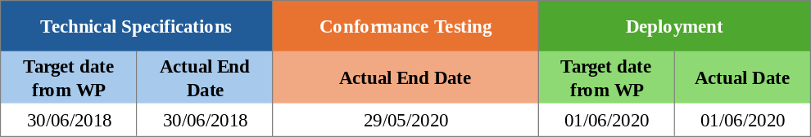
Table 8: Comparison of Planned and Actual Dates – INF for SP

UCC Import Control System 2 (ICS2) – Release 1 & 2
Deployment ICS2-R1 | 15 March 2021
Deployment ICS2-R2 | 1 March 2023
The goal of the UCC Import Control System 2 (ICS2) programme is to strengthen the Safety and Security of the supply chain for goods moved via all modes of transport. The aim is to do so through better targeted risk-based controls of EU customs authorities on improved Entry Summary Declaration (ENS) data quality, data filing, data availability and data sharing, and through real-time collaborative risk analysis and coordinated Safety and Security controls at the EU entry points. The main purpose of the system is to implement the new requirements resulting from the UCC and strategic objectives endorsed by the Member States in the risk management strategy and action plan of 2014. In terms of planning, the programme will be implemented in three releases.
Release 1 (ICS2-R1) covers the obligation on the relevant EOs (postal operators and express carriers in air transport) to provide the minimum data (i.e., ENS pre-loading dataset). The cut-off date for ICS2-R1 related operations in production was on 19 April 2024.
Release 2 (ICS2-R2) covers the implementation of further ENS obligations and related business and risk management processes for all the goods in full air (postal, express, general cargo) traffic. The ICS2-R2 system was deployed and became operational on 1 March 2023, as originally planned and is fully operational.
For Release 3 (ICS2-R3), please refer to Section 3.9.
Some statistical information on the use of the ICS2 Release 1 and 2 – situation until 16 May 2025:
ENS filing messages
Period | Release 1 | Release 2 | Total
01/03/21 – 31/12/21 | 98,369,662 | - | 98,369,662
01/01/22 – 31/12/22 | 293,101,713 | - | 293,101,713
01/01/23 – 31/12/23 | 214,849,041 | 108,269,533 | 323,118,574
01/01/24 – 31/12/24 | 40,408 | 373,503,457 | 373,543,865
01/01/25 – 16/05/25 | - | 137,402,173 | 137,402,173
Total | 606,360,824 | 619,175,163 | 1,225,535,987

Figure 10: Statistical information – ICS2 – Release 1 and 2

Overview of Project Progress
Table 9 highlights that there were no divergences in the planning compared to the dates set in the UCC WP.
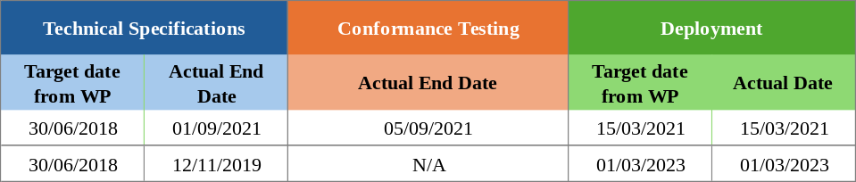
Table 9: Comparison of Planned and Actual Dates – ICS2 – Release 1 and 2

UCC Guarantee Management (GUM) – Component 1
Deployment | 11 March 2024
The UCC Guarantee Management (GUM) project assures the effective and efficient management of the different types of guarantees. A guarantee is the financial cover for customs duties and other charges.
The UCC GUM system is comprised of two components.
Component 1 (GUM-C1) enhances the granting and the management of authorisations for comprehensive guarantees that may be used in more than one Member State. It was implemented in the UCC CDS and will interface with a national component (GUM-C2) for the monitoring of the reference amount. Transit guarantees monitoring is an exception to the above and it is handled as part of the New Computerised Transit System (NCTS) project. GUM C1 became operational in March 2024 and the Member States had until 2 June 2025 to deploy their GUM-C2 system.
For Component 2 (GUM-C2), please refer to Section 3.5.

Overview of Project Progress
Table 10 highlights any known divergences in the planning compared to the dates set in the UCC WP.
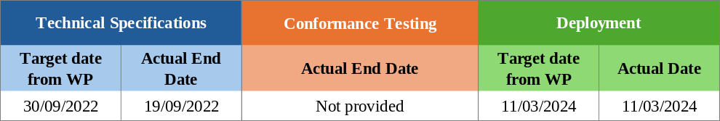
Table 10: Comparison of Planned and Actual Dates – GUM-C1

UCC Proof of Union Status (PoUS) – Phase 1
Deployment | 1 March 2024
The UCC Proof of Union Status (PoUS) is a trans-European system designed to allow storage, management, and retrieval of certain types of documents (e.g., T2L, T2LF, Customs Goods Manifest [CGM]) that traders provide to prove the Union Status of their goods. To this effect, PoUS includes a central repository for the storage and exchange of data and documents dealing with PoUS between the customs authorities across all the Member States. The system is meant to improve the uniformity of the procedures across the European Union and contribute to the establishment of a more consistent, harmonised and, thus, simplified process related to customs clearance for Union goods.
The project is divided into two phases. For both Phase 1 and Phase 2, the Member States had the option of using the central PoUS system or developing their own national application. From all Member States, only ES and PL chose to develop their own national system.
Phase 1 (PoUS-P1) covers the implementation of the electronic T2L/F data with all the necessary functionalities. The Technical Systems Specifications (TSS) were completed in Q1 2022 and conformance testing activities were completed by Q1 2024. ES and PL along with the Commission reported the PoUS-P1 system deployed on 1 March 2024.
For Phase 2 (PoUS-P2), please refer to Section 3.10.

Some statistical information on the use of the PoUS-P1 system – situation until 31 July 2025:
PoUS Registered and Presented Proofs by MS
MS | # Registered Proofs | # Presented Proofs
AT | 2589 | 2
BE | 56442 | 3580
BG | 11656 | 5251
CY | 17589 | 118581
CZ | 2921 | 14
DE | 56462 | 7411
DK | 10268 | 2103
EE | 8022 | 5281
ES | 136171 | 16314
FI | 10185 | 3196
FR | 19665 | 14587
GR | 65065 | 77844
HR | 1397 | 1918
HU | 4825 | 3066
IE | 4235 | 3476
IT | 113097 | 13009
LT | 10893 | 2107
LU | 256 | 0
LV | 8168 | 1288
MT | 1782 | 1151
NL | 52223 | 5106
PL | 26974 | 5681
PT | 17424 | 5730
RO | 8996 | 5550
SE | 10390 | 4144
SI | 3342 | 664
SK | 2970 | 8
XI | 1114 | 30
Grand Total | 665121 | 307093

Figure 11: Statistical information – PoUS – Phase 1

Overview of Project Progress
Table 11 highlights any known divergences in the planning compared to the dates set in the UCC WP.
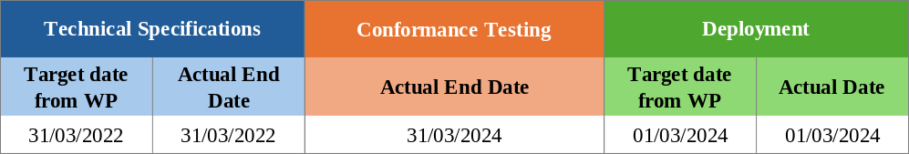
Table 11: Comparison of Planned and Actual Dates – PoUS-P1

UCC New Computerised Transit System (NCTS) Upgrade – Component 1
Deployment | 21 January 2025
This project aimed to align the existing New Computerised Transit System (NCTS) to the UCC legal provisions. The scope of the project included the alignment of Information Exchanges to UCC data requirements, the upgrade and development of interfaces with other systems such as the Automated Export System (AES), in addition to new Safety and Security requirements. The transit system offers significant benefits and simplifies processes while ensuring continuity with existing systems. This achievement is the result of close collaboration between national customs authorities, trade associations and the Commission.
It is important to highlight that the NCTS system specifications developed by the Commission cover the Information Exchange in the common, national, and external domains. Regarding the message exchanges on the Common Domain, the NCTS specifications prepared by DG TAXUD are mandatory for all Common Transit Convention (CTC) contracting parties. In the case of external or national domains, the common NCTS specifications are strongly recommended, aiming to harmonise the transit formalities as much as possible among the CTC contracting parties. The UCC Data Annex B and Annex A3a of the CTC Convention are the binding legal framework for Transit Declarations.
In terms of the planning approach, the project was divided into two components.
Component 1 (NCTS-P5) included steps to upgrade and extend the current NCTS processes in alignment with the UCC legal provisions, to introduce new processes such as the pre-lodgement of customs declarations, to provide for the registration of ‘en route’ events, to align Information Exchange to UCC data requirements and to upgrade and update the development of interfaces with other systems. The system included some components that were developed centrally, but the main components were developed at the national level. NCTS-P5 was deployed in two steps: the first related to core functionalities (operational continuity aligned with UCC) and the second to non-core functionalities (Pre-Lodgement, Incident ‘en route’ Management, Office of Exit and Export followed by Transit). The National Administrations had the possibility to deploy both steps at once or to deploy them in sequence.
There are 40 National Administrations currently in operation for NCTS: the 27 Member States, Northern Ireland under the terms of the Northern Ireland Protocol (NIP), Andorra, San Marino, and the CTC Countries (Switzerland with Liechtenstein connected, Serbia, North Macedonia, Norway with Iceland connected, Türkiye, Ukraine, the United Kingdom and Georgia). Georgia acceded to Common Transit and entered NCTS-P5 operations on 1 February 2025. Montenegro, and Moldova are acceding countries to the Common Transit Convention at various stages of preparation and aim to go into operation by the end of 2025.
NCTS-P5 was deployed in line with the following calendar: Core functionalities (Step 1) on 01/12/2023, none core-functionalities (Step 2) on 02/12/2024. It became fully operational on 21 January 2025, after the end of transition date. All 40 National Administrations are currently operating in NCTS-P5, while NCTS-P4 systems will be decommissioned in the coming months.
For Component 2 (NCTS-P6), please refer to Section 3.7.

Overview of Project Progress
Table 12 highlights any known divergences in the planning compared to the dates set in the UCC WP.
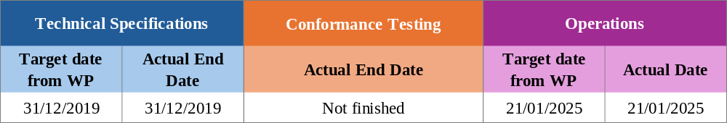
Table 12:Comparison of Planned and Actual Dates – NCTS-P5

Ongoing Projects
Figure 12 provides an overview of the deployment windows of the UCC projects that are currently ongoing:
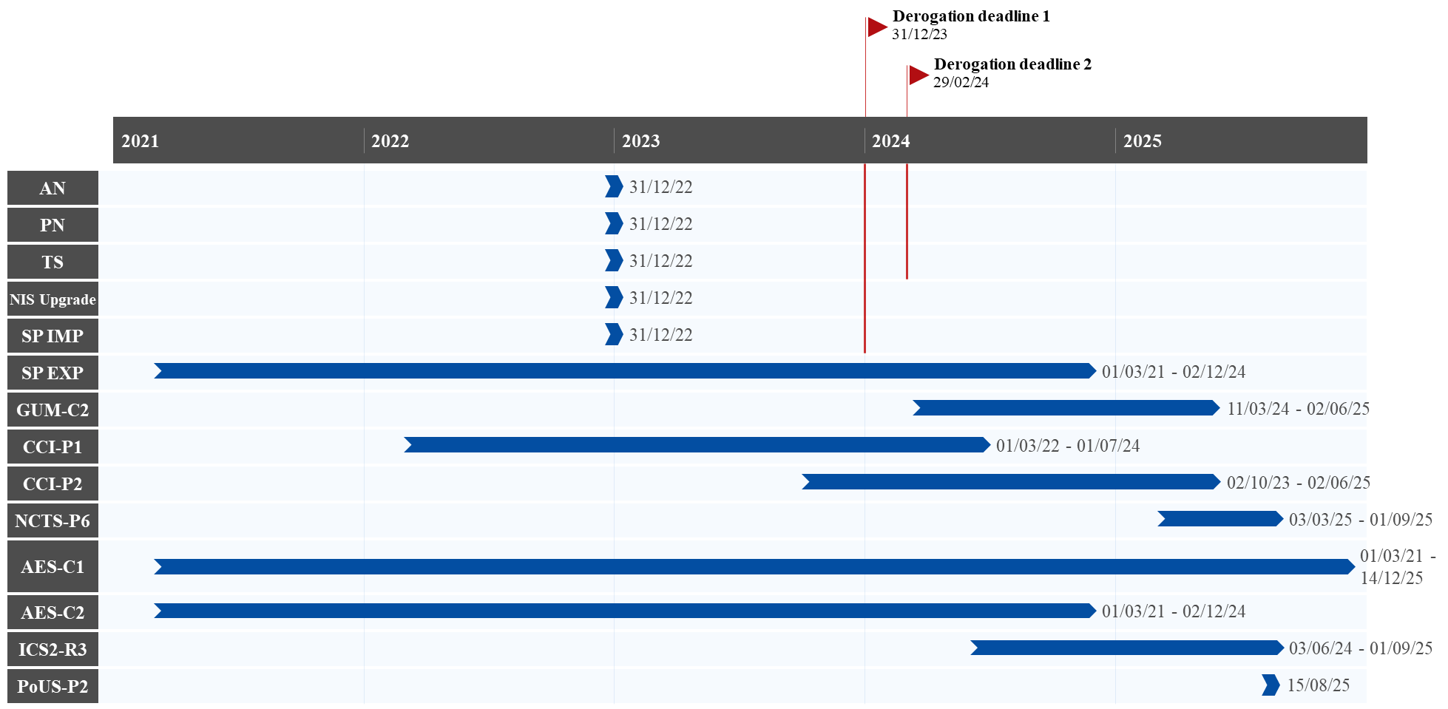
Figure 12: Overview of projects to be completed by the end of 2025

UCC Notification of Arrival (AN), Presentation Notification (PN) and Temporary Storage (TS)
The goal of this project is to define the processes at the national level in respect of the Notification of Arrival (AN), Presentation Notification (PN), and Temporary Storage (TS) notifications, as described in the UCC. The project aims to ensure that Safety and Security-related customs formalities for goods entering and exiting are properly conducted, and customs supervision begins at the appropriate time and is duly performed. It also aims to support harmonisation across the Member States regarding the data exchange between trade and customs. Furthermore, the project covers the automation of processes at the national level.
The project also considers that customs authorities may accept port or airport systems or other available methods of information for the notification of the arrival of the means of transport, the presentation of goods to customs, and/or the temporary storage declarations. Therefore, in this report, a distinction between air transport, maritime transport or inland waterways and other modes of transport is provided. The other modes of transport cover road & rail transport.
The development activities related to this project are a national matter, with processes and data requirements for the external domain to be defined and agreed at the EU level. In this light, the systems were planned to be in operation by 31 December 2022, as defined in the UCC basic Regulation. However, several Member States requested a derogation as stated in Article 6(4) of the UCC, addressing a formal request, of a temporary nature, stating a scope and clear justification. On 1 February 2023, the Commission adopted Implementing Decisions granting derogations to certain Member States for AN, PN, and TS, extending the previously stated deadlines to 31 December 2023 for air transport and 29 February 2024 for other modes of transport (maritime transport or inland waterways and road & rail transport).

Summary of Responses
Notification of Arrival (AN)
Summary from the Member States:
While most Member States have completed the AN/PN/TS projects, a few reported delays. These delays are often attributed to the project’s strong interlinkage with other major initiatives such as NIS, ICS2, and the European Maritime Single Window (EMSW), frequently cited by Member States as a key reason for assessing the project as high risk.
Common risk factors contributing to delays include procurement issues, interdependencies between national systems, coordination challenges, limited human resources, and the varying readiness of EOs. Further delays were linked to internal development bottlenecks and the prioritisation of other national projects, notably NIS.
To address these risks, Member States have reported the implementation of various mitigation measures. These include corrective actions in project management and staffing, enhanced support for EOs, parallel development and testing activities, interim reliance on existing systems such as the Maritime Single Window (MSW) to prevent procedural disruptions, and the joint implementation of related national projects to streamline timelines.
The above summary also applies to PN and TS.
As of the time of writing, the following Member States reported that the AN system has been deployed for both air and maritime transport: BE, BG, CY, CZ, DE, DK, EE, ES, FI, FR, GR, HR, HU, IE, IT, LT, LV, MT, NL, PL, RO, SE, and SI. AT, LU and SK indicated that the system is operational for air transport but noted that maritime transport is not applicable. PT shared that the AN system for both air and maritime transport is delayed but will be deployed before the end of 2025.

Important remark:
Several Member States submitted a written notification to DG TAXUD, asking for a derogation under Article 6(4) of the UCC, concerning the delay of AN beyond the deadline of 31 December 2022. The derogation requests from the Member States were assessed by the Commission services in terms of the justifications provided for the specific situations of the Member States requesting it and in view of a set of common assessment criteria.
In this light, the Commission adopted an Implementing Decision (EU) 2023/235 on 1 February 2023, granting a derogation to AT, BE, BG, CY, CZ, DK, EE, ES, FR, GR, HR, HU, LU, MT, NL, PL, PT, RO, SE, SI, and SK for AN provided for in Article 133 of the UCC. The derogation applied from 1 January 2023 until the deployment of the AN system, but not later than 31 December 2023, in respect of goods entering the customs territory of the Union by air, and 29 February 2024, in respect of goods entering the customs territory of the Union by maritime transport or inland waterways, whichever date is sooner. This differentiation by transport mode aligned with ICS2-R2 and the date specified in the UCC WP 2023 for ICS2-R3, respectively, as the projects are closely linked.
Detailed Responses:
Table 13 provides the individual updates from the Member States on their responses to the survey and the national project plans provided in June 2025:
MS | Additional Comments
AT | AT reported that the AN system for air transport has been deployed since 16/05/2023, with ICS2 functionalities being used for the implementation of the AN system.
BE | BE informed that the AN system was deployed on 30/06/2023 for air transport and on 03/06/2024 for maritime transport.
BG | BG shared that the AN system was deployed on 01/03/2023 for air transport and on 03/06/2024 for maritime transport.
CY | CY reported that the AN system was deployed on 19/05/2025 for both air and maritime transport. CY informed that it experienced delays due to multiple factors, including procurement issues, interdependencies between core and supporting systems, parallel upgrades, coordination challenges between contractors, limited human resources, and the readiness of its EOs. To address these issues, CY implemented corrective measures in project management and resourcing, and strengthened support for EOs, which helped reduce the delays.
CZ | CZ informed that the AN system for both air transport and maritime transport was deployed on 05/12/2023.
DE | DE indicated that the AN system has been completed as it is covered by their ICS2 system.
DK | DK reported that the AN system for air transport was deployed on 06/11/2023 and for maritime transport on 25/05/2024.
EE | EE shared that the AN system was deployed on 01/10/2023 for air transport and on 03/06/2024 for maritime transport.
ES | ES informed that the AN system was deployed on 01/03/2023 for air transport. Additionally, ES shared that the AN system for maritime transport is aligned with ICS2-R3 and was deployed on 03/06/2024.
FI | FI reported that the AN system was deployed in Q1 2023 for air transport and in Q2 2024 for maritime transport.
FR | FR indicated that the AN system for air transport was deployed on 30/06/2023 and for maritime transport on 03/06/2024. Additionally, FR shared that AN messages are processed by their ICS2 system.
GR | GR shared that the AN system was deployed on 31/10/2023 for air and maritime transport. GR noted that the implementation was based on ICS2.
HR | HR reported that the AN system was deployed on 01/07/2023 for air transport and on 04/12/2024 for maritime transport.
HU | HU indicated that the AN system was deployed for all modes of transport on 02/04/2024.
IE | IE shared that the AN system was deployed on 01/07/2023 for air transport and on 03/06/2024 for maritime transport. Additionally, IE noted that developments have started in relation to include AN messages through the EMSW, but this will not be in production until late 2026 or early 2027.
IT | IT informed that the AN system was deployed on 13/12/2022 for air transport and on 03/06/2024 for maritime transport.
LT | LT reported that the AN system was deployed on 01/03/2023 for air transport and on 03/06/2024 for maritime transport. Additionally, LT informed that the central ICS2 system is being used for the implementation of AN.
LU | LU shared that the AN project was completed, having deployed the system for air transport on 01/03/2023.
LV | LV reported that the AN system was deployed on 24/09/2017 for air transport and on 01/03/2023 for maritime transport. Additionally, the AN system part of the ICS2 system.
MT | MT indicated that the AN system was deployed on 24/03/2025 for all modes of transport.
NL | NL shared that the AN system was deployed on 30/06/2023 for air transport and on 27/05/2024 for maritime transport. However, NL indicated that the project is still delayed, as EOs will be following the ICS2 implementation dates to join operations. NL aims to have AN fully implemented on 01/10/2025.
PL | PL shared that the AN system was deployed on 01/07/2023 for air transport, on 03/06/2024 for maritime transport. Additionally, PL shared that the AN functionalities were developed within ICS2.
PT | PT reported that the AN project is delayed beyond the UCC WP deadline, with deployment for both air and maritime transport planned for 30/09/2025. PT attributed a high-risk level to the timely delivery of the project, with delays attributed to the strong interdependencies among national systems, which complicated the overall development of the AN system. PT shared that the project was particularly complex, as it involved building an entirely new system for AN, PN, and TS, requiring integration with airport and port authorities. Additional delays were caused by the need to connect this system with ICS2, NIS, the Customs Risk Management System (CRMS), and the Temporary Storage Facilities system. To address these challenges, PT adopted Agile development to shorten the implementation timeframe and improved its planning processes.
RO | RO shared that the AN system was deployed on 01/05/2024 for air transport and on 16/12/2024 for maritime transport.
SE | SE informed that the AN system was deployed on 01/03/2023 for air transport and on 03/06/2024 for maritime transport. Additionally, SE noted that it will be using the central functionalities within the ICS2 project for AN messages.
SI | SI reported that the AN system joined operations on 01/03/2023 for air transport and on 02/06/2024 for maritime transport. In addition, SI shared that it will use ICS2 for the AN processes.
SK | SK shared that the central ICS2 system is being used for the AN functionalities, which were deployed for air transport on 01/03/2023.
Table 13: Detailed responses from Member States – AN

Figure 13 provides the progress reported by the Member States through their national project plans, along with the status of the project.
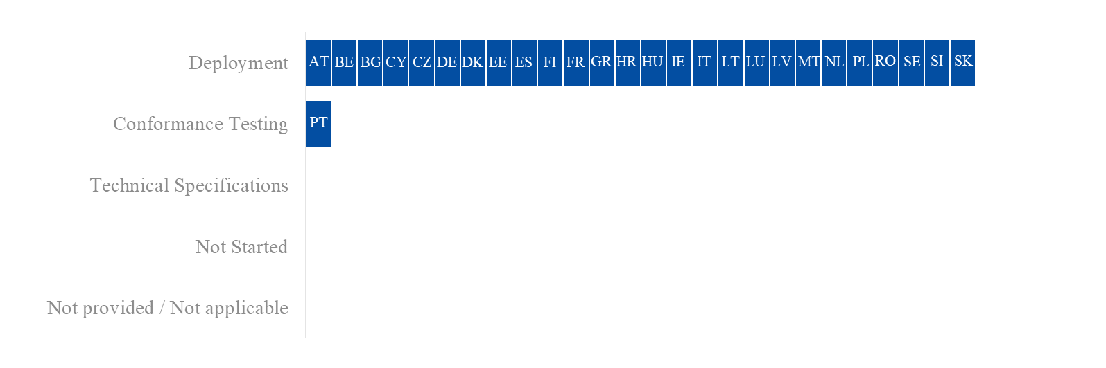
Figure 13: Project progress and status per milestone – AN

Presentation Notification (PN)
Summary from the Member States:
Please see also the summary from AN.
For the PN system, Member States were requested to comply with the requirements of the new Annex B of the Commission Delegated Regulation (EU) 2021/234 to the common data requirements for declarations, notifications, and proof of the customs status of union goods provided for in Article 2(2) of the Commission Delegated Regulation (EU) 2021/234.
As of the time of writing, the following Member States reported that the PN system has been deployed for all modes of transport: BG, CZ, DE, DK, EE, ES, FI, FR, HR, HU, IE, LT, LV, MT, PL, RO, and SE. CY, IT, NL and SI, have deployed the PN system for air and maritime transport and indicated that road & rail transport is not applicable. BE has also deployed the PN system for air and maritime transport but did not provide information regarding road & rail transport. AT, LU and SK reported deployment for air transport only, noting that maritime and road & rail transport are not applicable. In addition, PT shared that the PN system for both air and maritime transport is delayed, but will be deployed before the end of 2025.

Important remark:
Several Member States submitted a written notification to DG TAXUD, asking for a derogation under Article 6(4) of the UCC, considering the delay of PN beyond the deadline of 31 December 2022. The derogation requests from the Member States were assessed by the Commission services in terms of the justifications provided for the specific situations of the Member States requesting it and in view of a set of common assessment criteria.
In this light, the Commission adopted on 1 February 2023 an Implementing Decision (EU) 2023/234 granting a derogation to AT, BE, CY, CZ, DK, EE, ES, FR, GR, HR, HU, LU, MT, NL, PL, PT, RO, SE, SI, and SK for the PN system provided for in Article 133 of the UCC. The derogation applied from 1 January 2023 until the deployment of the PN system, but not later than 31 December 2023, in respect of goods entering the customs territory of the Union by air and 29 February 2024, in respect of goods entering the customs territory of the Union by maritime transport, inland waterways, road & rail transport, whichever date is sooner. This differentiation by transport mode aligned with ICS2-R2 and the date specified in the UCC WP 2023 for ICS2-R3, respectively, as the projects are closely linked.
Detailed Responses:
Table 14 provides the individual updates from the Member States on their responses to the survey and the national project plans provided in June 2025:
MS | Additional Comments
AT | AT shared that the PN project was completed within the ICS2 system and was deployed on 16/05/2023 for air transport.
BE | BE informed that the PN system was deployed on 05/07/2023 for air and maritime transport.
BG | BG reported that the PN system for all modes of transport was deployed on 10/11/2023.
CY | Same response as for AN.
CZ | CZ informed that the PN system for both air transport and maritime transport was deployed on 05/12/2023 and for road & rail transport on 01/06/2024.
DE | DE shared that the PN system was deployed for air transport on 06/03/2021. Additionally, it indicated that PN was updated as part of ‘National Entry System’ of the national IT-System Automated Customs Tariff and Local Processing Application System (ATLAS) (Release 9.1), which covers all modes of transport.
DK | DK reported that the PN system was deployed for air transport on 06/11/2023, for maritime transport on 25/05/2024 and for road & rail transport on 29/07/2023.
EE | EE informed that the PN system was deployed on 15/03/2021 for all modes of transport.
ES | ES shared that the PN system was deployed on 01/01/2024 for air transport and on 01/03/2024 for both maritime transport and road & rail transport.
FI | FI informed that the PN system was deployed in Q1 2021 for air transport and in Q2 2024 for both maritime transport and road & rail transport.
FR | FR reported that the PN system was deployed on 06/03/2024 for air transport, on 03/06/2024 for maritime transport and on 01/04/2025 for road & rail transport.
GR | GR indicated that the PN system was deployed on 31/10/2023 for all modes of transport.
HR | HR shared that the PN system was deployed for all modes of transport on 17/04/2023 and was implemented as part of ICS2.
HU | HU indicated that the PN system was deployed for all modes of transport on 02/04/2024.
IE | IE shared that the PN system was deployed for all modes of transport on 23/11/2020. Additionally, IE noted that PN messages will reflect the revised Annex B format in January 2026 and will be included in the European Maritime Single Window environment (EMSWe) in late 2026 or early 2027.
IT | IT informed that the PN system was deployed on 13/12/2022 for air transport and on 03/06/2024 for maritime transport.
LT | LT informed that the PN system was deployed on 28/02/2023 for all modes of transport.
LU | LU shared that the PN project is complete, having deployed the system for air transport on 10/01/2023.
LV | LV reported that the PN system was deployed on 24/09/2017 for air transport and 01/03/2023 for maritime and road & rail transport. Additionally, LV shared that PN messages will be implemented as part of ICS2-R3 when all EOs join the system.
MT | MT informed that the PN system was deployed on 24/03/2025 for all modes of transport.
NL | NL reported that the PN system was deployed on 01/12/2023 for air transport and on 27/05/2024 for maritime transport. However, NL indicated that the project is delayed, as EOs will be following the ICS2 implementation dates to join operations. NL aims to have PN fully implemented on 01/09/2025.
PL | PL shared that the PN system was deployed on 20/04/2025 for all modes of transport. However, due to the parallel implementation of the NIS upgrade, full functionality is delayed for road and rail transport and will become operational on 01/09/2025. In addition, PN functionalities were developed within the NIS and ICS2 systems.
PT | Same response as AN.
RO | RO indicated that the PN system was deployed on 14/11/2024 for both air and maritime transport and on 01/04/2025 for road & rail transport. Additionally, RO noted that the PN system is dependent on ICS2.
SE | SE shared that the PN system was deployed on 27/09/2023 for air transport and on 01/03/2024 for both maritime transport and road & rail transport. However, SE shared that it has faced delays concerning maritime traffic due to the dependency with the EMSW deployment. SE shared it intends to use the current data filing system via the MSW until the new Maritime National Single Window (MNSW) is deployed by the Swedish Martime Authority in Q3 2027. This approach aims to minimise the burden on trade and prevent the need for SE to change procedures and filing systems twice within a short timeframe. As PN should pertain to the entry summary declaration, SE added several data elements to the current data filing system in the MSW since 03/06/2024. In addition, SE is analysing the consequences of the delays for the customs formalities since the deployment of the MNSW will be delayed until Q3 2027.
SI | SI informed that the PN system was deployed on 01/03/2023 for air transport and on 29/02/2024 for maritime transport.
SK | SK reported that all PN functionalities were implemented in all impacted systems and deployed on 01/10/2023 for air transport.
Table 14: Detailed responses from Member States – PN
Figure 14 provides the progress reported by the Member States through their national project plans, along with the status of the project.
Figure 14: Project progress and status per milestone – PN

Temporary Storage (TS)
Summary from the Member States:
Please see also the summary from AN.
For the TS system, Member States were requested to comply with the requirements of the new Annex B of the Commission Delegated Regulation (EU) 2021/234.
As of the time of writing, the following Member States reported that the TS system has been deployed for both all modes of transport: BG, CZ, DE, DK, EE, ES, FI, FR, HR, HU, IE, LV, MT, PL and SI. CY, IT, LT and NL have indicated that the TS system for air and maritime transport has been deployed and indicated that road & rail is not applicable. BE has also deployed the TS system for air and maritime transport but did not provide information regarding road & rail transport. LU has deployed the system for air and road and rail transport while indicating that maritime transport is not applicable. Moreover, SE has deployed the system for air transport but reported delays for maritime and indicated road and rail as not applicable. AT, GR, PT, RO and SK have reported delays beyond the legal deadline, with GR and SK expecting the delays to extend beyond 2025.
Important remark:
Several Member States submitted a written notification to DG TAXUD, asking for a derogation under Article 6(4) of the UCC, considering the delay of TS beyond the deadline of 31 December 2022. The derogation requests from the Member States were assessed by the Commission services in terms of the justifications provided for the specific situations of the Member States requesting it and in view of a set of common assessment criteria.
In this light, the Commission adopted on 1 February 2023 an Implementing Decision (EU) 2023/236 granting a derogation to AT, BE, CY, CZ, DK, EE, ES, FR, GR, HR, HU, LT, LU, MT, NL, PL, PT, RO, SE, SI, and SK for the TS system referred to in Article 145 of the UCC. The derogation applied from 1 January 2023 until the deployment of the TS system, but not later than 31 December 2023, in respect of goods entering the customs territory of the Union by air, and 29 February 2024, in respect of goods entering the customs territory of the Union by maritime transport or inland waterways, road or rail transport, whichever date is sooner. This differentiation by transport mode aligned with ICS2-R2 and the date specified in the UCC WP 2023 for ICS2-R3, respectively, as the projects are closely linked.
Detailed Responses:
Table 15 provides the individual updates from the Member States on their responses to the survey and the national project plans provided in June 2025:
MS | Additional Comments
AT | AT reported that the TS project is delayed beyond the UCC WP deadline but aims to ‘deploy on 01/11/2025 for air and road & rail transport. AT attributed a medium risk to the timely delivery of the project, due to delays with the internal developments and the finalisation of the public tender (pending the conclusion of negotiations with the software provider and the Commission). Additionally, AT plans to deploy TS alongside the upgrade of NIS, instead of with Centralised Clearance for Import (CCI-P2) in order to reduce delays and deploy before the end of 2025.
BE | BE shared that the TS system was deployed on 29/11/2023 for air and maritime transport.
BG | BG reported that the TS system for all modes of transport was deployed on 10/11/2023.
CY | Same response as for AN.
CZ | CZ informed that the TS system for all modes of transport was deployed on 05/12/2023.
DE | Same response as PN.
DK | DK reported that the TS system was deployed on 07/06/2025 for all modes of transport. However, some delays occurred due to its dependency on the import system, which was postponed as priority was given to export and transit systems. DK also delayed the go-live to ensure quality and usability for its EOs. To support deployment, DK implemented parallel development and testing, increased project resources, and is actively working with its vendor to ensure timely delivery of other MASP-C initiatives scheduled for 2025.
EE | EE shared that the TS system was deployed on 01/07/2021 for air transport, on 01/10/2023 for maritime transport and on 03/06/2024 for road & rail transport.
ES | ES informed that the TS system was deployed on 01/01/2024 for air transport and on 01/03/2024 for both maritime transport and road & rail transport.
FI | FI shared that the TS system was deployed in Q1 2022 for air transport and in Q2 2024 for both maritime transport and road & rail transport.
FR | FR indicated that the TS system was deployed on 06/03/2024 for both air and maritime transport and on 01/04/2025 for road & rail transport.
GR | GR informed that deployment of the TS system is expected in Q4 2027 for air and road and rail transport and in Q4 2026 for maritime transport.
HR | HR reported that the TS system was deployed on 17/04/2023 for all modes of transport.
HU | HU indicated that the TS project was completed, having deployed the system for all modes of transport on 02/04/2024.
IE | IE shared that the TS system was deployed for all modes of transport on 23/11/2020. Additionally, IE noted that TS messages will reflect the revised Annex B format in January 2026 and will be included in the EMSWe in late 2026 or early 2027.
IT | IT informed that the PN system was deployed on 13/12/2022 for air transport and on 03/06/2024 for maritime transport.
LT | LT reported that the TS system was deployed for both air transport and maritime transport on 31/10/2023.
LU | LU shared that the TS project was completed, having deployed the system for air and road and rail transport on 10/01/2023.
LV | LV reported that the TS system was deployed on 24/09/2017 for all modes of transport. Additionally, LV reported that the TS system has been updated according to UCC data elements, and has confirmed it is aligned with the latest European Union Customs Data Model (EUCDM) version since 15/02/2022.
MT | MT informed that the TS system was deployed on 24/03/2025 for all modes of transport.
NL | NL reported that the TS system was deployed on 01/12/2023 for air transport and on 27/05/2024 for maritime transport. However, NL indicated that the project is delayed, as EOs will be following the ICS2 implementation dates to join operations. NL aims to have TS fully implemented on 01/10/2025.
PL | PL shared that the TS system was deployed on 20/04/2025 for all modes of transport. However, due to the parallel implementation of the NIS upgrade, full functionality was delayed and became operational only on 19/06/2025. During this period, the legacy NIS was used by incorporating the TS functionality in a transitional data model.
PT | Same response as AN.
RO | RO informed that deployment of the AN system is expected on 30/08/2025 for all modes of transport.
SE | SE reported that the TS system was deployed for air transport on 08/10/2024 but is delayed beyond the legal deadline for maritime transport, which it plans to deploy on 02/12/2025. SE shared that it had planned to use the MNSW as the external domain source for the temporary storage declarations. However, since the deployment of the MNSW in Sweden will be delayed until Q3 2027, SE is considering the possibility of submitting the temporary storage declarations directly to their TS system. This approach is intended to minimise disruption for traders.
SI | SI shared that the TS system was deployed on 01/03/2024 for all modes of transport.
SK | SK reported that the TS project is delayed beyond 2025, with a ‘go live’ date planned tentatively for Q1 2027. SK attributed the delay due to other UCC projects being prioritised, in particular NIS, as well as having a single contractor working on all systems. SK aims to complete the initiation phase by the end of the 2025.
Table 15: Detailed responses from Member States – TS

Figure 15 provides the progress reported by the Member States through their national project plans, along with the status of the project.
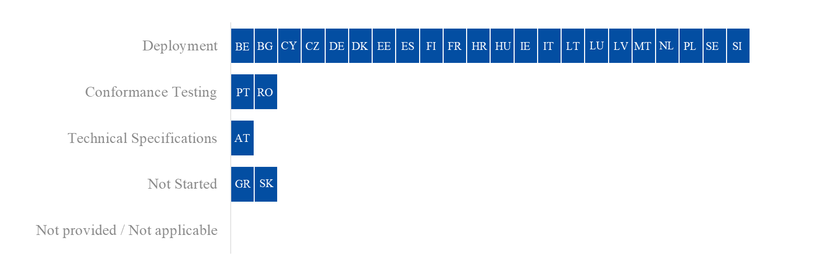
Figure 15: Project progress and status per milestone – TS

Overview of Project Progress
Figure 16, Figure 18, and Figure 21 for the air transport; Figure 17, Figure 19, and Figure 22 for the maritime transport, and Figure 20 and Figure 23 for other modes of transport highlight any known divergences in the Member States’ National Planning compared to the dates set in the UCC and/or the granted derogation deadline as well as the specific dates for each milestone. The dates reflected in the figures below indicate the full implementation of the project. Some Member States decided to deliver the system in several iterations or releases, linked to the ICS2 Releases.
Concerning the implementation of Notification of Arrival (AN) – Air transport, the following Member States have a planned/actual deployment date that is later than the deadline set by the UCC and/or the granted derogation: CY, FI, HU, IE, LT, MT, PT and RO. In addition, DE did not provide information through its National Planning on the deployment date, and SI indicated the project as not applicable.
Regarding the implementation of Notification of Arrival (AN) – Maritime transport, the following Member States have a planned/actual deployment date that is later than the deadline set by the UCC and/or the granted derogation: CY, FI, HR, IE, IT, LT, LV, MT, PT, and RO. In addition, DE did not provide information through its National Planning on the deployment date and AT, LU, SI and SK indicated the project as not applicable.
The specific dates of each milestone can be found in Figure 16 for air transport and Figure 17 for maritime transport.
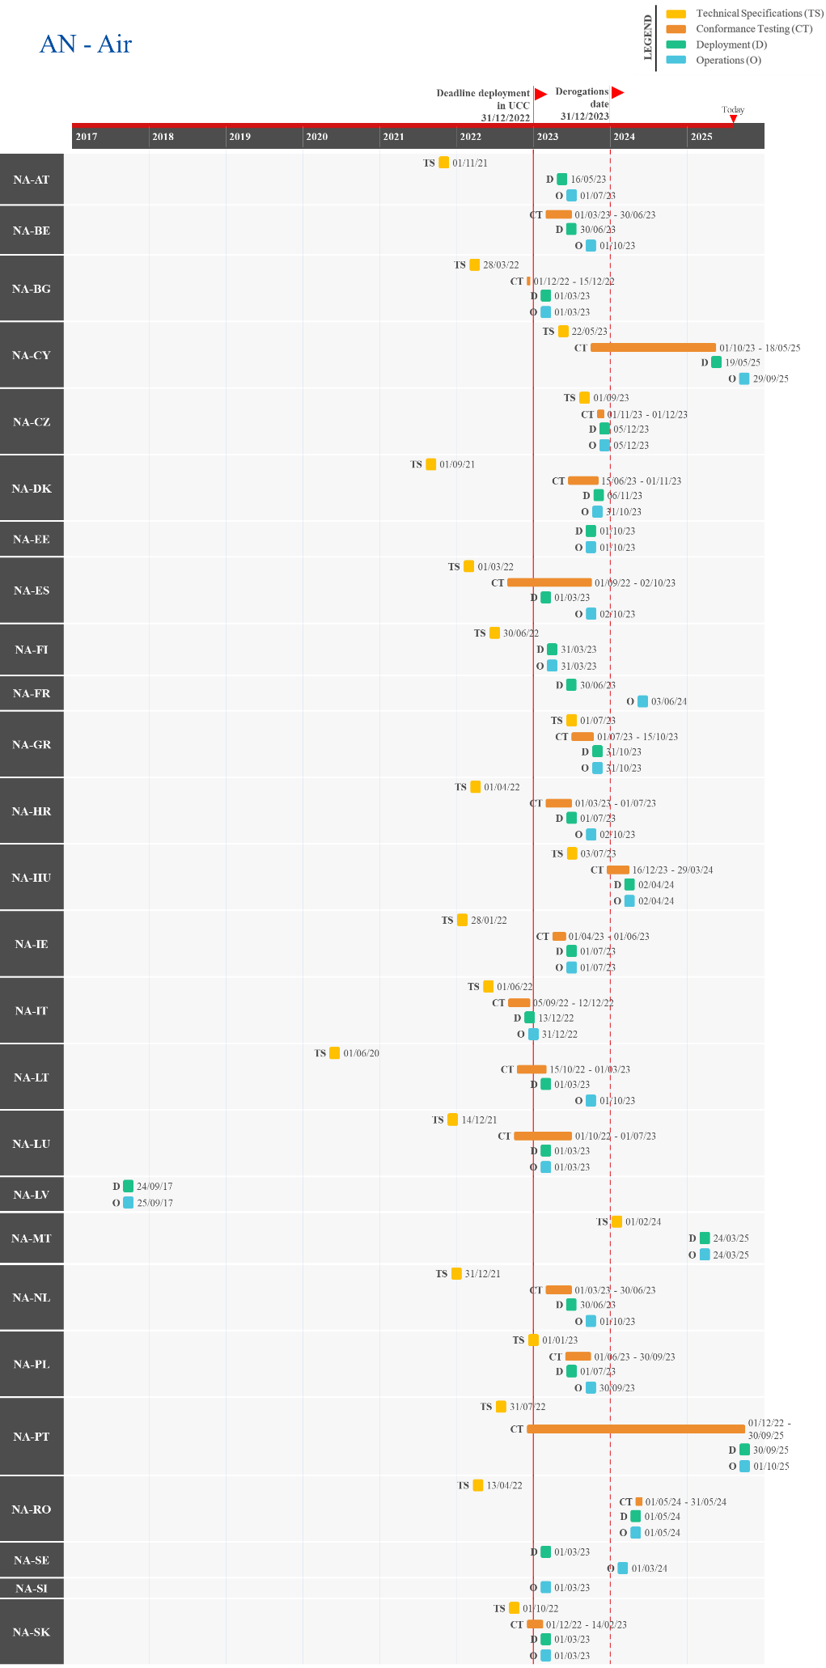
Figure 16: Actual/Planned dates per milestone – AN – Air transport
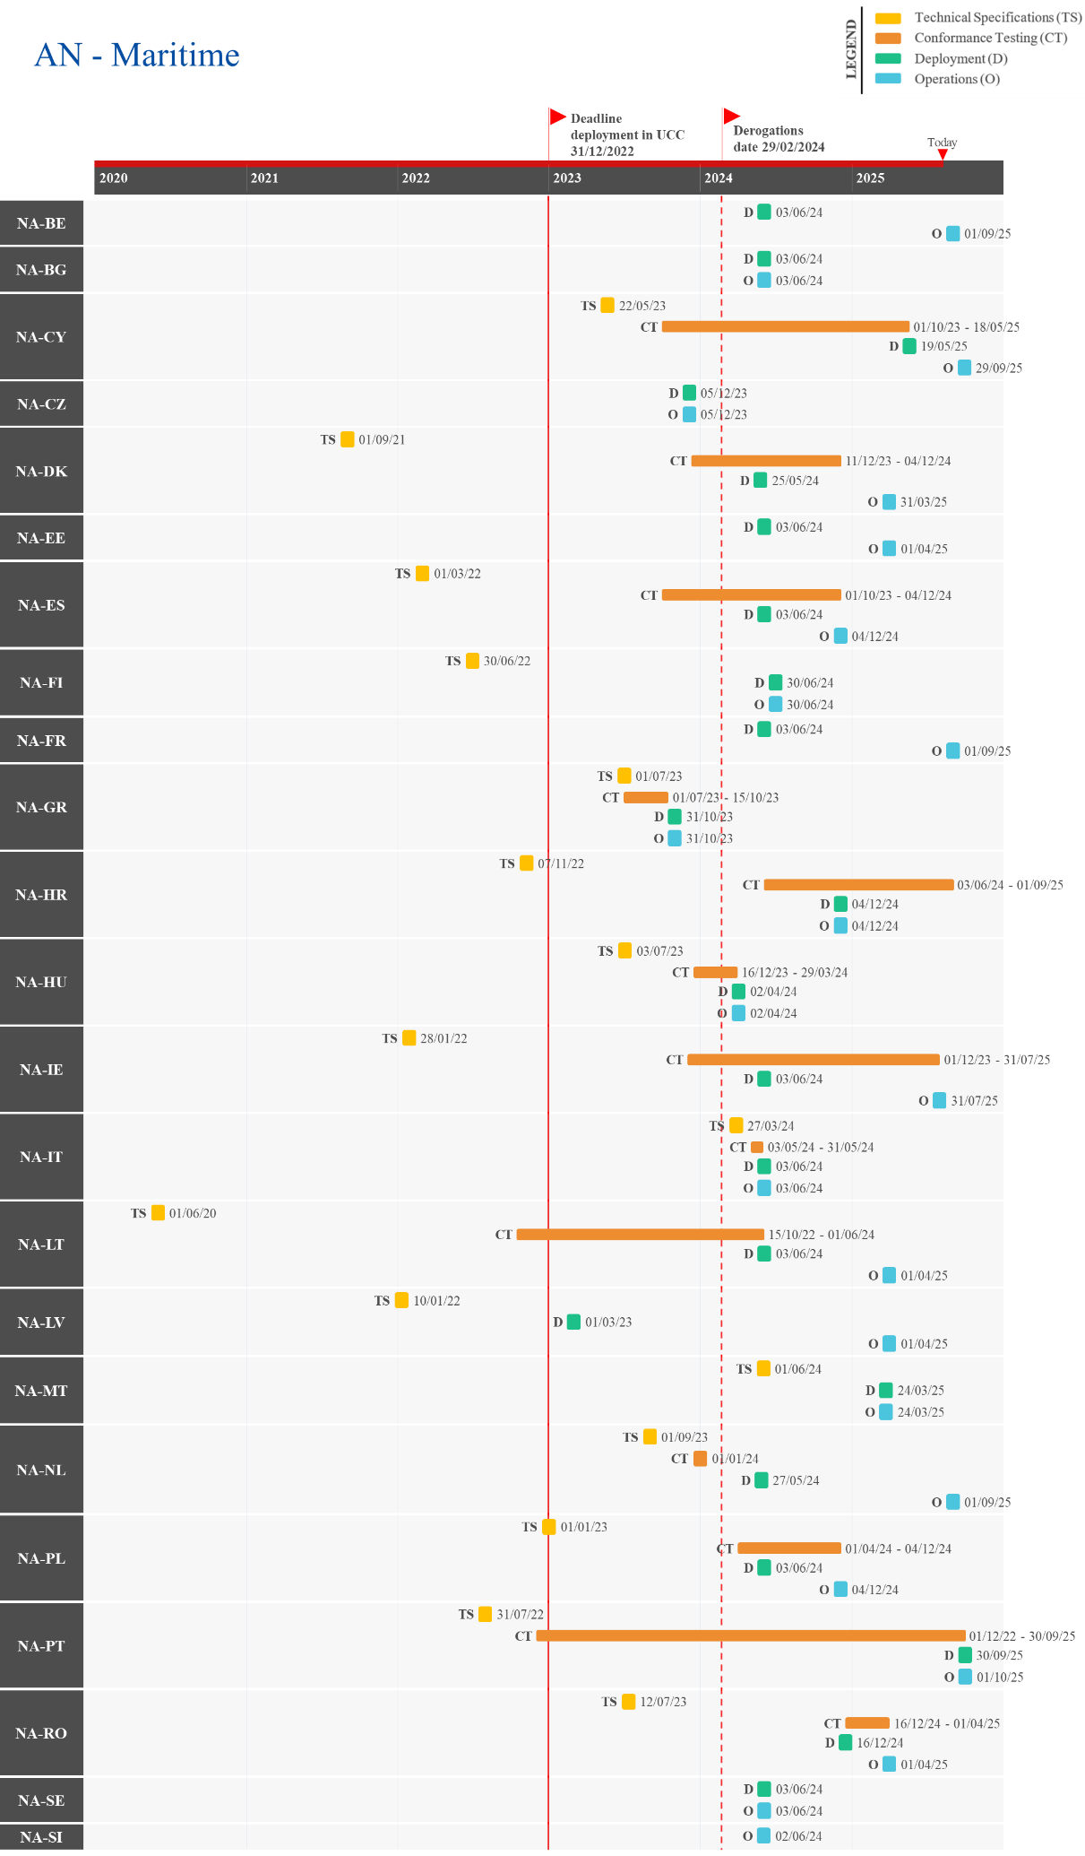
Figure 17: Actual/Planned dates per milestone – AN – Maritime transport
Regarding the implementation of Presentation Notification (PN) – Air transport, the following Member States indicated a planned/actual deployment date that is later than the deadline set in the UCC and/or the granted derogation: BG, CY, FR, HU, LT, MT, PL, PT, and RO.
Concerning the implementation of Presentation Notification (PN) – Maritime transport, the following Member States have a planned/actual deployment date that is later than the deadline set by the UCC and/or the granted derogation: BG, CY, FI, IT, LT, LV, MT, PL, PT and RO. In addition, DE did not provide information on the deployment date and AT, LU, and SK indicated the project as not applicable.
Concerning the implementation of Presentation Notification (PN) – Other modes of transport, the following Member States have a planned/actual deployment date that is later than the deadline set by the UCC and/or the granted derogation: BG, FI, FR, LT, LV, MT, PL, and RO. In addition, BE and DE did not provide information through their National Planning on the deployment date. Furthermore, AT, CY, IT, LU, NL, PT, SI and SK indicated the project as not applicable.
The specific dates of each milestone can be found in Figure 18 for air transport, Figure 19 for maritime transport and Figure 20 for other modes of transport.

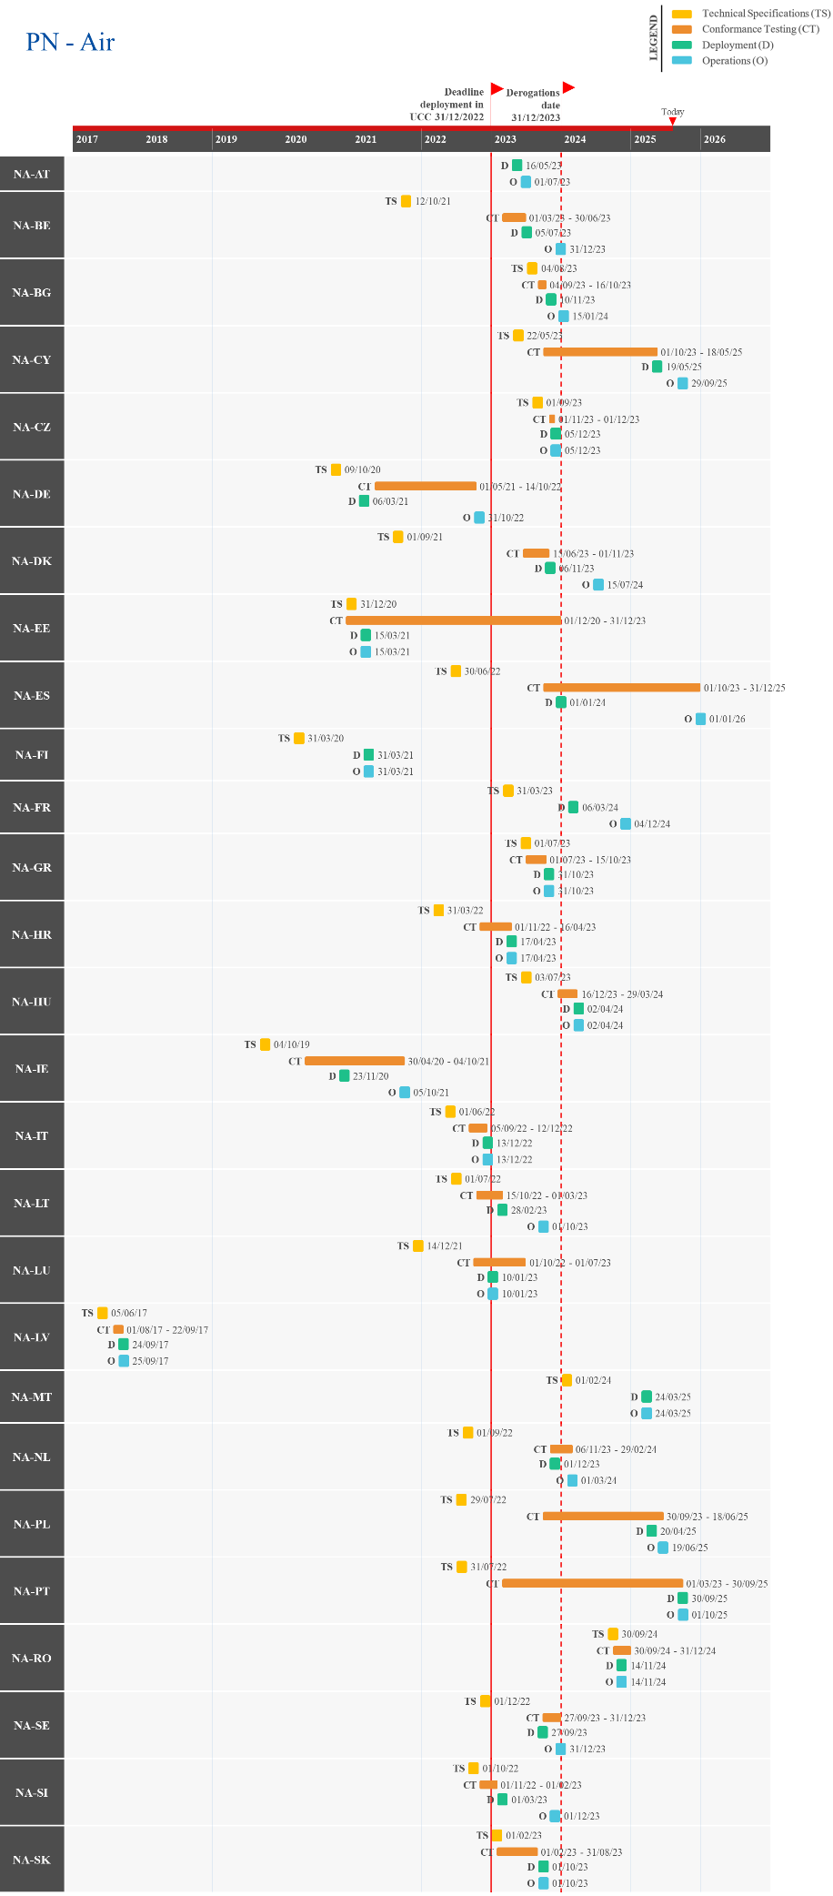
Figure 18: Actual/Planned dates per milestone – PN – Air transport
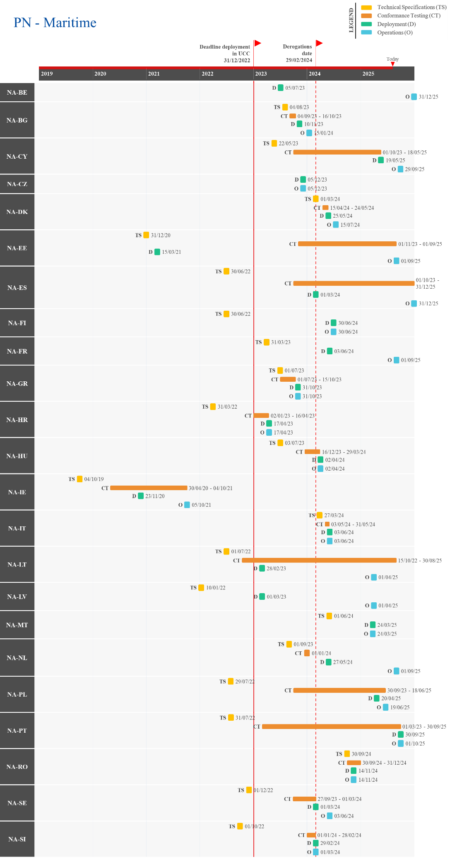
Figure 19: Actual/Planned dates per milestone – PN – Maritime transport
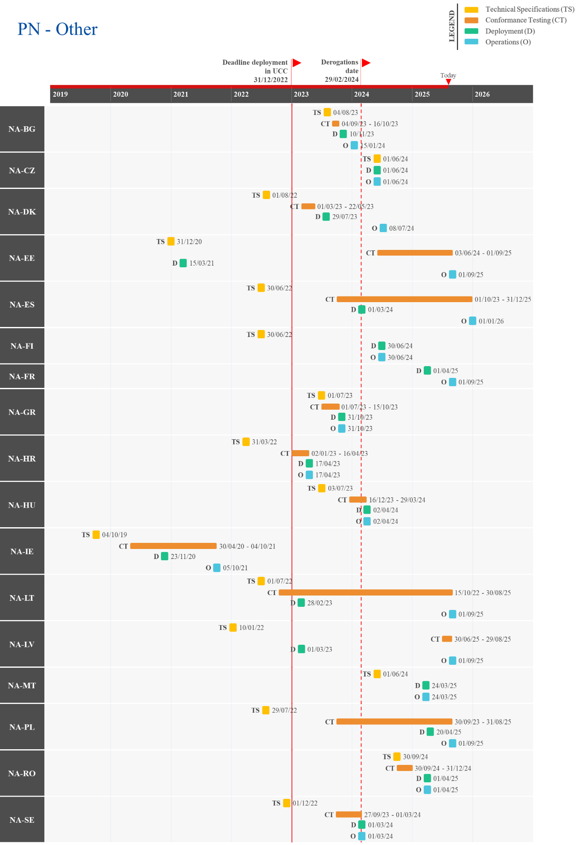
Figure 20: Actual/Planned dates per milestone – PN – Other modes of transport

Regarding the implementation of Temporary Storage (TS) – Air transport, the following Member States indicated a planned/actual deployment date that is later than the deadline in the UCC and/or the granted derogation: AT, BG, CY, DK, GR, MT, PL, PT, RO, SE, and SK.
Concerning the implementation of Temporary Storage (TS) – Maritime transport, the following Member States have a planned/actual deployment date that is later than the deadline set by the UCC and/or the granted derogation: BG, CY, DK, FI, GR, IT, MT, PL, PT, RO, and SE. In addition, DE did not provide information through its National Planning on the deployment date and AT, LU and SK indicated the project as not applicable.
Concerning the implementation of Temporary Storage (TS) – Other modes of transport, the following Member States have a planned/actual deployment date that is later than the deadline set by the UCC and/or the granted derogation: AT, BG, DK, FI, FR, GR, MT, PL, RO, and SK. In addition, the following Member States did not provide information through their National Planning on the deployment date: BE, DE, and LT. Furthermore, CY, IT, NL, PT, and SE indicated the project as not applicable.
The specific dates of each milestone can be found in Figure 21 for air transport, Figure 22 for maritime transport and Figure 23 for other modes of transport.
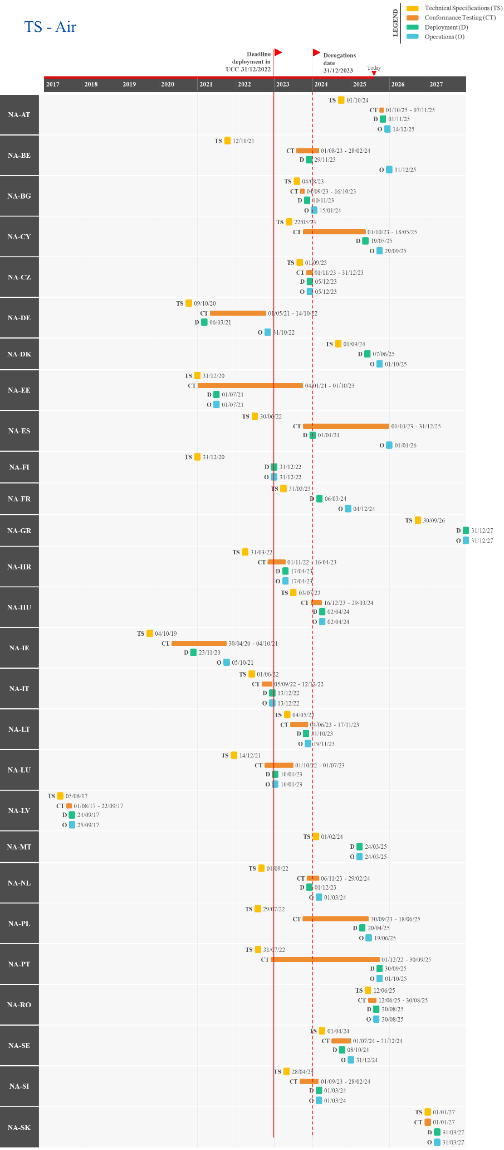
Figure 21: Actual/Planned dates per milestone – TS – Air transport
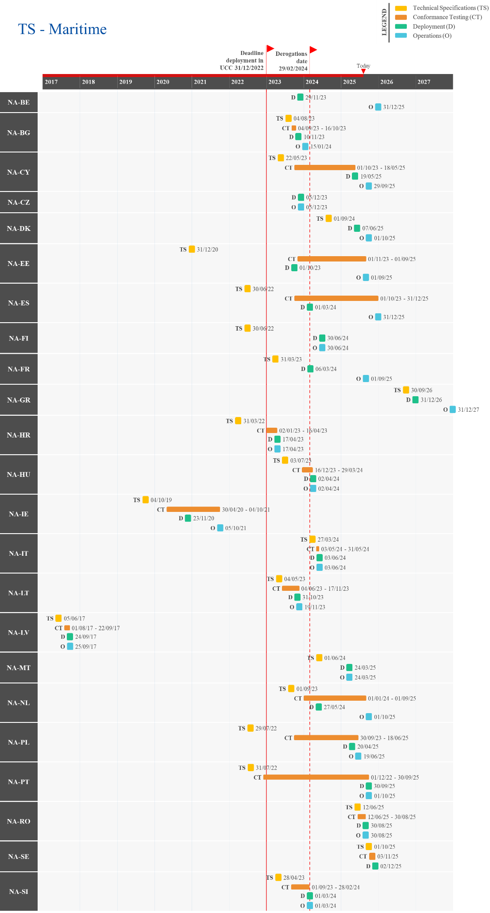
Figure 22: Actual/Planned dates per milestone – TS – Maritimes transport
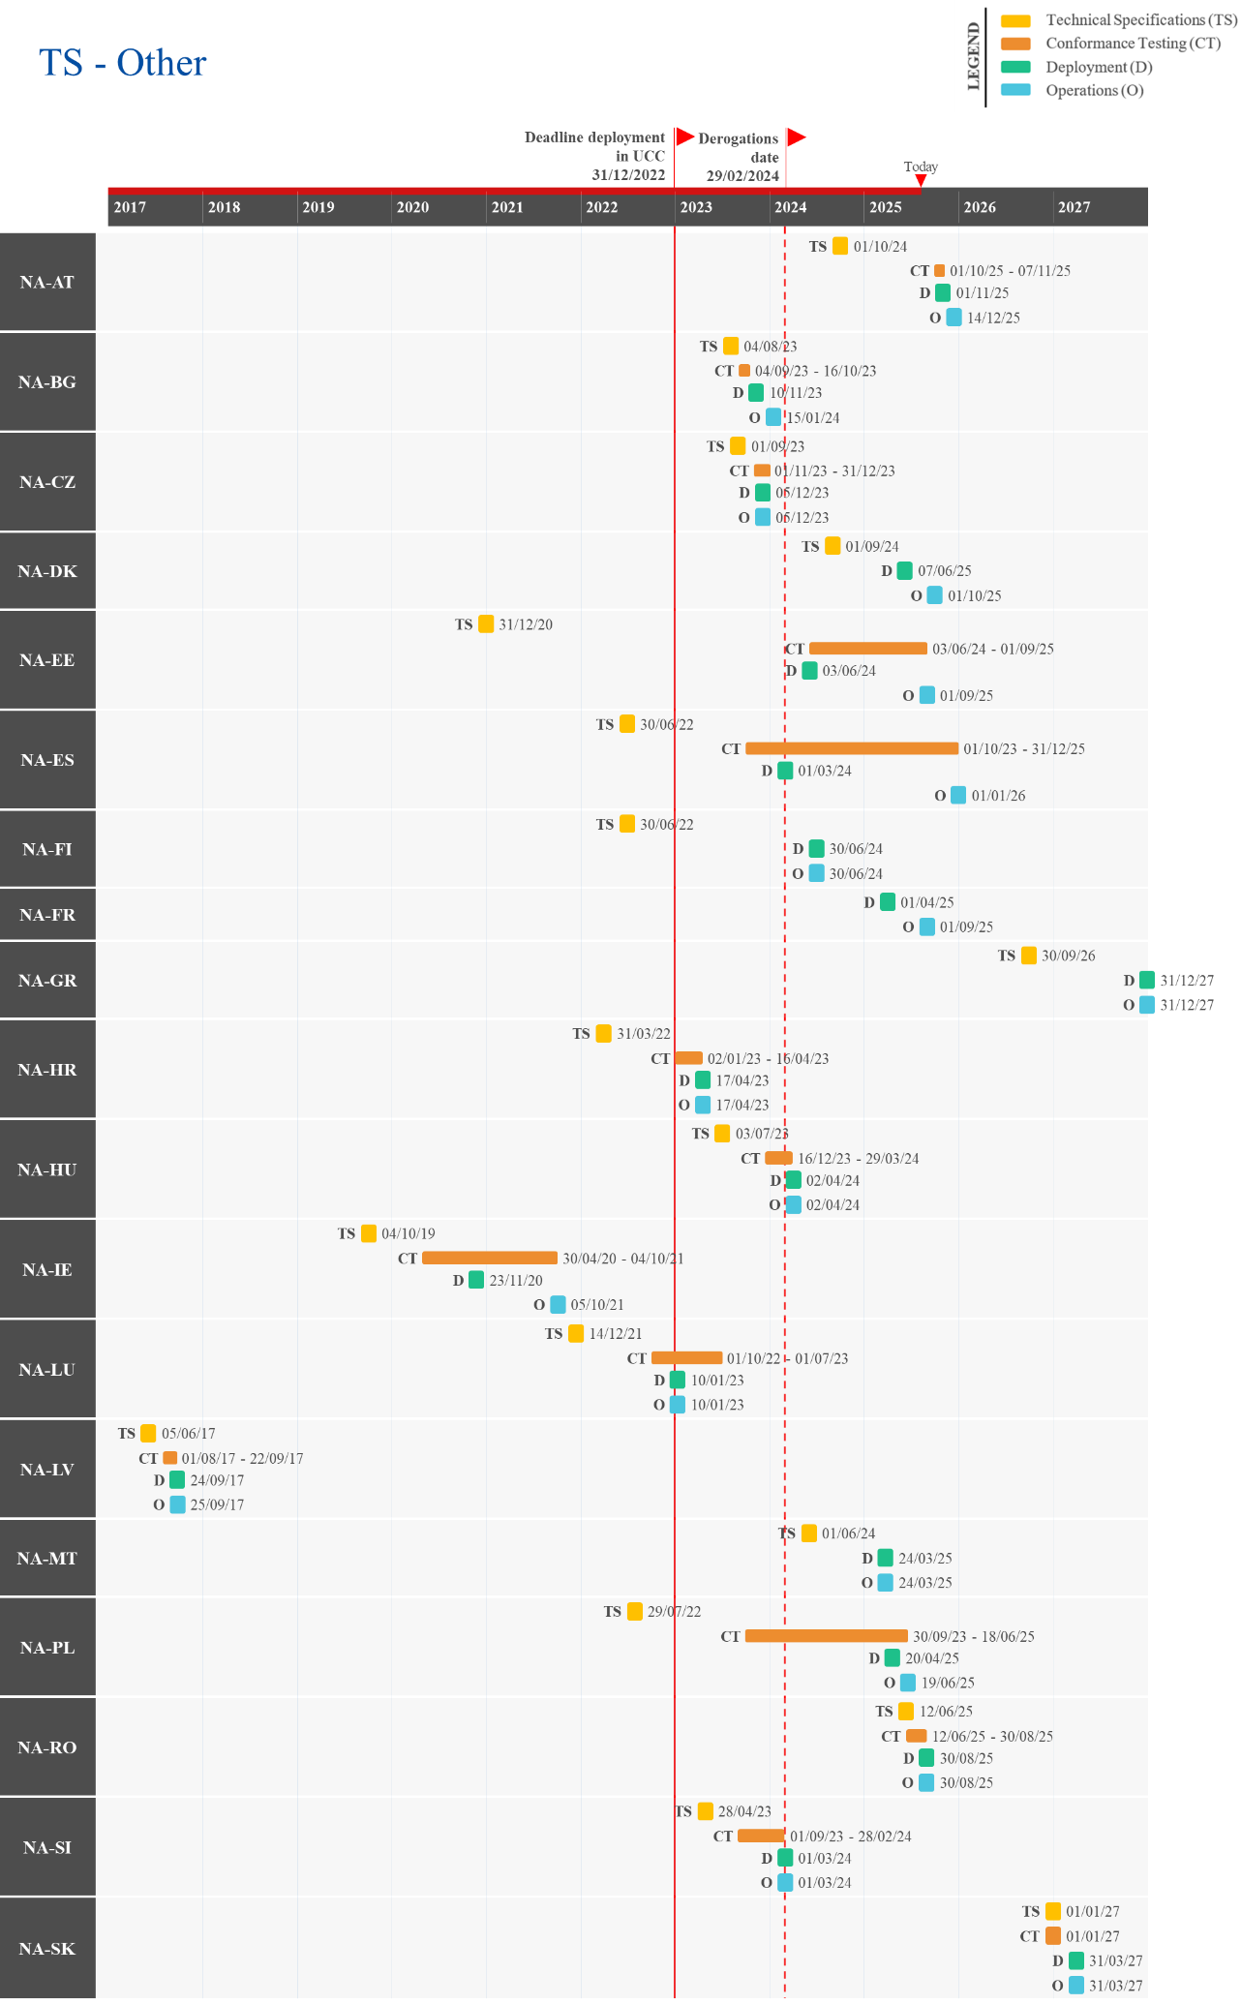
Figure 23: Actual/Planned dates per milestone – TS – Other modes of transport

UCC National Import System (NIS) Upgrade
The project will implement all processes and data requirements deriving from the UCC, which relate to the import of goods into the Union. The existing National Import System (NIS) has to be upgraded in line with these new UCC requirements. The development activities related to this project are a national matter, with processes and data requirements for the external domain to be defined and agreed at the EU level.
The upgrade mainly relates to:
  - Changes to support the different possibilities for lodging a customs declaration (e.g., standard, simplified declaration, including pre-lodged one, made through entry in the declarant's records, supplementary declaration) and its processing in the customs systems;
  - Changes for Centralised Clearance at national level;
  - Changes to the exchange of information;
  - Adjustments of the respective messages with the datasets in Annex B to the UCC Delegated Act (UCC DA) and UCC Implementing Act (UCC IA);
  - Impact of changes in other electronic systems at national level.

Summary of Responses
Summary from the Member States:
For the NIS upgrade, Member States were requested to align their systems with the new data requirements in Annex B of the Commission Delegated Regulation (EU) 2015/2446, as amended by Delegated Regulation (EU) 2021/234.
Most Member States have deployed the NIS upgrade; however, the remaining ones assessed the project as medium-to-high risk due to delays extending beyond the UCC WP deadline.
The most commonly cited causes of delays include financial resource constraints, the prioritisation of other systems, such as export and transit over NIS, and the time needed to accommodate the transition for EOs. Further delays were attributed to the strong interdependencies between national systems and evolving technical specifications during the development phase.
To mitigate these challenges, Member States have reported adopting various measures. These include Agile development approaches to shorten implementation timelines, parallel development and testing, and increased allocation of project resources. Other actions involve planning the phase-out of outdated applications to support the shift to new systems and ensuring timely access to technical specifications for EOs to minimise disruption. In several cases, designating the NIS upgrade as a high-priority project has also helped concentrate resources and maintain momentum despite delays in related areas.
At the moment of writing, the Member States that have already deployed the NIS upgrade are BE, BG, CY, DE, DK, EE, ES, FI, FR, GR, HR, HU, IE, IT, LT, LU, LV, MT, NL, PL, SE, SI, and SK, with IE, PL, and SK reporting having deployed NIS but need to implement a further update. In addition, AT, CZ, PT, and RO have reported a delay beyond the UCC deadline, with all but CZ aiming to deploy the NIS upgrade before the end of 2025.
Important remark:
Several Member States submitted a written notification to DG TAXUD, asking for a derogation under Article 6(4) of the UCC, considering the delay of NIS beyond the deadline of 31 December 2022. The derogation requests from the Member States were assessed by the Commission services in terms of the justifications provided for the specific situations of the Member States requesting it and in view of a set of common assessment criteria.
In this light the Commission adopted an Implementing Decision (EU) 2023/237 on 1 February 2023, granting a derogation to AT, BE, CY, CZ, DK, ES, FR, GR, HU, LT, LU, MT, NL, PT, RO, and SE for the NIS system upgrade to use means other than electronic data-processing techniques for the exchange and storage of information. The derogation applied from 1 January 2023 until the deployment of NIS, but not later than 31 December 2023. Additionally, where Article 2(4a) of Commission Delegated Regulation (EU) 2015/2446 applies, Member States had until 01/07/2024 to deploy the system upgrade.
Detailed Responses:
Table 16 provides the individual updates from the Member States on their responses to the survey and the national project plans provided in June 2025:
MS | Additional Comments
AT | Same response as for TS.
BE | BE reported that the NIS upgrade was deployed on 28/08/2024.
BG | BG shared that the NIS upgrade was deployed on 10/11/2023 and confirmed the system is aligned to the new Annex B.
CY | Same response as for AN.
CZ | CZ shared that the NIS project is delayed beyond the legal deadline but aims to deploy the upgrade on 18/05/2026. CZ attributed a high level of risk to the timely delivery of the project, due to financial resource constraints. No mitigation measures have been implemented, as timely deployment depends on securing additional funding.
DE | DE informed that the NIS upgrade was deployed on 06/03/2021. Additionally, DE indicated that the upgrade was implemented as part of major release of the national IT-System ATLAS (Release 9.1), which ensures all data requirements from Annex B are covered.
DK | DK reported that the NIS upgrade was deployed on 07/06/2025. Delays occurred as priority was given to the export and transit systems. DK also delayed the go-live to ensure quality and usability for its EOs. To decrease delays, DK implemented parallel development and testing, increased project resources, and is actively working with its vendor to ensure timely delivery of other MASP-C initiatives scheduled for 2025.
EE | EE informed that the NIS upgrade was deployed on 01/07/2021.
ES | ES shared that the NIS upgrade was deployed on 05/09/2023. Additionally, ES noted that the system currently is in the migration window for EOs and plans to be fully operational on 14/10/2025.
FI | FI informed that the NIS upgrade was deployed in Q4 2019.
FR | FR reported that the NIS upgrade was deployed on 26/11/2024.
GR | GR informed that the NIS upgrade was deployed on 06/08/2024.
HR | HR shared that the NIS upgrade was deployed on 01/01/2023.
HU | HU informed that the NIS upgrade was deployed on 12/10/2023.
IE | IE reported that the NIS upgrade was deployed on 23/11/2020 but noted that the system upgrade, from the original Annex B (EUCDM 5) to the revised Annex B (EUCDM 6), will be deployed concurrently with the full CCI system (CCI-P1 and CCI-P2) on 31/12/2025.
IT | IT shared that the NIS upgrade was deployed on 01/07/2021.
LT | LT reported that the NIS upgrade was deployed on 31/12/2023.
LU | LU informed that the NIS upgrade was deployed on 02/05/2023.
LV | LV shared that the NIS upgrade was deployed on 03/06/2018.
MT | MT reported that the NIS upgrade was deployed on 24/03/2025.
NL | NL informed that the NIS upgrade was deployed on 01/04/2022 but noted a delay, since the EOs have required more time to transition to the new system (Entry In the Declarant’s Records [EIDR]). NL will depreciate and remove the old application, but anticipates minimal impact on EOs as they have all the specifications needed to transfer to the new system by Q2 2025.
PL | PL reported that the NIS upgrade was deployed on 20/04/2025, with full functionalities operational on 19/06/2025. Delays were attributed to staff shortages and the limited readiness of EOs. During the transition, the legacy NIS was used with a temporary data model incorporating import functionality. The delay also provided EOs with additional time to adapt to the upgrade.
PT | PT reported that the NIS upgrade is delayed beyond the UCC WP deadline, with deployment expected on 30/09/2025. PT attributed a high-risk level to the timely delivery of the project, with delays stemming from the strong interdependencies among national systems, which complicated the development of the NIS. PT noted that the project was particularly complex, as it involved creating an entirely new import system requiring integration with various national and EU systems. To address these challenges, PT adopted Agile development to shorten the implementation timeframe and enhanced its planning processes.
RO | RO informed that deployment of the NIS upgrade is expected on 30/08/2025.
SE | SE shared that the NIS upgrade was deployed on 15/03/2022.
SI | SI reported that the NIS upgrade was deployed on 01/01/2022.
SK | SK reported that the deployment of the NIS project is delayed beyond the legal deadline, as SK plans to be fully aligned with Annex B by 30/09/2025. However, a NIS version aligned with Annex D is currently operational and was deployed in 2016. SK shared that the delay occurred due to issues with procurement, lack of human resources and the scale of the project. SK has assigned the highest priority to the NIS project, which will be done in concert with CCI-P1 & CCI-P2, but has noted that other projects are subsequently having delays as most of the human resources have been assigned to NIS. Additionally, SK informed that it switched from CCI-P1 to CCI-P2 technical specifications during 2024, which caused further delays on the NIS project.
Table 16: Detailed responses from Member States – NIS Upgrade
Figure 24 provides the progress reported by the Member States through their national project plans, along with the status of the project.
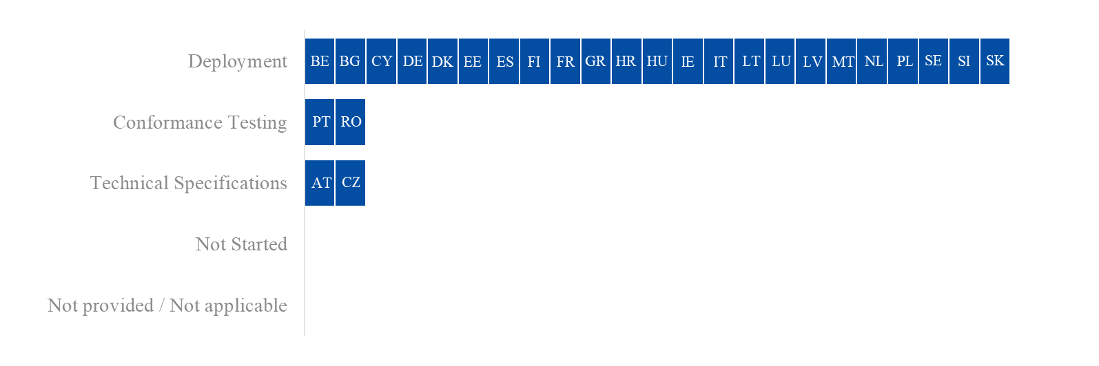
Figure 24: Project progress and status per milestone – NIS Upgrade

Overview of Project Progress
Figure 25 highlights any divergences in the Member States’ National Planning compared to the dates set in the UCC and/or the granted derogation deadline as well as the specific dates of each milestone. As this project has a deployment window, the deployment and operations milestones are shown. Any difference between these two dates indicates that a migration period is planned.
Regarding the implementation of the National Import System (NIS) upgrade, the following Member States have a planned/actual deployment date that is later than the deadline in the UCC and/or the granted derogation deadline: AT, BE, BG, CY, CZ, DK, FR, GR, MT, PT, and RO. In addition, IE, PL, and SK reported having deployed NIS but need to implement a further update.
The Commission adopted on 1 February 2023 an Implementing Decision (EU) 2023/237, granting a derogation to AT, BE, CY, CZ, DK, ES, FR, GR, HU, LT, LU, MT, NL, PT, RO, and SE from 01/01/2023 until the deployment of the NIS system, but not later than 31/12/2023. Additionally, where Article 2(4a) of Commission Delegated Regulation (EU) 2015/2446 applies, Member States had until 01/07/2024 to deploy the system.

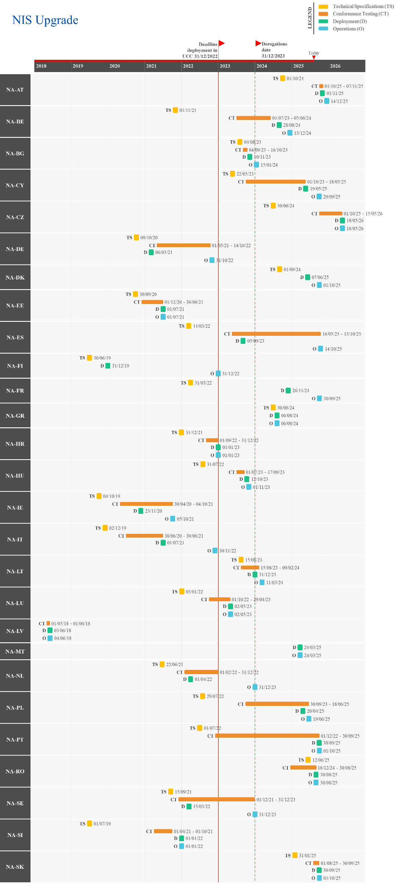
Figure 25: Actual/Planned dates per milestone – NIS Upgrade

UCC Special Procedures – Component 1 (SP EXP)
This project aims to accelerate, facilitate, and harmonise Special Procedures (SP) across the Union, by means of providing common Business Process Models (BPMs). The national systems will implement all the UCC changes required for all SP (customs warehousing, end-use, temporary admission, and inward/outward processing). It is noteworthy that, in many Member States, the implementation of this project occurs within the context of the upgrades to AES.
In terms of planning, this project will be implemented in two stages/phases.
Component 1 is the national SP EXP with the view to providing the required national electronic solutions for the export-related special procedure activities. The implementation of SP EXP will occur through the AES upgrade project. Therefore, the information provided for under the AES project also applies in this context.
For Component 2 (SP IMP), please refer to Section 3.4.

Summary of Responses
Summary from the Member States:
Most Member States have successfully deployed the SP EXP system. A few reported that its close link with AES affected the timing of deployment or operations, with interdependencies across national systems causing cascading delays in AES development. However, the implementation of Agile methodologies by Member States was noted to have reduced implementation delays.
From the information shared, the following Member States reported the system as deployed: AT, BE, BG, CY, CZ, DE, DK, EE, ES, FI, HR, HU, IE, IT, LT, LU, LV, NL, PL, RO, SE, SI and SK. FR, GR, MT and PT have indicated that the project is delayed beyond the UCC WP deadline, but aim to deploy the system before the end of 2025.
Detailed Responses:
Table 17 provides the individual updates from the Member States on their responses to the survey and the national project plans provided in June 2025:
MS | Additional Comments
AT | AT informed that the SP EXP system was deployed on 26/01/2025.
BE | BE reported that the SP EXP system was deployed on 19/06/2024.
BG | BG shared that the SP EXP system was deployed on 28/08/2023.
CY | CY reported that the SP EXP system has been deployed since 18/12/2023.
CZ | CZ shared that the SP EXP system was deployed on 01/10/2023.
DE | DE informed that the SP EXP system has been deployed since 06/03/2021 and was implemented in line with AES.
DK | DK reported that the SP EXP system has been deployed since 29/07/2023.
EE | EE informed that the SP EXP system was deployed on 30/09/2023.
ES | ES shared that the SP EXP system has been deployed since 18/10/2022.
FI | FI reported that the SP EXP system was deployed on 05/11/2024.
FR | FR informed that deployment of the SP EXP system is expected on 15/10/2025.
GR | GR shared that deployment of the SP EXP system is expected on 01/12/2025 and will be developed within the AES framework.
HR | HR reported that the SP EXP system was deployed on 01/01/2023.
HU | HU shared that the SP EXP system was deployed on 06/05/2025. However, HU reported a delay, given that all related components and functionalities are part of the HU-AES system, which is still under development and expected to be operational by the end of Q3 2025.
IE | IE informed that the SP EXP system was deployed on 21/03/2023.
IT | IT reported that the SP EXP system has been deployed since 08/06/2023.
LT | LT shared that the SP EXP system was deployed on 03/12/2023.
LU | LU reported that the SP EXP system has been deployed since 08/07/2024.
LV | LV shared that the SP EXP system has been deployed since 10/10/2023, alongside AES.
MT | MT informed that deployment of the SP EXP system is expected on 21/07/2025.
NL | NL reported that the SP EXP system has been deployed since 01/04/2022.
PL | PL reported that the SP EXP system was deployed on 01/07/2021. Following analytical work on the UCC SP conducted in 2024, additional functionalities were identified for integration into the Special Procedures Settlement (RPS) system. This implementation is ongoing between 2024 and 2025.
PT | PT reported that the SP EXP project is delayed beyond the legal deadline, with deployment planned for 01/11/2025. PT attributed the delays to the strong interdependencies among national systems, which complicated the development of AES. PT noted that the project was particularly complex, as it involved creating an entirely new export system requiring integration with various national and EU systems. To address these challenges, PT adopted Agile development to shorten the implementation timeframe, enhance its planning processes and adjust the scheduling of training activities.
RO | RO informed that the SP EXP system was deployed on 16/03/2024.
SE | SE shared that the SP EXP system has been deployed since 01/10/2024.
SI | SI reported that the SP EXP system was deployed on 24/05/2023.
SK | SK informed that the SP EXP system was deployed on 01/11/2024 and was developed as part of the AES system.
Table 17: Detailed responses from Member States – SP EXP
Figure 26 provides the progress reported by the Member States through their national project plans, along with the status of the project.
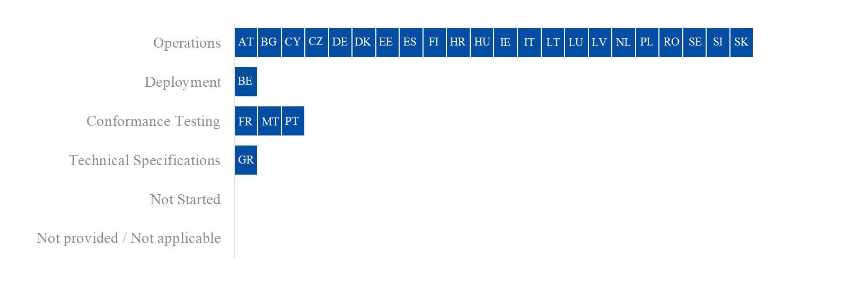
Figure 26: Project progress and status per milestone – SP EXP

Overview of Project Progress
Figure 27 highlights any known divergences in the Member States’ National Planning of SP EXP compared to the dates set in the UCC WP, along with the specific dates of each milestone. As this project has a deployment window, the deployment and operations milestones are shown. Any difference between these two dates indicates that a migration period is planned.
Regarding the implementation of UCC Special Procedures – Component 1 (SP EXP), the following Member States have a planned/actual operations date that is later than the deadline in the UCC WP: AT, FR, GR, HU, MT and PT. In addition, BE did not provide information on the operations date through its National Planning.
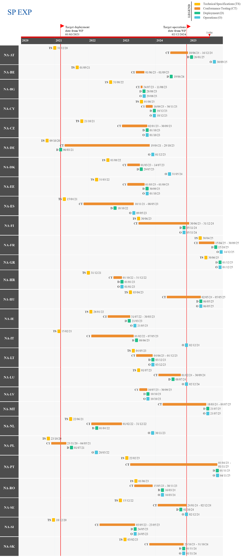
Figure 27: Actual/Planned dates per milestone – SP EXP

UCC Special Procedures – Component 2 (SP IMP)
This national project aims to accelerate, facilitate, and harmonise Special Procedures (SP) across the Union, by means of providing common BPMs. The national systems will implement all the UCC changes required for all the SP (customs warehousing, end-use, temporary admission, and inward/outward processing). It is noteworthy that, in many Member States, the implementation of this project occurs within the context of the upgrades to NIS.
In terms of planning, this project will be implemented in two stages/phases.
For Component 1 (SP EXP), please refer to Section 3.3.
Component 2 is the national SP IMP with the view to provide the required national electronic solutions for the import-related SP activities. The implementation of SP IMP will occur through the NIS upgrade project. Therefore, the information provided for under this project also applies in this context.

Summary of Responses
Summary from the Member States:
Most Member States have successfully deployed the SP IMP system. However, some assessed the system as medium-to-high risk due to deployment delays extending beyond the UCC WP deadline. Reported causes include financial and procurement issues, complex interdependencies between core and supporting systems, and the parallel replacement of related systems. Additional delays stemmed from coordination challenges with contractors, limited human resources, EO readiness, integration with the NIS system, unresolved public tenders, and ongoing negotiations with software providers.
To address these delays, Member States indicated the implementation of measures such as Agile development, parallel development and testing, and joint deployment with NIS. Further actions included enhanced project management, resource reallocation, and increased support for EOs to maintain deployment timelines.
At the time of writing, the following Member States indicated the system as deployed: BE, BG, CY, DE, DK, EE, ES, FI, FR, GR, HR, HU, IE, IT, LT, LU, LV, MT, NL, PL, SE, SI and SK. Meanwhile, AT, CZ, PT and RO, reported that the development of the system is delayed beyond the UCC WP deadline, with only CZ planning to deploy after 2025.
Important remark:
Several Member States submitted a written notification to DG TAXUD, asking for a derogation under Article 6(4) of the UCC, considering the delay of SP IMP beyond the deadline of 31 December 2022. The derogation requests from the Member States were assessed by the Commission services in terms of the justifications provided for the specific situations of the Member States requesting it and in view of a set of common assessment criteria.
In this light the Commission adopted an Implementing Decision (EU) 2023/237, granting a derogation to AT, BG, CY, CZ, DK, ES, FR, GR, HU, LT, LU, MT, NL, PT, RO, and SE for the SP IMP system to use means other than electronic data-processing techniques for the exchange and storage of information. The derogation applied from 1 January 2023 until the deployment of the SP IMP system, but not later than 31 December 2023. Additionally, where Article 2(4a) of Commission Delegated Regulation (EU) 2015/2446 applies, Member States had until 01/07/2024 to deploy the system.

Detailed Responses:
Table 18 provides the individual updates from the Member States on their responses to the survey and the national project plans provided in June 2025:
MS | Additional Comments
AT | AT reported that the SP IMP project is delayed beyond the UCC WP deadline but aims to deploy the system on 01/11/2025. AT attributed a medium risk to the timely delivery of the project, due to delays with the internal developments and the finalisation of the public tender (pending the conclusion of negotiations with the software provider and the Commission). Additionally, AT plans to deploy SP IMP alongside the upgrade of NIS, instead of with CCI-P2 in order to reduce delays and deploy before the end of 2025.
BE | BE reported that the SP IMP system was deployed on 28/08/2024.
BG | BG reported that the SP IMP system has been deployed as of 10/11/2023.
CY | Same response as for AN.
CZ | CZ reported that the SP IMP project is delayed beyond the legal deadline but plans for the system to be deployed on 18/05/2026. CZ attributed a high-risk level to the timely delivery of the project, citing financial resourcing issues as the main cause of delay.
DE | DE informed that the SP IMP system was deployed on 06/03/2021 Additionally, it indicated that upgrade was implemented as part of major release of the national IT-System ATLAS (Release 9.1).
DK | Same response as for TS.
EE | EE shared that the SP IMP system was deployed on 01/07/2021.
ES | ES shared that the SP IMP system was deployed on 05/09/2023. Additionally, ES noted that it currently is in the migration window for EOs and plans to be fully operational on 14/10/2025.
FI | FI reported that the SP IMP system was deployed in Q4 2022.
FR | FR informed that the SP IMP system has been deployed since 26/11/2024.
GR | GR reported that the SP IMP system was deployed on 06/08/2024.
HR | HR shared that SP IMP was deployed on 01/01/2023, as part of the new import system.
HU | HU reported that the SP IMP system was deployed on 12/10/2023. Additionally, HU shared that the developments were implemented within the NIS framework.
IE | IE informed that the SP IMP system was deployed on 23/11/2020 and will be updated to the revised Annex B in Q1 2026.
IT | IT reported that the SP IMP system has been deployed since 01/07/2021.
LT | LT reported that the SM IMP system was deployed on 31/12/2023.
LU | LU shared that the SP IMP system was deployed on 02/05/2023.
LV | LV reported that the SP IMP system was deployed on 03/06/2018.
MT | MT informed that the SP IMP system was deployed on 24/03/2025.
NL | NL reported that the SP IMP system was deployed on 01/04/2022.
PL | Same response as SP EXP.
PT | Same response as NIS.
RO | RO reported that deployment of the SP IMP system is expected on 30/08/2025.
SE | SE shared that the SP IMP system has been deployed since 23/02/2023. Additionally, SE noted that an update from the ‘current’ Annex B to the ‘new’ Annex B will be performed for the customs warehousing procedure.
SI | SI reported that the SP IMP system was deployed on 01/01/2022.
SK | SK reported that the SP IMP system was deployed on 11/06/2016. Additionally, SK shared that the system is being remade within the NIS upgrade to be aligned with Annex B.
Table 18: Detailed responses from Member States – SP IMP
Figure 28 provides the progress reported by the Member States through their national project plans, along with the status of the project.
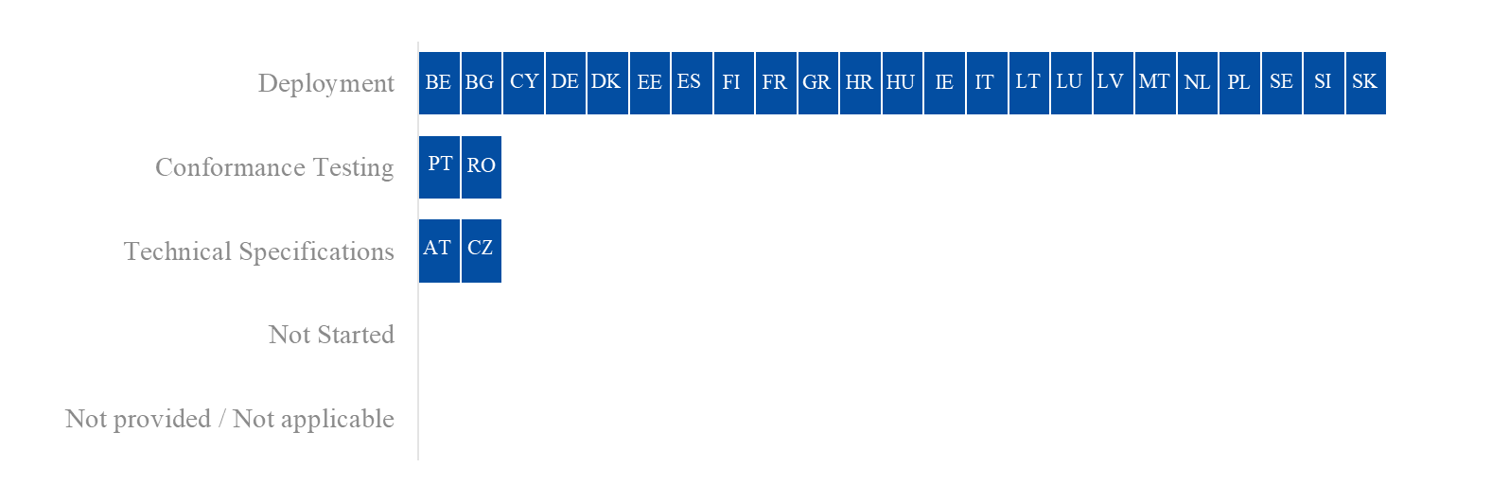
Figure 28: Project progress and status per milestone – SP IMP

Overview of Project Progress
Figure 29 highlights any known divergences in the Member States’ National Planning of SP IMP compared to the dates set in the UCC and/or the granted derogation deadline, along with the specific dates of each milestone. As this project has a deployment window, the deployment and operations milestones are shown. Any difference between these two dates indicates that a migration period is planned.
Regarding the implementation of UCC Special Procedures – Component 2 (SP IMP), the following Member States have a planned/actual deployment date that is later than the deadline in the UCC and/or the granted derogation deadline: AT, BE, CY, CZ, DK, FR, GR, MT, PT, and RO.
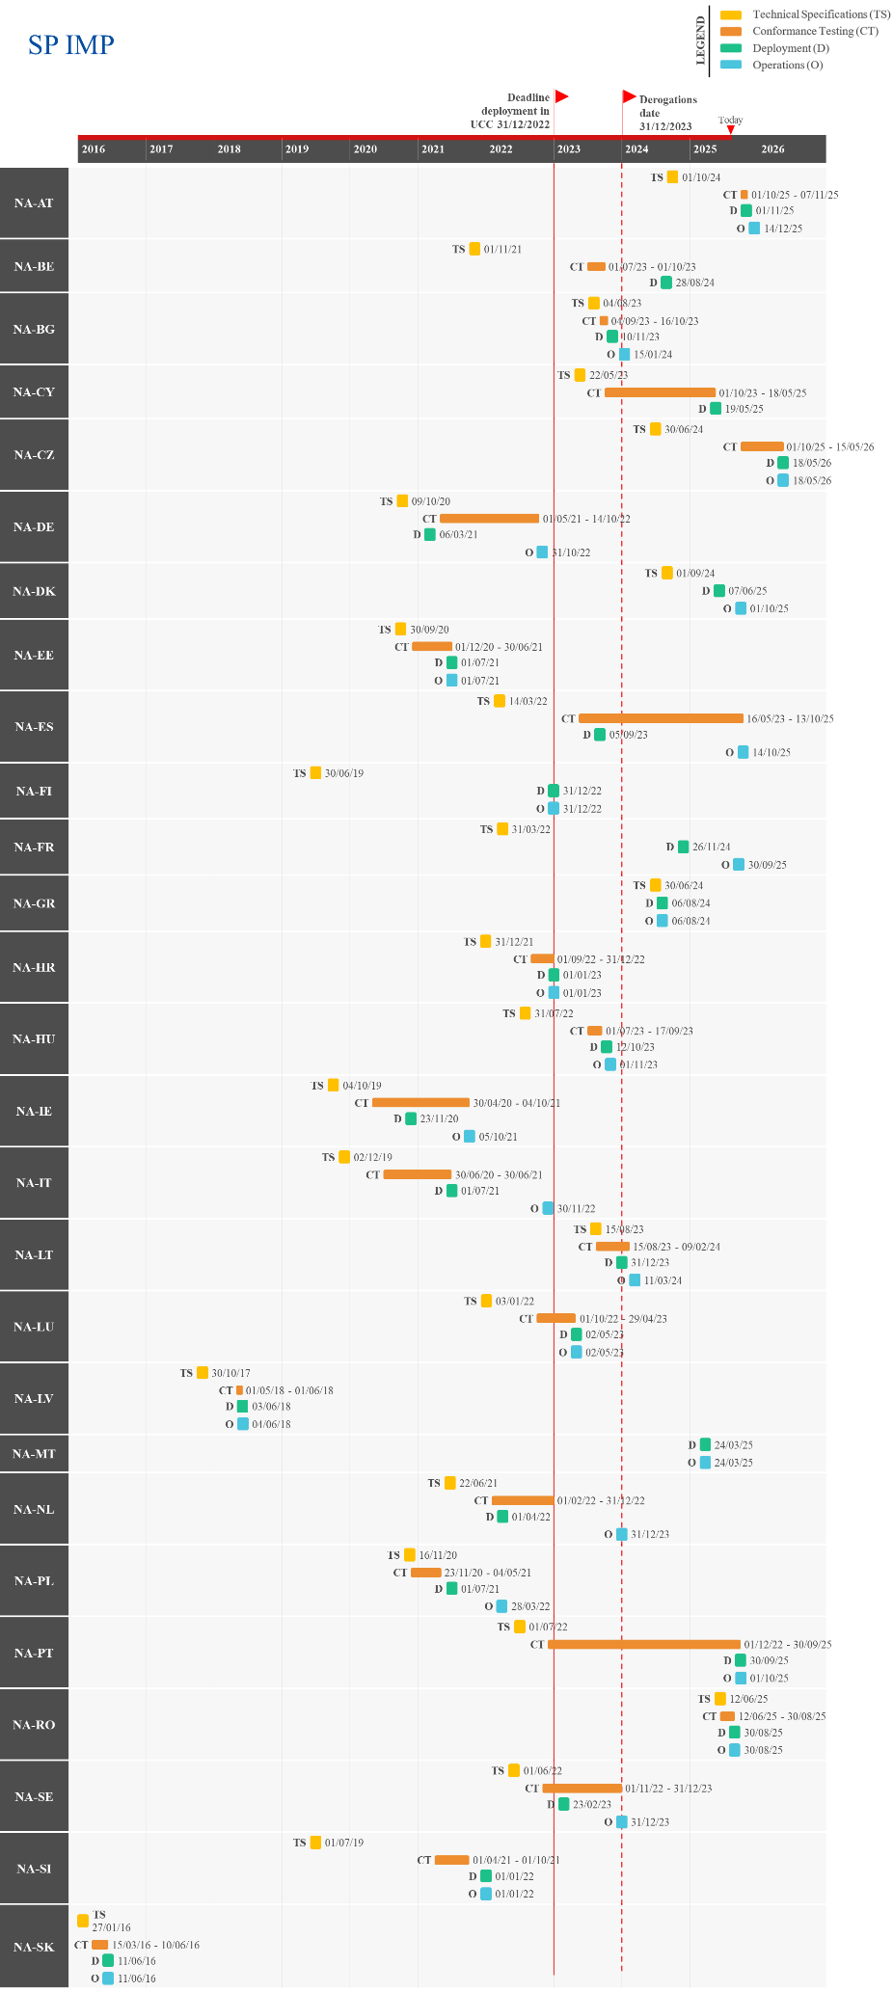
Figure 29: Actual/Planned dates per milestone – SP IMP

UCC Guarantee Management (GUM) – Component 2
The UCC Guarantee Management (GUM) project assures the effective and efficient management of the different types of guarantees. A guarantee is the financial cover for customs duties and other charges.
The UCC GUM system is comprised of two components.
For Component 1 (GUM-C1), please refer to Section 2.10.
Component 2 (GUM-C2) refers to the national Guarantee Management systems, meaning the guarantee management system that each Member States deploys individually, but in line with the GUM requirements. These national guarantee management systems are e.g. used for the management of the guarantees and the monitoring of the reference amount. The deadline for the deployment of GUM 2 systems was 2 June 2025.

Summary of Responses
Summary from the Member States:
GUM-C2 refers to the development of the national GUM systems of the Member States, which can largely be conducted in parallel with GUM-C1.
Some Member States have already implemented GUM-C2, though several Member States have still reported a risk for on-time delivery. Key risk factors include the parallel deployment and, in some cases, prioritisation of other major systems such as NCTS, AES, CCI, and NIS; limited personnel, and the simultaneous replacement or upgrade of support systems like the Customer Reference Services (CRS). Additional delays were linked to internal development timelines, procurement, and the finalisation of public tenders.
To mitigate these risks, Member States applied corrective actions in project management and budgeting, improved interdepartmental coordination, and gave GUM-C2 higher prioritisation than in previous years. In some cases, it was deployed in parallel with NIS and CCI-P2 to minimise further delays.
At the time of writing, the following Member States have joined operations: BE, BG, CZ, EE, ES, FI, IE, LT, LU, LV, NL, PL, SE, SI and SK. Additionally, AT, CY, DE, DK, FR, GR, HR, HU, IT, MT, PT and RO have reported delays beyond the UCC WP deadline, with FR, GR and HR expected to go operational after 2025.
Detailed Responses:
Table 19 provides the individual updates from the Member States on their responses to the survey and the national project plans provided in June 2025:
MS | Additional Comments
AT | AT reported that the GUM-C2 project is delayed beyond the UCC WP deadline but aims to have the system operational on 14/12/2025. AT attributed a medium risk of delay to the timely delivery of the project, due to delays with the internal developments and the finalisation of the public tender (pending the conclusion of negotiations with the software provider and the Commission). AT noted that GUM-C2 will be implemented alongside the NIS update, in order to reduce delays and deploy before the end of 2025.
BE | BE shared that the GUM-C2 system joined operations on 15/06/2025.
BG | BG reported that the GUM-C2 system became operational on 23/04/2025.
CY | CY reported that the GUM-C2 is delayed beyond the UCC WP deadline, with the start of operations expected on 31/12/2025. CY attributed a high level of risk to the timely delivery of the project, noting that deployment was delayed due procurement issues, interdependencies between systems, parallel upgrades of supporting systems, limited human resources, and delays in other dependent systems. To address these challenges, CY implemented corrective measures in project management, resource allocation, and support for EOs.
CZ | CZ shared that the GUM-C2 system was deployed and became operational on 01/01/2025.
DE | DE informed that the start of operations of the GUM-C2 system is expected on 15/11/2025.
DK | DK reported that the GUM-C2 project is delayed beyond the legal deadline, but aims for the system to become operational on 27/09/2025. DK attributed a high risk to the timely delivery of the project, noting GUM-C2 has been delayed so as to prioritise the deployment of its national import system.
EE | EE informed that the GUM-C2 system was deployed on 09/06/2024 and became operational on 09/06/2025.
ES | ES indicated that the GUM-C2 system was deployed on 01/09/2016 and has been in operations since 01/05/2019.
FI | FI shared that the GUM-C2 functionalities linked with NCTS were deployed in Q4 2024 while the remaining functionalities became operational on 24/05/2025.
FR | FR reported that the GUM-C2 project is delayed beyond the legal deadline, with deployment and operations planned for 30/03/2026. FR assessed a medium risk for timely implementation, citing the prioritisation of the CCI project in 2025 and reliance on third-party suppliers as key causes of delay. To mitigate further setbacks and budget overruns, a detailed 2025–2026 timeline has been developed, new contractors have been engaged, and project milestones have been adjusted to reflect evolving national priorities and stakeholder needs.
GR | GR informed that the start of operations of the GUM-C2 system is expected in Q2 2026.
HR | HR reported that the GUM-C2 project is delayed beyond the UC WPP deadline, with the start of operations expected on 31/03/2026. HR shared that the implementation was delayed due to the parallel development of other systems. In the interim, the existing system is being used to maintain continuous monitoring of guarantees.
HU | HU informed that the GUM-C2 project is delayed beyond the UC WPP deadline, with the system expected to become operational on 17/11/2025. HU attributed a medium level of risk to the timely delivery of the system, sharing the delays are due to the parallel deployment of multiple systems and constraints in available personnel. In order to mitigate the delays, HU held consultations with the IT department to prioritise the project and enhance cooperation between technical and professional teams.
IE | IE informed that the GUM-C2 system has been operational since 05/10/2021.
IT | IT shared that the GUM-C2 system is expected to become operational on 17/11/2025.
LT | LT reported that the GUM-C2 system was deployed on 16/11/2022 and has been operational since 20/03/2023.
LU | LU shared that the GUM-C2 system became operational on 02/06/2025.
LV | LV informed that the GUM-C2 system started operations on 04/06/2018.
MT | MT reported that the GUM-C2 system is expected to start operations on 12/12/2025.
NL | NL shared that the GUM-C2 system became operational on 01/06/2025.
PL | PL reported that the GUM-C2 system joined operations on 02/06/2025.
PT | PT informed that the GUM-C2 system is expected to become operational on 01/10/2025.
RO | RO shared that the GUM-C2 system is expected to start operations on 30/08/2025.
SE | SE reported that the GUM-C2 system has been operational since 17/04/2021.
SI | SI shared that the GUM-C2 system joined operations on 01/06/2025.
SK | SK reported that the GUM-C2 system became operational on 02/06/2025.
Table 19: Detailed responses from Member States – GUM-C2
Figure 30 provides the progress reported by the Member States through their national project plans, along with the status of the project.
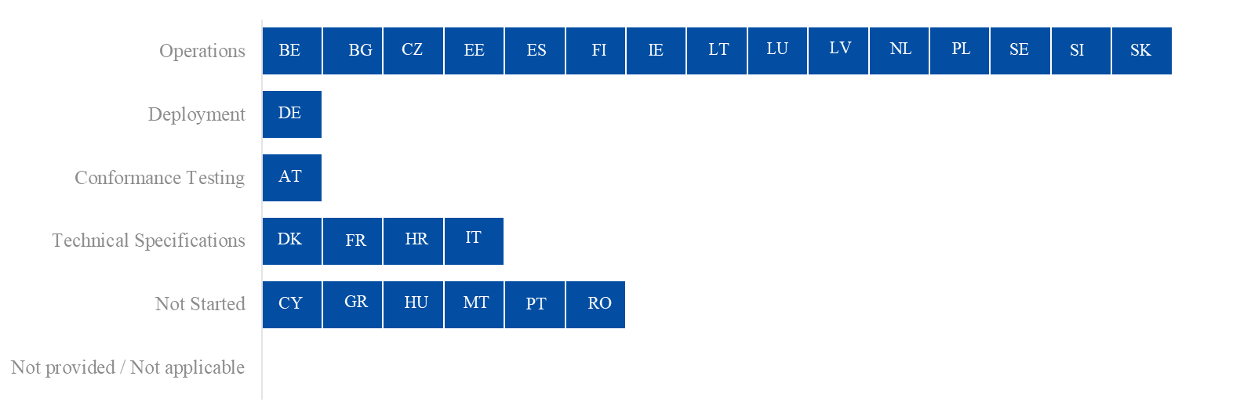
Figure 30: Project progress and status per milestone – GUM-C2

Overview of Project Progress
Figure 31 highlights any known divergences in the Member States’ National Planning compared to the dates set in the UCC WP. As this project has a deployment window, the deployment and operations milestones are shown. Any difference between these two dates indicates that a migration period is planned.
With regards to the implementation of the national UCC Guarantee Management (GUM-C2), AT, BE, CY, DE, DK, EE, FR, GR, HR, HU, IT, MT, PT and RO indicated a planned/actual operations date that is later than the deadline in the UCC WP.
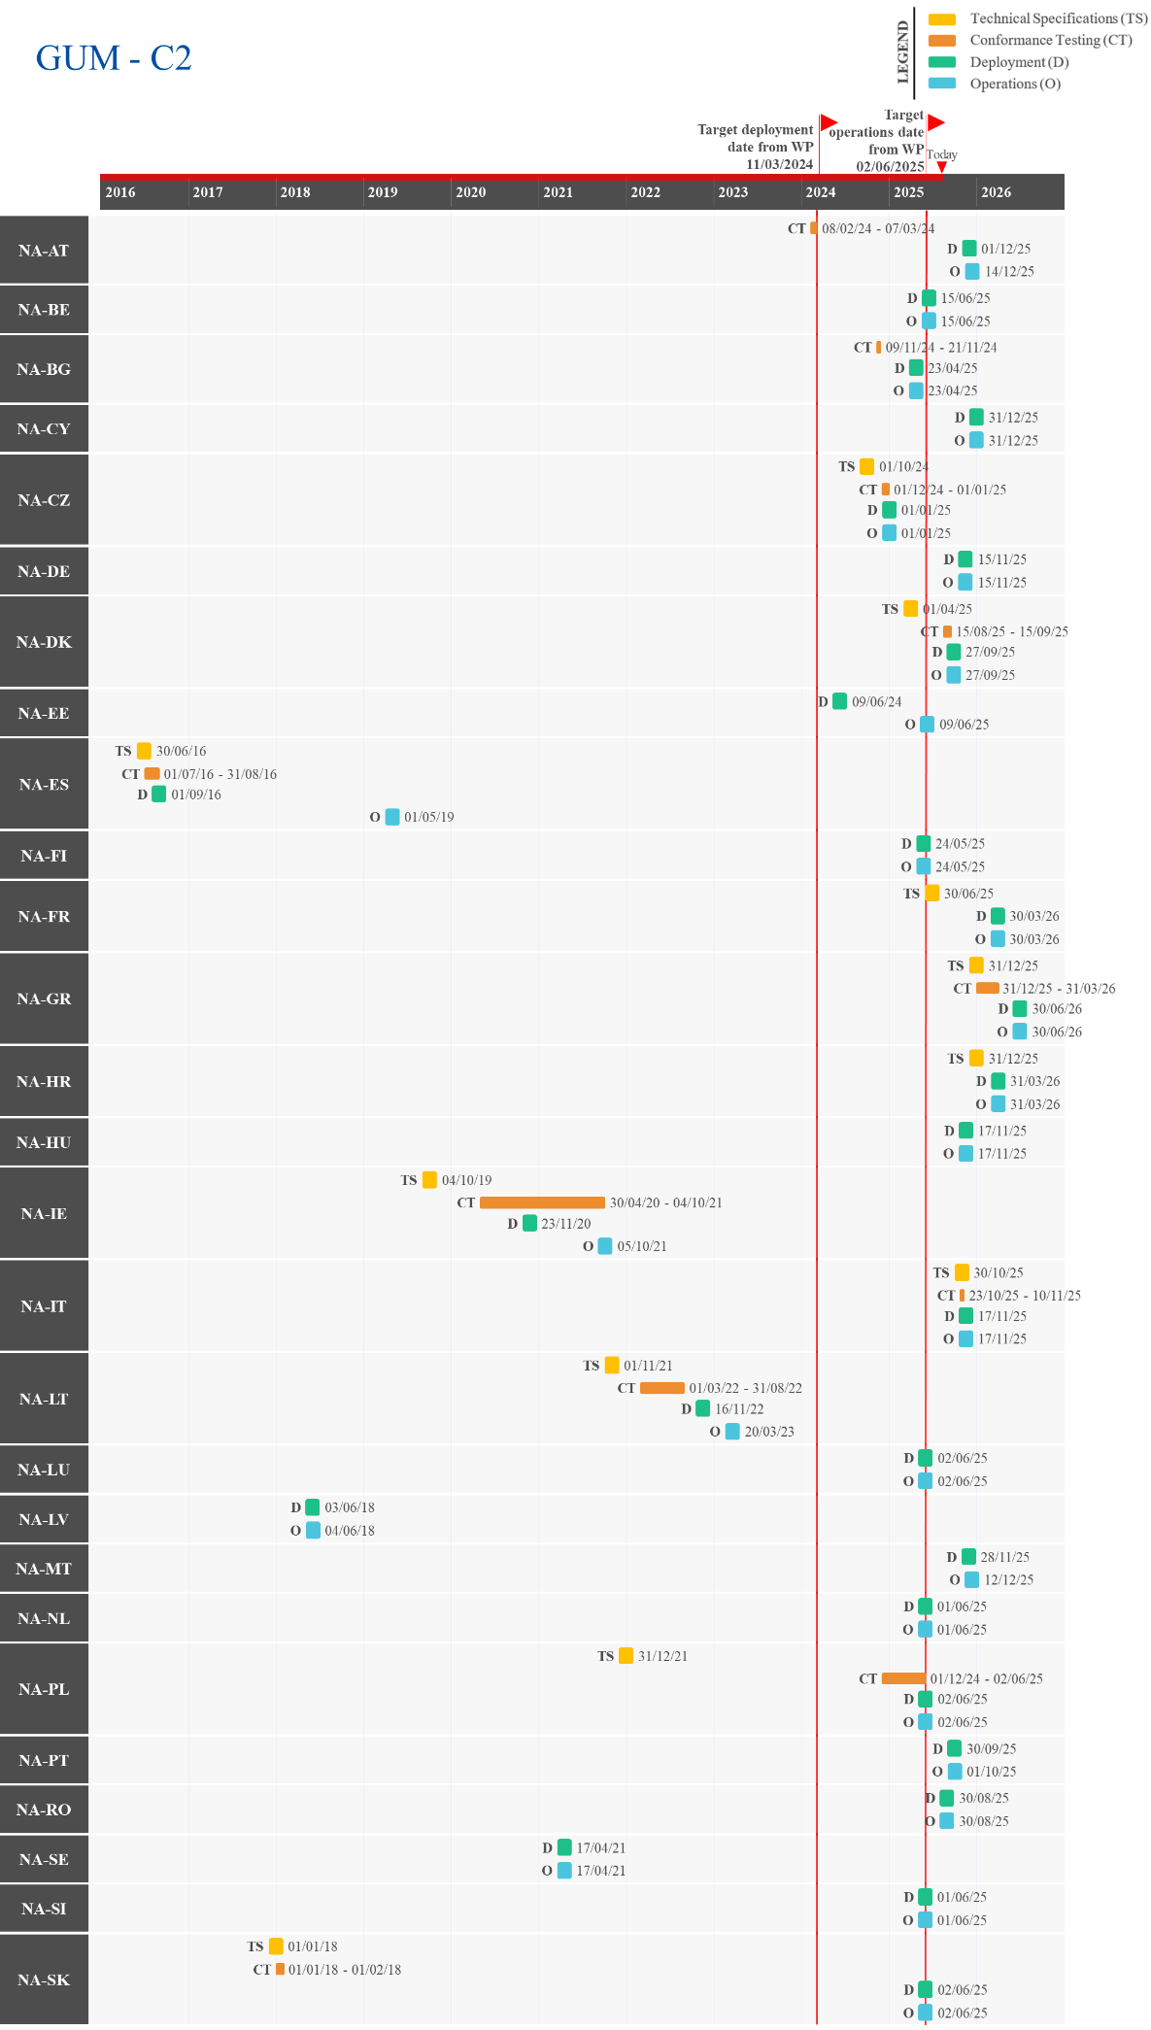
Figure 31: Actual/Planned dates per milestone – GUM-C2

UCC Centralised Clearance for Import (CCI)
The UCC Centralised Clearance for Import (CCI) project aims to allow for goods to be placed under a customs procedure using centralised clearance, enabling the EOs to centralise their business from a customs point of view. The processing of the customs declaration and the physical release of the goods will be coordinated between the involved customs offices, both of which operate as part of one customs administration, although they are situated in different Member States.
The implementation of CCI through a new trans-European system will strengthen trade facilitation. It will enable EOs to centralise their import activities and reduce interactions with customs by only using a single customs office (supervising customs office), acting as a one-stop shop in the EU. The modernised and harmonised UCC CCI customs system enables customs declaration processing and physical release of goods electronically and in a seamless, predictable and coordinated way among the customs offices located in different Member States. In addition, the new CCI system will introduce harmonisation and standardisation of processes and electronic exchange of information across the Union for centralised clearance at import. It is also expected to reduce the administrative burden for the Customs Administration with automated processes and to allow tax authorities to have better supervision and control on the collection of import Value Added Tax (VAT).
In terms of the planning approach, as a trans-European system, the project contains components developed centrally and nationally. The project will be implemented in two phases.
Phase 1 (CCI-P1) covers the combination of centralised clearance with standard customs declarations and may also cover simplified customs declarations and related supplementary declarations, which regularise one simplified customs declaration. In addition, this phase covers the placing of goods under the following customs procedures: release for free circulation, customs warehousing, inward processing and end-use. Regarding the types of goods involved, this phase will cover all types of goods except for excise goods and goods subject to Common Agricultural Policy (CAP) measures.
Phase 2 (CCI-P2) covers the functionalities that are not part of CCI-P1, namely:
- The combination of centralised clearance with customs declarations through an Entry in the Declarant's Records and related supplementary declarations, including the recapitulative declaration;
- Supplementary declarations regularising more than one simplified customs declaration;
- The placing of goods under the temporary admission procedure;
- Goods subject to CAP measures and excise goods;
- Goods in the context of trade with special fiscal territories;
- The communication of supporting/additional documents between the related customs offices.

Summary of Responses
CCI – Phase 1 (CCI-P1)
Summary from the Commission:
The introduction of the EU CCI system, the first trans-European system for import formalities, required a fresh approach by adopting the new network architecture Common Communications Network 2nd Generation (CCN2ng) and Common Reference Architecture (CoRA). This involved the redefinition of specifications and effective communication with the Member States. The Commission is diligently monitoring the progress of other key projects to ensure alignment with the new infrastructure. The coordination of multiple project teams has proven crucial for synchronising all activities.
As regards the Commission, the technical system specifications (TSS) for CCI-P1 were completed in 2020, and the conformance testing environment was assured for the Member States well in advance before the end date of the deployment window for the first phase of the system.
The Commission is adopting a new iterative approach, introduced in 2023 within the UCC WP and MASP-C revision, to address Member States' reported delays and ease the transition between CCI-P1 and CCI-P2. This approach allows for the prioritisation of CCI-P1 with standard declarations and the freedom to choose the message type CCI-P1 or CCI-P2, providing flexibility for other combinations of CCI-P1 (such as simplified and supplementary declarations in the first phase) and ensures an extended deadline for CCI-P1 by seven months until 1 July 2024. To simplify the process, additional facilitation is provided by enabling the implementation of CCI-P1 functionalities using CCI-P2 Full Scope specifications (i.e., the ones also supporting the functionalities of the CCI-P1 system), removing the need for a transition from CCI-P1 to CCI P2. Furthermore, to facilitate the Member States, DG TAXUD developed a consolidated CCI-P2 (Full) Scope TSS package that consolidates the specifications for both phases, offering a single package that covers all CCI scenarios and processes. A corresponding guide has been provided to assist Member States and traders in effectively implementing both phases using this package.
A medium risk level has been noted due to the dependency of conformance testing and deployment on the actions of the Member States. To mitigate risks efficiently, the Commission is closely monitoring and coordinating activities with a dedicated team managing the conformance testing environment. The Conformance Test Application (CTA) system is accessible in the conformance environment, facilitating CCI-P1 conformance testing activities through the CCN2ng exchange platform. DG TAXUD carries out a close monitoring on the Member States’ CCI (P1 and P2) national project planning, organisational, development, connectivity set-up, the conformance testing, deployment, and entry in operations of CCI-P1 and CCI-P2. Monitoring of Member States’ CCI activities, including integration with NIS and other national systems, takes place, while assistance is provided where needed. Regular meetings are held for the synchronisation of the planned CCI-related activities, weekly and bi-weekly technical meetings for the status progress, feedback sessions for the execution of the conformance testing. DG TAXUD will continue the close technical support to the Member States, while monitoring the progress according to the deployment plan for CCI. In this context, DG TAXUD initiated issuing quarterly reports in Q1 2024 for monitoring UCC CCI system deployment, releasing six reports in total by June 2025.
By the 1 July 2024 deadline, eight Member States (BG, EE, ES, LU, LV, LT, PL and RO) had successfully deployed the CCI-P1 system, while HR and IT deployed later in 2024, on 30 September and 8 November respectively. An additional seven Member States deployed by June 2025. The remaining Member States have reported deployment dates ranging from the end of 2025 to Q3 2026.
Overall, there is reassurance that most of them will meet the final deployment milestone of the CCI Full (P1 and P2) system by 31 December 2025, as required under Article 278(3) of the UCC. Some MSs (BE, FR, PL and PT) plan to deploy CCI-P1 by the end of 2025, with CCI-P2 scheduled for Q2 2026. FI and SE will deploy the CCI full system by the end of 2025 but will delay certain functionalities, targeting Q2 2026 and Q3 2026 respectively. Finally, there are four Member States that plan to delay the CCI full system implementation until 2026: CZ and GR expect to deploy the full system by Q2 2026, while NL and HU aim for Q3 2026.
Summary from the Member States:
Less than half of the Member States have completed the CCI-P1 project. Among those still in progress, most reported a medium to high risk of delayed delivery. The main causes of delay included procurement and funding issues, limited supplier capacity, and the need to finalise public tenders. Further challenges were linked to the complexity of integrating national and EU systems, interdependencies between core and supporting systems, technical limitations of existing national applications. Delays in deploying the NIS upgrade and the parallel rollout of other major UCC projects in 2025, such as NCTS and AES, also strained human and technical resources.
To mitigate these delays, Member States implemented phased rollouts, adopted Agile development methods, and prioritised the project nationally. Additional measures included reinforcing project management, reallocating resources, and engaging in high-level negotiations with suppliers to improve planning and oversight.
The above summary also applies to CCI-P2.
In terms of assessing the level of completeness of the system, BG, EE, ES, HR, IT, LT, LU, LV, PL, RO, and SE reported the project as completed. AT, BE, CY, CZ, DE, DK, FI, FR, GR, HU, IE, MT, NL, PT, SI and SK shared that the project is delayed beyond the UCC WP deployment deadline, with CZ, DE, GR, HU, NL and SK expected to go operational after 2025
Detailed Responses:
Table 20 provides the individual updates from the Member States on their responses to the survey and the national project plans provided in June 2025:
MS | Additional Comments
AT | AT reported that the CCI-P1 project is delayed beyond the legal deadline, however, it aims to have the system operational on 14/12/2025. AT attributed a medium risk of delay to the timely delivery of the project, due to delays with the internal developments and the finalisation of the public tender (pending the conclusion of negotiations with the software provider and the Commission). AT noted that CCI-P1 will be implemented alongside CCI-P2 in order to reduce delays and deploy before the end of 2025.
BE | BE plans to have the CCI-P1 system operational on 15/10/2025.
BG | BG shared that the CCI-P1 system began operations on 15/01/2024. Additionally, BG added that the system functionalities are aligned with NIS, which was upgraded according to the new Annex B requirements.
CY | CY aims to have the CCI-P1 system operational on 29/09/2025. CY reported the delays are due to several factors, including procurement challenges, interdependencies between core and supporting systems, parallel upgrades, contractor coordination issues, limited human resources, and the readiness of their EOs. Additional delays stem from the late deployment of other systems critical to the CCI project. To mitigate these issues, CY applied corrective measures in project management and resourcing, and reinforced support for EOs, which will help reduce the overall delay.
CZ | CZ reported that the CCI-P1 project is delayed beyond the legal deadline, with operations planned for 18/05/2026. A high level of risk was attributed to the timely delivery of the project, primarily due to financial resource constraints. CZ plans to develop and deploy CCI-P1 and CCI-P2 simultaneously.
DE | DE noted that the CCI-P1 project is delayed beyond the legal deadline, with operations planned for 28/02/2026. The delay was attributed to the need to implement the second stage of the VAT package for eCommerce and adjustments related to Brexit. To mitigate this, DE established a new expert group with additional staff and budget. Both Phase 1 and Phase 2 are planned for joint deployment.
DK | DK reported that the CCI-P1 project is delayed beyond the legal deadline, but it plans for the system to join operations on 27/09/2025. DK attributed a medium risk to the timely delivery of the project, noting that the deployment of CCI is dependent on the rollout of the national import system.
EE | EE shared that the CCI-P1 system started operations on 09/06/2024.
ES | ES reported that the CCI-P1 system joined operations on 03/10/2022. Additionally, ES informed that the system was built and integrated with the NIS.
FI | FI informed that the CCI-P1 project is delayed beyond the UCC WP deadline but aims to have the system operational on 22/11/2025. FI attributed the delays to a lack of supplier resources but shared that it held management level negotiations with the supplier and has focused on project planning and progress monitoring to mitigate the delay.
FR | FR reported that the CCI-P1 project is delayed beyond the legal deadline, with operations planned for 15/12/2025. The delay was attributed to the prioritisation of the national import system. To mitigate the delay, FR has divided the implementation into two steps. Step 1, to be completed by the end of 2025, will cover customs declaration submission upon presentation, invalidation, and amendment in Presentation Customs Office (PCI) for procedures 40 00 and 42 00. Step 2 is planned to cover the remaining functionalities and go into operations on 30/06/2026.
GR | GR plans to start operations for both CCI-P1 and CCI-P2 on 30/06/2026.
HR | HR reported that the CCI-P1 system has been operational since 30/09/2024.
HU | HU reported that the CCI-P1 project is delayed beyond the legal deadline and aims to have the system operational on 30/09/2026. A medium level of risk was attributed to the timely delivery of the project, with delays primarily linked to the parallel deployment of multiple systems, including AES, and limited human resources. Both Phase 1 and Phase 2 are planned for joint deployment.
IE | IE informed that the CCI-P1 project is delayed beyond the UCC WP deadline, with deployment and operations planned on 31/12/2025. IE attributed a medium risk to the timely delivery of the project, highlighting that technical issues with the existing national import applications are being prioritised. IE reported that the number of UCC projects running simultaneously in 2025 puts significant pressure on limited internal and external resources. IE aims to implement CCI-P1 and CCI-P2 simultaneously.
IT | IT reported that the CCI-P1 system became operational on 04/11/2024.
LT | LT shared that the CCI-P1 system has been operational since 01/07/2024.
LU | LU indicated that the CCI-P1 system joined operations on 30/06/2024. Additionally, LU shared that CCI-P1 was integrated with its NIS and that no EOs are using the system yet.
LV | LV reported that the CCI-P1 system started operations on 01/07/2024 and that it is part of its new national import system.
MT | MT aims for the CCI-P1 system to join operations on 31/12/2025.
NL | NL informed that the CCI-P1 project is delayed beyond the UCC WP deadline and aims for the system to become operations on 01/09/2026. NL attributed a high risk to the timely delivery of the project, noting that CCI is a complicated process and that the increased integration of European systems over the common domain limits solutions. NL also highlighted the challenges of integrating national processes for managing the control findings, noting that the supplementary declaration with recapitulative nature combined with the use of multiple goods shipment will require major adjustments to the national system. To mitigate the risk, NL aims to implement its national system in multiple phases, starting with operations for EIDR, and implementing standard customs declarations and simplified declarations at a later date.
PL | PL shared that the CCI-P1 system has been operational since 01/07/2024. Additionally, PL noted that CCI-P1 was implemented as a module of the NIS.
PT | PT reported that the CCI-P1 project is delayed beyond the legal deadline, with operations planned to start on 15/12/2025. A high level of risk was attributed to the timely delivery of the project, mainly due to the implementation of the NIS upgrade, which underpins the CCI system and requires integration with various national and EU systems. PT noted that strong interdependencies among national systems complicated the NIS development but stated that Agile methodologies and a revised plan were used to shorten the implementation timeframe.
RO | RO informed that the CCI-P1 system became operational on 01/07/2024.
SE | SE reported that the CCI-P1 system became operational on 02/06/2025, although EOs have yet to submit an authorisation. Delays were attributed to the prioritisation of other UCC IT systems, though SE noted that significant resources were allocated to support the implementation of all UCC-related projects.
SI | SI plans to have the CCI-P1 system operational on 10/11/2025.
SK | SK reported that the CCI-P1 project will be delayed beyond 2025, with operations now slated to begin on 01/01/2026, alongside CCI-P2. SK attributed the delay to the parallel development of NCTS-P5 and AES as well as the switch from CCI-P1 to CCI-P2 technical specifications. In addition, SK noted that this project is being prioritised.
Table 20: Detailed responses from Member States – CCI-P1
Figure 32 provides the progress reported by the Member States through their national project plans, along with the status of the project.
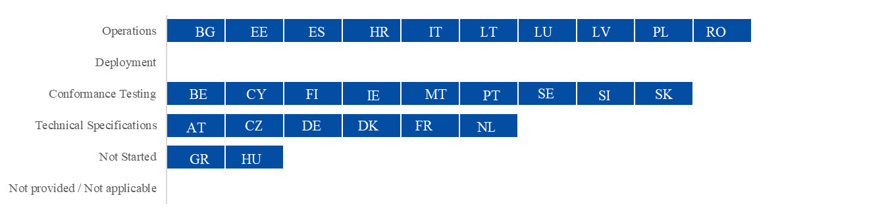
Figure 32: Project progress and status per milestone – CCI-P1

CCI – Phase 2 (CCI-P2)
Summary from the Commission:
Please see also the summary from CCI-P1.
CCI-P2 broadens the scope of the complex matters tackled in CCI-P1, leading to a heightened intricacy across multiple project areas. The technical specifications were finalized on 17 June 2022, and the CTA system was made available in the conformance environment for Member States well ahead of the deployment window deadline for the system’s second phase.
Member States have the flexibility to develop, implement, and deploy CCI-P2 and thus the CCI Full system functionalities in multiple iterations using agile approach within the final deployment window by 31 December 2025.
Summary from the Member States:
Please see also the summary from CCI-P1.
In terms of assessing the level of completeness of the system, the following Member States have completed the CCI-P2 project: BG, EE, ES, HR, LU, LV and RO. AT, BE, CY, CZ, DE, DK, FI, FR, GR, HU, IE, IT, LT, MT, NL, PL, PT, SE, SI and SK informed that the project is scheduled to become operation beyond deployment deadline, with AT, CY, DK, FI, IE, LT, MT and SI aiming to go operational before the end of 2025.
Detailed Responses:
Table 21 provides the individual updates from the Member States on their responses to the survey and the national project plans provided in June 2025:
MS | Additional Comments
AT | AT reported that the CCI-P2 project is delayed beyond the UCC WP deadline and aims for the system to become operational on 14/12/2025. AT attributed a medium risk of delay to the timely delivery of the project, due to delays with the internal developments and the finalisation of the public tender (pending the conclusion of negotiations with the software provider and the Commission). Additionally, AT plans to minimise the extent of the delays by prioritising the deployment of CCI-P2 and deploy before the end of 2025.
BE | BE aims to have the CCI-P2 system operational on 30/06/2026.
BG | BG shared that the CCI-P2 system became operational on 23/04/2025. Additionally, BG added that the system functionalities are aligned with NIS, which was upgraded according to the new Annex B requirements.
CY | CY reported that the CCI-P2 system will begin operations on 29/09/2025 alongside CCI-P1.
CZ | Same response as for CCI-P1.
DE | Same response as for CCI-P1.
DK | Same response as for CCI-P1.
EE | EE reported that the CCI-P2 system started operations on 09/06/2025.
ES | ES indicated that the CCI-P2 system became operational on 02/06/2025. Additionally, ES shared that the CCI system has been built and integrated with the NIS.
FI | FI aims for the CCI-P2 system to join operations on 22/11/2025.
FR | FR reported that the CCI-P2 project is delayed beyond the legal deadline, with operations planned for 15/12/2026. The delay was due to the prioritisation of the national import system. To mitigate this, FR has allocated additional resources to improve planning. Technical Specifications are expected to begin by the end of 2025 and be finalised and shared by June 2026.
GR | GR plans to implement both CCI-P1 and CCI-P2 on 30/06/2026.
HR | HR shared that the CCI-P2 system joined operations on 02/06/2025.
HU | Same response as CCI-P1.
IE | Same response as CCI-P1.
IT | IT aims for the CCI-P2 systems to join operations on 13/10/2026.
LT | LT shared that the CCI-P2 project is delayed beyond the legal deadline but aims for the system to be in operation on 31/12/2025. LT noted that there have been delays in the public procurement process due to lack of timely funding and supplier issues. LT aims to finalise this process and complete the implementation of CCI-P2 by the end of 2025. In addition, LT confirmed that the delays will not affect other Member States as LT has not issued any CCI authorisations and isn’t involved in their use as a participating Member State.
LU | LU reported that the CCI-P2 system became operational on 02/06/2025, despite issues that were encountered during conformance testing. Both Phase 1 and Phase 2 were implemented together, however, as of yet, no EOs have requested an authorisation.
LV | LV informed that the CCI-P2 system joined operations on 02/06/2025.
MT | MT aims for the CCI-P2 system to join operations on 31/12/2025.
NL | NL informed that the CCI-P1 project is delayed beyond the UCC WP deadline and aims for the system to become operations on 01/07/2026. NL attributed a high risk to the timely delivery of the project, noting that CCI is a complicated process and that the increased integration of European systems over the common domain limits solutions. NL also highlighted the challenges of integrating national processes for managing the control findings, noting that the supplementary declaration with recapitulative nature combined with the use of multiple goods shipment will require major adjustments to the national system. To mitigate the risk, NL aims to implement its national system in multiple phases, starting with operations for EIDR, and implementing standard customs declarations and simplified declarations at a later date.
PL | PL indicated that the CCI-P2 project will be delayed beyond 2025, as it aims for the system to become operational on 01/06/2026. PL attributed a medium risk level to the timely delivery of the project and noted that the delay is due to a prolonged public procurement procedure. Phase 2 will be developed under a new contract, with tendering in the preparation phase. PL shared that no mitigation measures have been taken but assured that EOs can submit import declarations without using centralised clearance.
PT | PT reported that the CCI-P2 project is delayed beyond the legal deadline but plans for the start of operations to begin on 16/11/2026. PT attributed a high level of risk to the timely delivery of the project, citing the challenge posed by the delayed implementation of Excise and EIR in the new NIS system forms the basis of the CCI systems and the integration with different national and EU systems. PT additionally remarked that the strong inter-dependencies of various national systems produced some difficulties in the development of the NIS as a whole but that Agile development will be used to reduce the implementation time-frame.
RO | RO shared that the CCI-P2 system became operational on 31/03/2025.
SE | SE informed that the CCI-P2 project will be delayed beyond 2025, as it aims for the system to become operational on 01/09/2026. SE indicated that the delays stem from the prioritisation of other UCC projects and the complexities of establishing a goods shipment level, which is not currently in place. This new level will require extensive changes not only in the customs declaration system but also in several surrounding systems, to ensure the correct collection of duties and effective risk management. By the end of 2025, SE expects to have finalised the majority of the development that is needed for the essential functionalities of the goods shipment level.
SI | SI aims to have the CCI-P2 system operational on 10/11/2025.
SK | SK reported that the CCI-P2 project will be delayed beyond 2025, noting that the system will become operational on 01/01/2026, alongside CCI-P1 and the NIS system upgrade. SK attributed the delay to the parallel development of other systems, namely NCTS-P5 and AES as well as the switch from CCI-P1 to CCI-P2 technical specifications.
Table 21: Detailed responses from Member States – CCI-P2
Figure 33 provides the progress reported by the Member States through their national project plans, along with the status of the project.
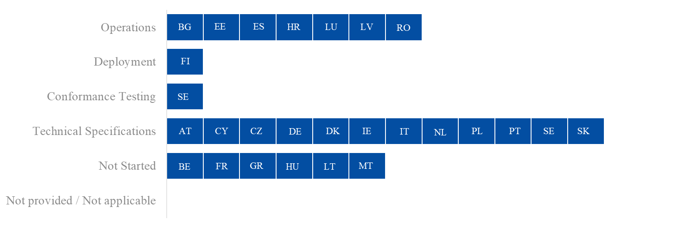
Figure 33: Project progress and status per milestone – CCI-P2

Overview of Project Progress
Figure 34 highlights any known divergences in the Member States’ National Planning compared to the dates set in the UCC WP, along with the specific dates of each milestone. As this project has a deployment window, the deployment and operations milestones are shown. Any difference between these two dates indicates that a migration period is planned.
Regarding UCC Centralised Clearance for Import – Phase 1 (CCI-P1), the following Member States have a planned/actual operations date that is later than the deadline in the UCC WP: AT, BE, CY, CZ, DE, DK, FI, FR, GR, HR, HU, IE, IT, MT, NL, PT, SE, SI, and SK.
Figure 35 highlights any known divergences in the Member States’ National Planning compared to the dates set in the UCC WP, along with the specific dates of each milestone. As this project has a deployment window, the deployment and operations milestones are shown. Any difference between these two dates indicates that a migration period is planned.
For the implementation of UCC Centralised Clearance for Import – Phase 2 (CCI-P2), the following Member States have a planned/actual operations date that is later than the deadline in the UCC WP: AT, BE, CY, CZ, DE, DK, EE, FI, FR, GR, HU, IE, IT, LT, MT, NL, PL, PT, SE, SI and SK.

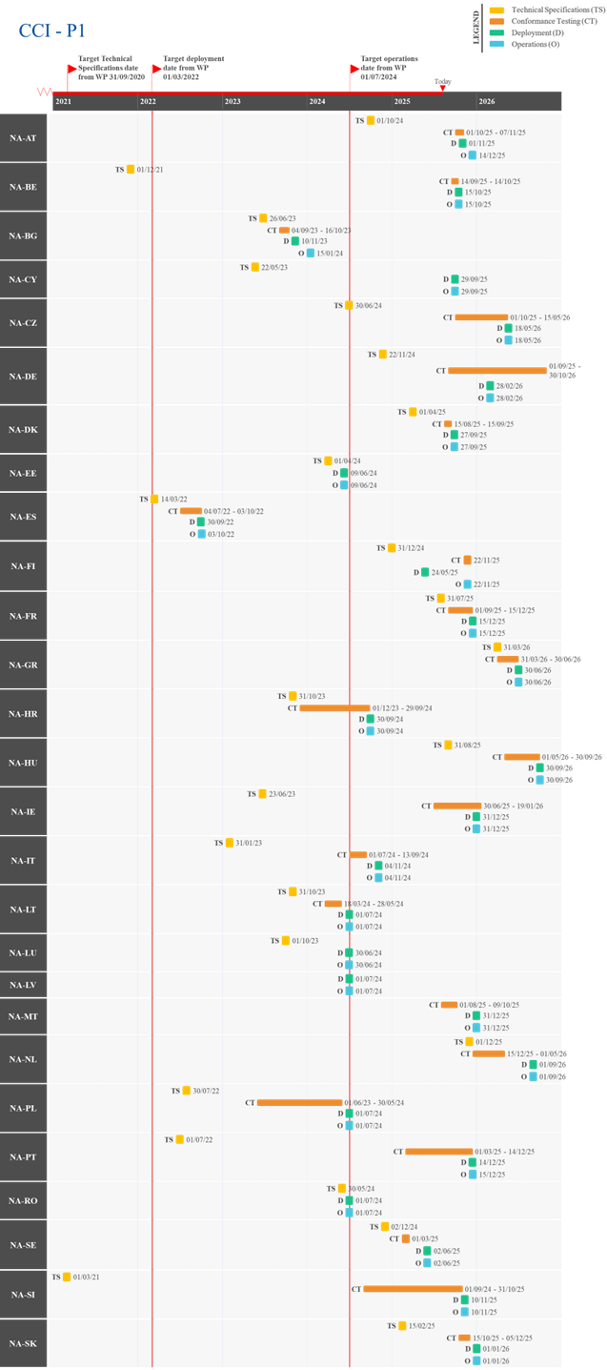
Figure 34: Actual/Planned dates per milestone – CCI-P1
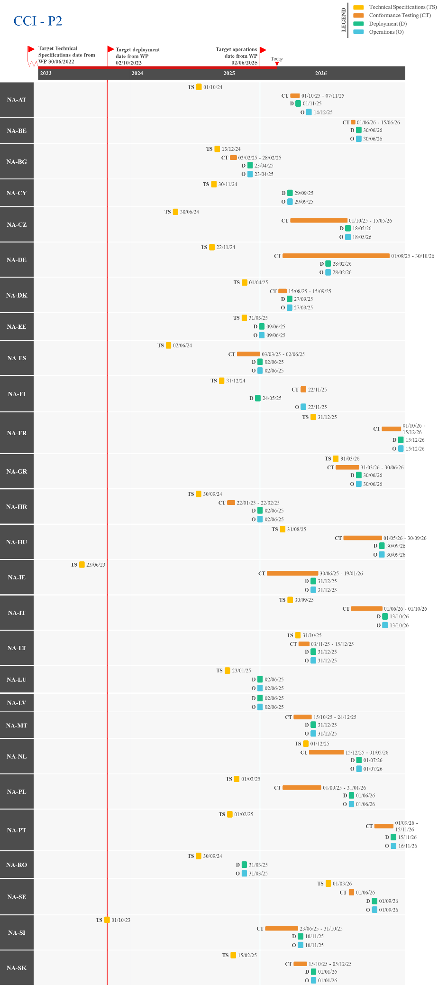
Figure 35: Actual/Planned dates per milestone – CCI-P2

UCC New Computerised Transit System (NCTS) Upgrade – Component 2
This project aims to align the existing NCTS to the UCC legal provisions. The scope of the project includes the alignment of Information Exchanges to UCC data requirements, the upgrade and development of interfaces with other systems such as AES, in addition to new Safety and Security requirements.
The transit system offers significant benefits and simplifies processes while ensuring continuity with existing systems. This achievement is the result of close collaboration between national customs authorities, trade associations and the Commission.
In terms of the planning approach, the project is divided into two components.
For Component 1 (NCTS-P5), please refer to Section 2.12.
Component 2 (NCTS-P6) will align NCTS to the new provisions set by the UCC regarding Advanced Cargo Information for Safety and Security, while continuing the practice of combined declaration for the Member States opting to offer this facilitation to their trade. It requires the set-up of an automated interface between NCTS and ICS2 to ensure that trade can serve both the transit procedure and the Safety and Security formalities simultaneously with a single process for the benefit of all. The timeline of NCTS-P6 is synchronised with that of ICS2-R3, having a transition window from 3 March 2025 until 1 September 2025 for the National Administrations to migrate from NCTS-P5 to NCTS-P6.
NCTS-P6 has been deployed in line with the following calendar (Figure 36) that is aligned to the UCC WP. Deadlines linked to ICS2/NCTS-P6 derogations are not depicted since they are separate of the legal deadlines.
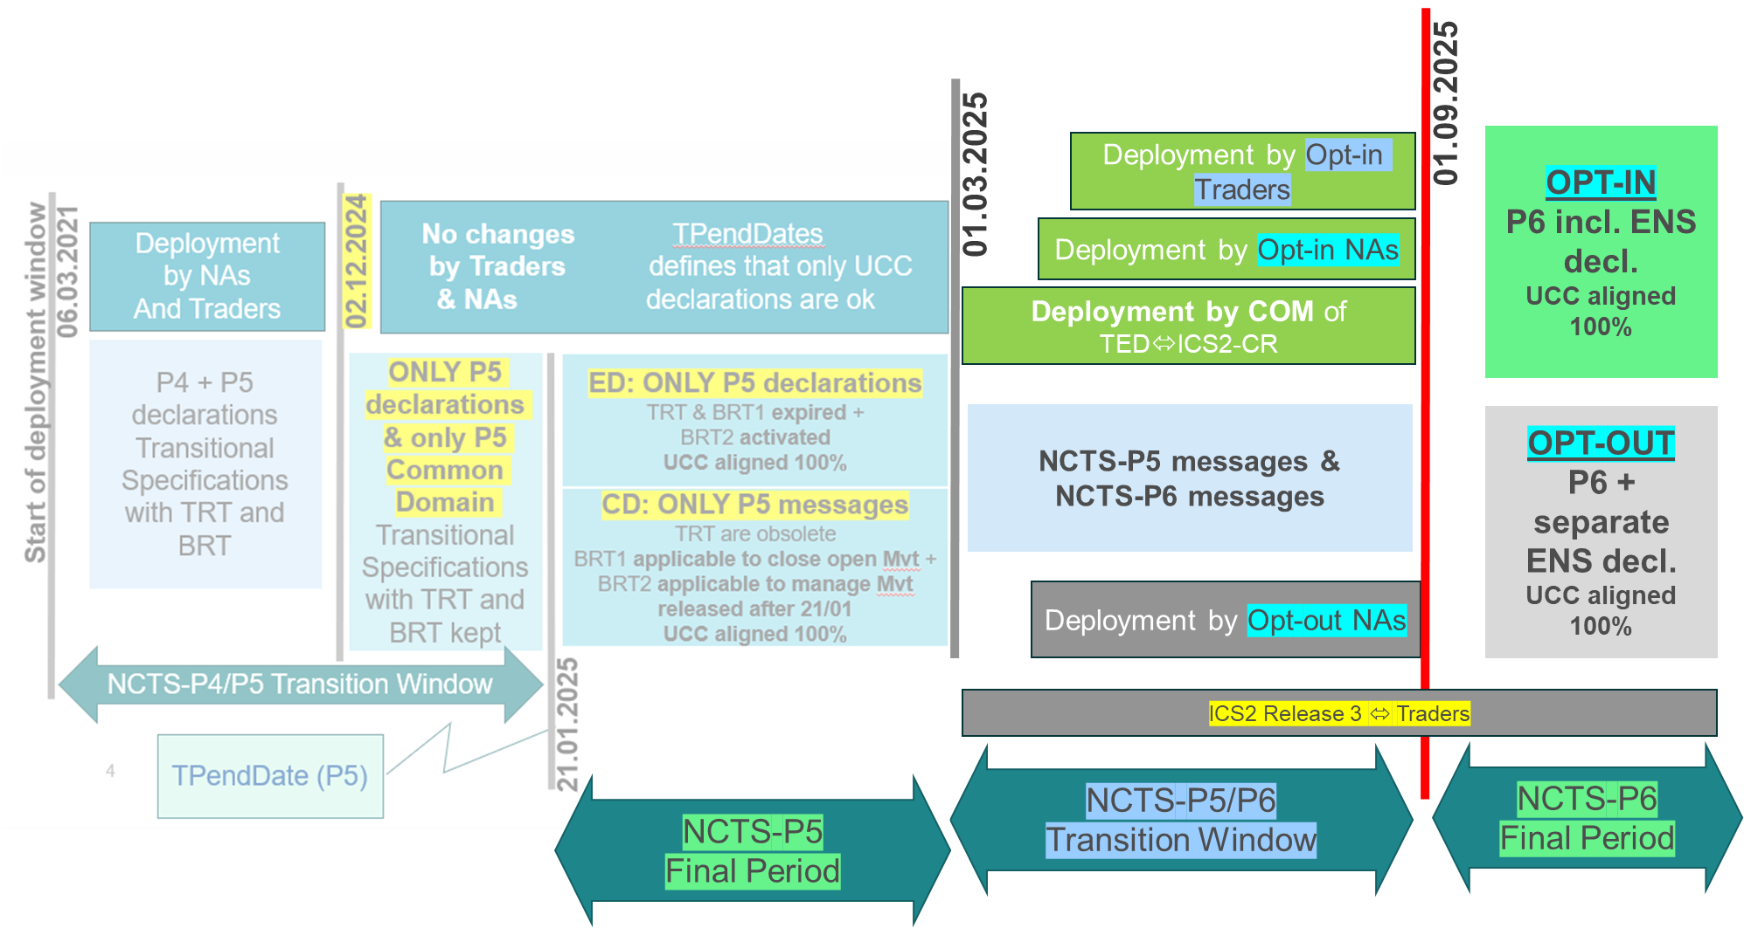
Figure 36: NCTS-P6 timeline

Summary of Responses
Summary from the Commission:
The aim of NCTS-P6 is to complete the alignment of NCTS to the Safety and Security data specified in the latest releases of the Annex B in the UCC DA and UCC IA. NCTS-P6 will also implement specific requirements in transit customs declarations of goods brought into the customs territory of the Union. The primary goals are to ensure continuity of the long-established combined declaration practice and achieve fully integrated management of the Safety and Security provisions of the UCC in NCTS. This integration aims to avoid duplication of the processes and systems for the National Administrations and trade. NCTS-P6 will interface with the ICS2 system, to minimise the IT burden on the National Administrations and trade. Another significative advancement is the harmonisation of the presentation process across all the Customs Offices of the National Administrations, which will serve as a steppingstone for future Smart Border initiatives between National Administrations and other neighbouring countries.
The integration of the system with ICS2-R3 requires the synchronisation of two significant and autonomous trans-European systems in terms of their process flow and information exchange. To achieve this synchronisation, a dedicated converter will be employed to facilitate seamless communication and data transfer between the systems. Therefore, the level of complexity associated with the development of NCTS-P6 is significant.
In April 2020, an initiative was launched to conduct a feasibility study on the interconnection between ICS2 and NCTS, including an analysis of Safety and Security requirements and the possible implementation options. The outcome confirmed the feasibility of communication between ICS2 and NCTS-P6. By mid-2021, the feasibility study was translated into a Business Case.
At the request of the National Administrations, the Business Case was temporarily suspended, awaiting analysis of the technical implications of the proposed measures. National Administrations sought more clarity regarding the combined declaration facility option that could be offered or not offered to their trades as well as the interface between NCTS and ICS2-R3.
In the second half of 2021, a Technical Study was conducted with the National Administrations to provide the expected clarifications and details. Based on this Technical Study, the VIS was produced by the end of 2021.
In December 2021, the Business Case and VIS were approved. The VIS for NCTS-P6 established a transition period from June 2024 to February 2025, aligning with the transition window of ICS2-R3. This assumed that NCTS-P5 would be completed on time, ensuring operational continuity of the transit combined declaration as a trade facilitation instrument.
During 2022, the Functional and TSS for NCTS-P6 were elaborated in collaboration with the National Administrations and subsequently accepted by the ECCG in December 2022.
A significant risk of overlap was identified between the delays of the ‘running-over’ National Administrations that joined NCTS-P5 operations in 2024 and the transitional period of NCTS-P6. The revision of the UCC WP addressed this risk by establishing a clear cut-off for the transition to NCTS-P5 as well as by postponing the start and end dates of the deployment window for NCTS-P6. The revised UCC WP aims to ensure operational continuity.
In 2024, to facilitate the upgrade from NCTS-P5 to NCTS-P6, considering the reduced transition window, the technical specifications have been optimised by eliminating the need for conversion of Common Domain messages.
At the beginning of 2025, early indications suggested that certain National Administrations might not be able to deploy (all) NCTS-P6 functionalities before the 1 September 2025 deadline. These concerns were later confirmed through official communications from several National Administrations, with revised deployment timelines.
An analysis of the potential impact of these delays, along with an examination of all possible mitigation measures, was carried out. The aim was to support National Administrations in meeting the established deadlines for ENS submissions under the UCC, while minimising disruptions to the functioning of NCTS. For each optimised functionality specified for NCTS-P6, a risk assessment and mitigation plan was developed to ensure operational continuity for all countries (aligned to either NCTS-P5 or P6) beyond the formal deployment date, should this prove necessary. At the time of writing, the derogation decisions are being prepared for the National Administrations that have requested an extension. These derogations will allow rail and road operators to connect to ICS2-R3 until 31 December 2025, and to NCTS-P6 interfacing with ICS2 until 31 May 2026. They were introduced to ease the transition for EOs, particularly small enterprises, who will be permitted to continue using NCTS-P5 and/or ICS1 until the new deadlines. Further details are provided in the Important Remark section below.
Important remark:
Member States, Common Transit Convention Countries and Trade Associations expressed some concerns in the ECCG/TCG meetings held in February and June 2025 about their readiness with the implementation of the new entry summary declaration requirements underpinned by the ICS2- R3 (Step 3) and NCTS-P6 (opt-in) implementation as of 1 September 2025. The Commission found that the appropriate legal approach was to issue derogation decisions according to the articles 6(4) and 8(2) of the UCC. Seven Member States (ES, FI, FR, HU, IE, IT and LT) and the U.K. in respect of Northern Ireland requested derogation from the deployment date of ICS2-R3 until 31/12/2025. In addition, seven Member States (BG, HR, GR, LV, PL, RO and SK) requested derogation from the deployment date of ICS2-R3 and NCTS-P6 opt-in version until 01/06/2026. At the moment of writing, the derogation decisions are being prepared. For more information regarding the derogations, please consult the 2025 APR Report from the Commission to the European Parliament and the Council.
Summary from the Member States:
More than half of the Member States shared that they are on track to meet the NCTS-P6 deployment deadline, though several reported a medium to high risk level for on-time delivery. Key challenges include the delayed publication of technical specifications, the parallel development of other UCC projects, ongoing procurement processes, and limited funding. Some Member States also cited delays to ensure system quality or due to contractor timelines.
Where mitigation measures have been taken, they focus on accelerating development through strengthened teams, improved coordination with contractors, and the finalisation of tenders.
At the time of reporting, only FI has started operations. The following Member States reported being on track to join operations within the legal deadline: BE, BG, CY, CZ, EE, ES, IE, IT, LT, LV, MT, and SI. Meanwhile, AT, DK, FR, GR, HR, HU, LU, NL, PL, PT, RO, SE and SK indicated delays beyond the legal deadline, with FR, GR, NL, PL, RO, and SK expected to become operational after 2025. Additionally, DE has not provided concrete implementation dates in its national project plan.
Detailed Responses:
Table 22 provides the individual updates from the Member States on their responses to the survey and the national project plans provided in June 2025:
MS | Additional Comments
AT | AT plans for the NCTS-P6 system to join operations on 04/09/2025.
BE | BE aims to have the NCTS-P6 system join operations on 01/09/2025.
BG | BG aims for the NCTS-P6 system to become operational on 21/07/2025.
CY | CY reported that the NCTS-P6 system is on track to become operational on 01/09/2025. Additionally, CY indicated it will be an opt-out country.
CZ | CZ shared that the NCTS-P6 system is on target to join operations on 01/09/2025.
DE | DE reported that NCTS-P6 system is on target and indicated a low risk to the timely delivery of the project. DE informed that it will not use the combined declaration following Article 130 of the UCC (NCTS-P6) but assured all measures will be taken to ensure the software is aligned with the deployment window of the project.
DK | DK reported that the NCTS-P6 project is delayed beyond the UCC WP deadline, but it aims for the system to join operations on 27/09/2025. DK attributed a high level of risk to the timely delivery of the project, noting NCTS-P6 has been postponed so as to ensure the quality of the import system and its usability for the EOs. DK plans to first deploy the national import system and subsequently NCTS-P6. Additionally, DK shared it will be an opt-out country due to time constraints.
EE | EE informed that the NCTS-P6 project is delayed within the legal deadline and aims for the system to be in operations on 16/08/2025. EE attributed a medium level of risk to the timely delivery of the project, primarily due to delays in the publication of technical specification amendments. These delays have resulted in increased efforts and costs. Nevertheless, EE plans to have the NCTS-P6 system operational as an opt-in country by the end of 2025.
ES | ES shared that the NCTS-P6 system is on target to become operational on 01/09/2025.
FI | FI informed that the NCTS-P6 system became operational on 24/05/2025 as an opt-out country. Additionally, FI shared that it is analysing the possibility of adopting opt-in in Q2 2026.
FR | FR reported that the NCTS-P6 project is delayed beyond 2025, with operations planned for 31/01/2026. A medium risk level was attributed to the timely delivery of the project, with delays attributed to the completion of NCTS-P5 and ongoing resource constraints. To address this, development teams have been reinforced, and continuous system testing is planned.
GR | GR shared that the NCTS-P6 project is delayed beyond 2025 but aims for the system to become operational on 30/06/2026.
HR | HR reported that the NCTS-P6 project is delayed beyond the legal deadline, with operations planned to start on 30/12/2025. The delay was attributed to the late publication of technical specifications and the subsequent need for multiple revisions.
HU | HU reported that the NCTS-P6 project is delayed beyond the legal deadline and plans to become operational on 15/12/2025. The main cause of delay is the ongoing public procurement process to secure the necessary software provider.
IE | IE shared that the NCTS-P6 system is on target to become operational on 01/09/2025.
IT | IT plans for the NCTS-P6 system to join operations on 01/09/2025.
LT | LT reported that the NCTS-P6 system is on target and aims for it to become operational on 01/09/2025.
LU | LU shared that the NCTS-P6 project is delayed beyond the UCC WP deadline but aims for the system to become operational on 01/12/2025. LU attributed the delay to changing specifications and a lack of information concerning the planning of the conformance testing activities.
LV | LV informed that it aims for the NCTS-P6 system to become operational on 01/09/2025. However, LV noted a medium risk of delay to the timely delivery of the project as it would like to adopt opt-in functionalities.
MT | MT reported that the NCTS-P6 system is on target to become operational on 01/09/2025.
NL | NL informed that the NCTS-P6 project is experiencing delays beyond 2025 and aims for the system to join operations on 01/04/2026. NL attributed a high level of risk to the timely delivery of the project given the accumulation of MASP-C projects.
PL | PL reported that the NCTS-P6 project is delayed beyond 2025, with operations planned for 22/06/2026. A high level of risk was attributed to the timely delivery of the project due to funding shortages under the current contract and a lengthy procurement process. A new contract is under tender, but further delays may occur if a new provider requires time to become familiar with the system. PL aims to sign the new contract and complete at least half of the analysis phase by the end of 2025.
PT | PT plans for the NCTS-P6 system to become operational on 01/10/2025.
RO | RO reported that the NCTS-P6 project is delayed beyond 2025 but aims to have the system join operation on 01/06/2026.
SE | SE reported that the NCTS-P6 project is delayed beyond the legal deadline but aims to start operations on 16/11/2025. SE attributed a medium risk to the timely delivery of the project, stating contractor deliverables as a contributing factor to the delay. To mitigate this delay, SE has been in close contact with the contractor and aims to deploy the system as a big bang.
SI | SI informed that the NCTS-P6 system is on track to become operational on 01/09/2025 as an opt-out country.
SK | SK reported that the NCTS-P6 project is delayed beyond 2025 and plans to ‘go live’ on 01/03/2026 as an opt-in country but will meet the 01/09/2025 deadline as an opt-out country. SK has attributed a medium risk to the timely delivery of the project, citing delays caused by prioritising other UCC projects. In addition, SK shared it is experiencing problems with the link between NCTS-P6 and the ENS requirements in ICS2-R3 (Step 3), noting its traders will not be ready to lodge separate ENS declarations. SK aims to complete all conformance testing campaign modes by the end of 2025.
Table 22: Detailed responses from Member States – NCTS-P6

Figure 37 provides the progress reported by the Member States through their national project plans, along with the status of the project.
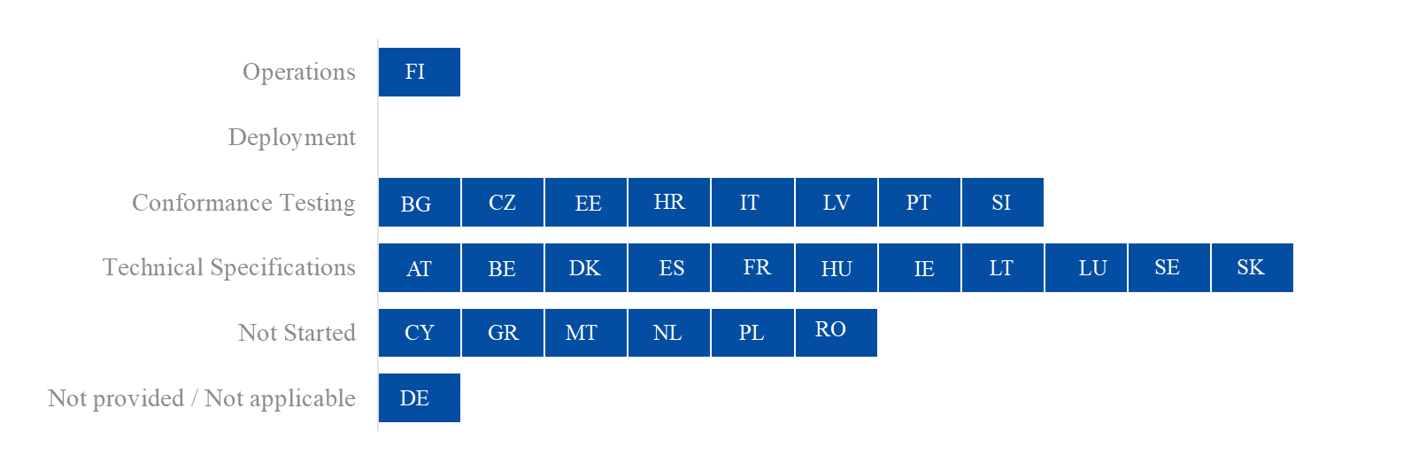
Figure 37: Project progress and status per milestone – NCTS-P6

Overview of Project Progress
Figure 38 highlights any known divergences in the Member State’s National Planning compared to the dates set in the UCC WP, along with the specific dates of each milestone. As this project has a deployment window, the deployment and operations milestones are shown. Any difference between these two dates indicates that a migration period is planned.
Regarding UCC New Computerised Transit System – Phase 6 (NCTS-P6), the following Member States have a planned/actual operations date that is later than the deadline in the UCC WP: AT, DK, FR, GR, HR, HU, LU, NL, PL, PT, RO, SE and SK. DE did not provide data through its National Planning regarding the operations date.
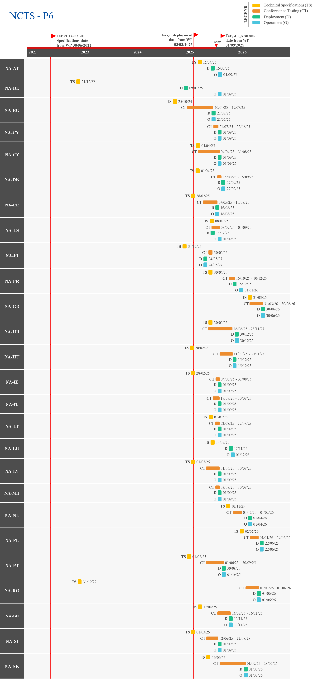
Figure 38: Actual/Planned dates per milestone – NCTS-P6

UCC Automated Export System (AES)
The Automated Export System (AES) project consists of an upgrade of both the existing trans-European Export Control System (ECS) and the existing National Export System (NES). It aims to implement the UCC requirements for the export and exit of goods, including export and re-export declarations, Exit Summary Declaration (EXS), Centralised Clearance for Export (CCE), re-export notifications and an interface with Excise Movement and Control System (EMCS) and NCTS. The project entails implementing the UCC simplifications offered to trade to facilitate the export of goods for European companies, such as CCE, and the UCC obligations to better monitor what exits the customs territory of the Union to prevent fraud. The export declaration and all linked message exchanges, the Arrival at Exit Notification and EXS are subject to considerable rework. The proposed message structures are fully convertible from/to ‘Legacy’/‘To Be’ ones, guaranteeing a smooth transition and fostering operational continuity from Q1 2021 until the latest trader is migrated to AES.
The following processes will be implemented:
- Export declaration pre-lodgement;
- Handling of simplified/supplementary declarations;
- CCE;
- Re-export notification;
- Export process followed by transit: interoperability with the NCTS trans-European system;
- Export handling of goods under excise duties suspension interoperability with EMCS;
- Exit Summary Declaration for Safety and Security at exit.
The new export system brings about substantial benefits and simplifications while ensuring continuity with the existing operational systems.
In terms of planning, the system is comprised of two components.
Component 1 (AES-C1) relates to the trans-European AES system. The project further develops the existing ECS to implement a full AES that covers the business requirements for processes and data brought about by the UCC. These processes and data include the coverage of simplified procedures and CCE. It also covers the development of harmonised interfaces with EMCS and NCTS. As such, AES enables the full automation of export procedures and exit formalities. The system includes some parts that have been developed centrally, but the main components are being developed at the national level.
AES-C1 was deployed in three steps: the first related to core functionalities (operational continuity aligned to UCC), the second to interface with Excise, and the third to non-core functionalities (Central Clearance, Export followed by Transit, Pre-Lodgement, and simplified/supplementary declarations). The Member States had the possibility to deploy all steps at once or to deploy them in sequence.
AES-C1 was scheduled be deployed in line with the following calendar:
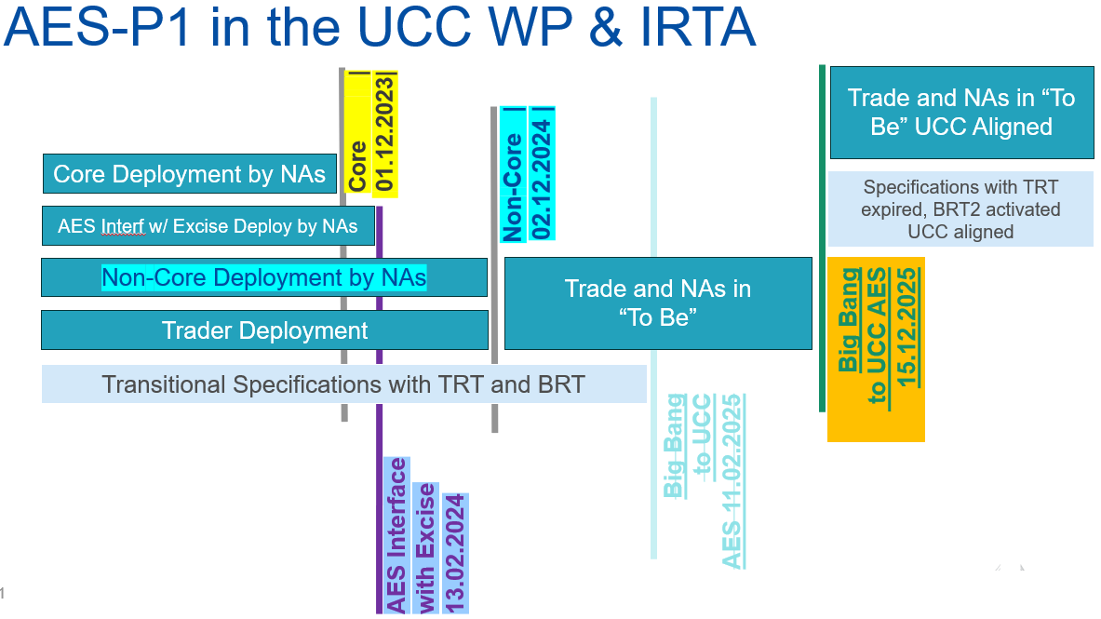
Figure 39: Updated AES-C1 timeline

Component 2 (AES-C2) relates to the NES upgrade and upgrades the national systems used for the completion of certain formalities not impacting the Common Domain of the AES.
It is important to highlight that the AES system specifications developed at the central level (FSS and TSS) cover the Information Exchange in the common, national, and external domains:
- The Common Domain communication refers to the Information Exchange between customs offices located in different Member States;
- The national domain includes the interface between national AES and other systems at national level (e.g., AES-EMCS and AES-NCTS);
- The external domain includes the communications between the customs offices and the declarant/trader at exit, at national level.
Regarding the message exchanges on the Common Domain, the AES specifications prepared by DG TAXUD are mandatory for all Member States. In case of external or national domains, the common AES specifications are strongly recommended, aiming to harmonise the export and exit formalities as much as possible among the Member States.
The 27 Member States and Northern Ireland under the NIP needed to transition to the AES-C1 system by 1 December 2023 for the core functionalities, by 13 February 2024 for the interface with Excise, and by 2 December 2024 for the non-core functionalities.
After 2 Member States requested the extension of the transitional rules and the ieCA converter until December 2025, the UCC Implementing Regulation for Technical Arrangements (IRTA) was re-activated to include a provision that allowed for the transitional measures to be prolonged. The IRTA revision package underwent interservice consultation between December 2024 and January 2025 and was voted in the Customs Code Committee General Legislation (CCC-GEN) of 7/02/2025, with all Member States in favour. The new IRTA was adopted on 13 March 2025 and published in the Official Journal on 20 March 2025. Article 56 of the IRTA extended the End of Transition deadline for AES-C1 until 14/12/2025.

Summary of Responses
AES – Component 1 (AES-C1)
Summary from the Commission:
For AES, the challenge lies in ensuring operational continuity and a seamless transition for Member States and trade, while implementing substantial changes in the applicable data and process models. The functional and technical specifications approved by the Member States govern the quality, technical support, operational continuity, security, and capacity of the transition to full AES-C1 operations.
The AES project pioneered a collaborative, iterative and Agile working method that has been praised by all the Member States and traders involved. The adoption of an Agile approach since the project's inception has yielded functional and technical quality as well as the actual progress among the Member States. The collective intelligence of the Member States is a critical asset for the success of the transition at stake. The Coordination Programme is also essential in enabling collaboration between the Member States and the Commission and providing transparency on the status of the project.
Considering the delays reported during 2023 by the Member States and the trade community regarding their transition to AES-C1 (see below), the deadlines for AES deployment and the end date for transition were updated in the UCC WP revision and in AES TSS. These updates aimed to ensure the operational continuity of AES until 11 February 2025 and full compliance with the deadlines set in Article 278(3) of the UCC. Following the adoption of the new IRTA, Member States that didn’t manage to complete their deployment within the UCC WP deadlines will benefit from the extension of the Transitional measures for AES-C1 until 14 December 2025.
Progress of the Central Project Team
Overall, the activities of the Central Project Team are on track according to the planned schedule for the development of the central system and the quality of the central services according to the agreed Service Level Agreement. The central converter demonstrated its fitness for purpose and its resilience with the growing volume of conversion. Other central systems have been continuously improved.
A new business scenario for the recapitulative supplementary declaration at export has been incorporated in the AES system specifications to promote harmonised implementations of simplified/supplementary declarations functions in the national AES systems.
Following the publication of the initial version of the AES Business Guidance in 2022 (versions for customs and for trade, available in English, German, and French), the first update was published at the end of 2023, accepted in ECCG97 in March 2024. This update was aligned with the Commission’s plan to provide regular updates of the Guidance to enhance the business understanding of AES functions. No further updates have been made since then.
Additionally, at the end of 2023, a Business Continuity Plan (BCP) for AES was established between the Member States and the Commission. This plan outlines the measures to be adopted in all Member States in the event of a temporary failure of the AES system. In Q2 2024, an update of the BCP was launched, introducing slight changes in the BC-EAD-Form. The updated package was accepted by the ECCG in August 2024, by written procedure. No further updates have been made since then.
Migration to AES-C1
The Member States and the Commission are actively involved in transitioning the trans-European customs systems for export. This started with the successful deployment of the new UCC AES system in DE in March 2021 and the entry into international operation by ES and DE on 26 April 2022. These achievements paved the way for the next generation of interconnected trans-European systems for the trade community and the national customs authorities, showcasing the quality of the specifications, the legal provisions supporting these systems and, most importantly, their operational continuity.
By 1 December 2023 (UCC WP deadline for the core functionalities), twelve Member States (DE, ES, IE, NL, HR, SI, DK, BG, CZ, EE, LV, and IT) were operating in the AES system. As of 1 September 2025, twelve additional Member States (LT, CY, RO, BE, LU, SE, FI, PL, SK, AT, HU, and MT) have joined AES operations.
Increasing progress of the Member States and the Commission in 2025 (as of 1 September 2025)
The Member States reported significant progress in deploying their national export applications in 2025. Currently, the remaining Member States (FR, GR and PT) are actively engaged in their implementation, performing conformance testing and planning to operate the new system by December 2025. However, XI has announced that it will not be able to join the system before the end of the transition period.
The central converter, ieCA, developed and operated by the Commission along with other central systems, has performed as expected. This significant achievement is the outcome of over three years of intensive collaboration between the Member States and the Commission, marking the beginning of the transition in the Common Domain.
Entry into operation
Figure 40 is based on the date which a Member State joined or will join the ‘To Be’ operation on the Common Domain with their core functionalities. Thus far, all entries in operations have occurred without causing any disruption to the continuity and quality of the operation, reflecting the effective efforts of the National Project Teams.
Almost all Member States confirmed that they will be in operations with the core functionalities, the interface with EMCS and the non-core functionalities by 14 December 2025. FR plans to go-live with only the core functionalities (Step 1) in Q4 2025, with the traders’ migration completed by 14 December 2025. GR plans to be operational by 1 December 2025 without a migration period for the traders. PT is operating AES only in the common domain as a first step and intends to complete deployment with all functionalities before December 2025.
However, a few Member States announced that certain non-core functionalities and/or the harmonised interface with EMCS will only be deployed after 2025. BE plans to deploy CCE and the interface with NCTS in 2026; FR will gradually deploy non-core functionalities and the EMCS interface during 2026 and 2027; HU intends to deploy non-core functionalities in 2026; and NL has not yet scheduled the deployment of CCE and the interface with NCTS. In addition, XI faces significant challenges in deploying the full scope of AES and is expected to be delayed beyond 14 December 2025.
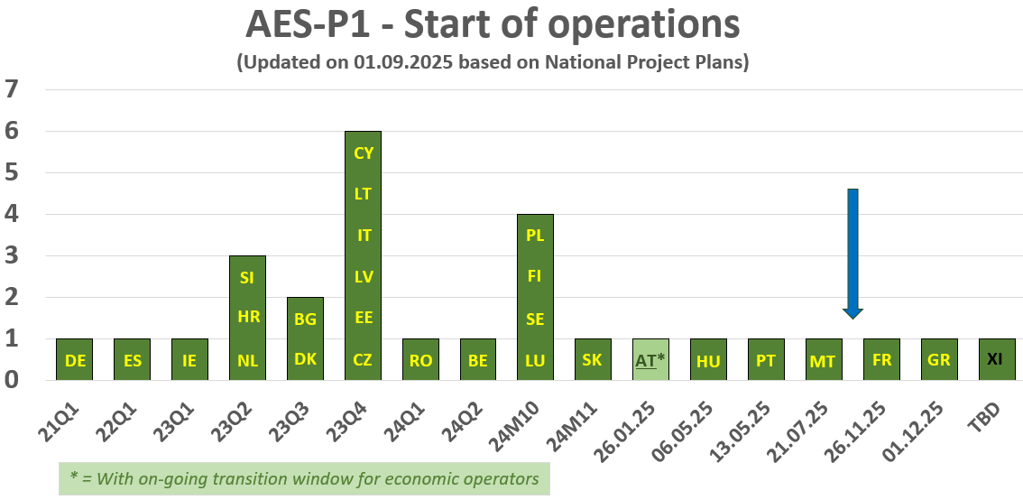
Figure 40: AES-C1 Member States entry into operations as of September 2025

Overall, the National Administrations have collectively achieved significant progress. All remaining National Administrations, except XI, will enter into operation before 14 December 2025.
Recommendations to the Member States
The Commission invited the Member States, particularly those that announced running over the 1 December 2023 milestone for the core functionalities, to maintain a high level of compliance with all their national projects so that AES-C1 can be deployed in time or with the shortest delay possible.
Member States that are late are advised to take advantage of the remaining time before the end of the extended transition period to undertake all necessary steps to minimise delays as much as possible.
Furthermore, the Member States have been reminded about the implementation of all the requirements of the Design Document for National Export Application (DDNXA), including the transitional Rules and Conditions, to ensure operational continuity.
Additionally, the Commission invited the Member States that have not yet done so to publish their trade specifications in accordance with the latest DDNXA v5.15.2 and RfCs promptly.
It is essential for Member States that do not offer a transition window to their trade to communicate their transition strategy well in advance to the EOs. This will allow sufficient time for the development and testing of the trade system. Member States that offer a transitional window should track the progress of their traders and periodically report via submission of the updated National Project Plans template or business statistics. Moreover, all Member States should initiate their outreach and support programme for the EOs.
The Coordination Programme
Under the umbrella of the ‘National Administration Coordination Programme,’ the Commission assists and monitors the development and deployment of the national components for AES-C1 by the Member States. The programme is being extended to monitor the transition of the Member States and traders during their transition to AES-C1.
The trade community is regularly updated on the progress achieved and the National Planning.
The National Project Plan template has been updated to include additional milestones pertaining to the upload of business statistics as well as the projected or actual data on progress of transition by traders and their software providers.
DG TAXUD will monitor closely the deployment progress of trade via the Coordination Programme and report to each ECCG.
Summary from the Member States:
Most Member States have started operations for AES-C1, while the few facing delays reported varying levels of risk. Key challenges included internal development issues, complex system interdependencies, and the prioritisation of other national projects. To reduce implementation timeframes, Member States adopted Agile methodologies and reinforced project teams and resources.
At the time of writing, the following Member States reported that they have entered operations, either through a single-step or multi-step approach: BE, BG, CY, CZ, DE, DK, EE, ES, FI, HR, IT, LT, LU, LV, NL, PL, RO, SE, SI, and SK. AT, GR, HU, IE, MT and PT are on track to begin operations before the end of the transition period. Some MS are, however, facing delays beyond the deployment deadline, with non-core functionalities (Step 3) expected to become operational after 2025.
Detailed Responses:
Table 23 provides the individual updates from the Member States on their responses to the survey and the national project plans provided in June 2025:
MS | Additional Comments
AT | AT reported that the AES-C1 system was deployed on 26/01/2025 and aims for it to become fully operational on 30/09/2025, following the completion of the transition period with the EOs. Additionally, AT shared that export declaration pre-lodgement, handling of simplified/supplementary declarations and re-export notification functionalities are not yet in operation. CCE functionality is planned to be operational by 17/07/2025 and interoperability with the NCTS trans-European system functionality is planned to be fully operational without the use of a workaround solution by 30/09/2025.
BE | BE shared that AES-CI system was deployed on 19/06/2024 and the system joined operations with core functionalities (Step 1) and the interface with Excise (Step 2) on 18/12/2024.
BG | BG informed that the AES-C1 system has been operational, with all functionalities since 29/08/2023.
CY | CY reported that the AES-C1 system entered operations with core functionalities (Step 1) on 18/12/2023, interface with Excise (Step 2) on 31/07/2024, and non-core functionalities (Step 3) on 20/01/2025.
CZ | CZ shared that the AES-C1 system started operations with all functionalities on 01/10/2023.
DE | DE reported that the AES-C1 system has been operational, with all functionalities since 29/10/2023.
DK | DK informed that the AES-C1 system joined operations with all functionalities on 31/05/2024.
EE | EE shared that the AES-C1 system has been operational, with all functionalities since 01/10/2023.
ES | ES reported that the AES-C1 system joined operations on 09/05/2023 with all functionalities.
FI | FI informed that the AES-C1 system is completed, the core functionalities (Step 1) have been operational since 05/11/2024 and the non-core functionalities (Step 3) since 24/05/2025.
FR | FR reported that the AES-C1 project is delayed beyond the legal deadline, with operations planned for core functionalities (Step 1) on 14/12/2025, Excise interface (Step 2) on 31/12/2025, and non-core functionalities (Step 3) on 30/03/2028. A medium risk level was attributed to the project due to delays in finalising the Information System (IS) construction. The application is now complete, with internal testing underway in collaboration with EOs and the Commission. To prevent further delays, the project team has been reinforced with additional resources to meet key milestones and improve output quality.
GR | GR reported that the AES-C1 project is delayed but still aims to be operational on 01/12/2025. The delays were attributed to procurement issues and limited resources, with GR assessing a medium risk to timely delivery. To mitigate this, additional budget has been allocated to support on-time implementation.
HR | HR shared that the AES-C1 system started operations with all functionalities on 03/05/2023.
HU | HU reported that the AES-C1 project is delayed beyond the legal deadline but is expected to be fully operational by the end of 2025. HU shared that the core functionalities (Step 1) and the interface with excise (Step 2) have been operational since 06/05/2025. For the non-core functionalities (Step 3), it aims to have the AES-NCTS interface in operations on 07/07/2025, while CCE, re-export notification and the EIDR functionalities are planned for 31/12/2025.
IE | IE reported the AES-C1 project is almost completed. IE shared that the system joined operations with core functionalities (Step 1) on 21/05/2023, the interface with Excise (Step 2) on13/02/2024 and aims for the non-core functionalities (Step 3) to become operational on 01/08/2025.
IT | IT shared that the AES-C1 system joined operations with the core functionalities (Step 1) and the non-core functionalities (Step 3) on 01/12/2024.
LT | LT informed that the AES-C1 system is completed. The core functionalities (Step 1) and the interface with Excise (Step 2) joined operations on 03/12/2023 while the non-core functionalities (Step 3) have been operational since 01/12/2024.
LU | LU shared that the AES-C1 system joined operations on 02/12/2024 with all functionalities.
LV | LV reported that the AES-C1 system is fully implemented. The system entered operations with the core functionalities (Step 1) on 10/10/2023, followed by the interface with Excise (Step 2) on 13/02/2024 and the remaining non-core functionalities (Step 3) on 01/12/2024.
MT | MT aims to deploy AES-C1 on 21/07/2025. In addition, operations for the core functionalities (Step 1) are planned for 21/07/2025, the Excise interface (Step 2) on 27/10/2025 and the non-core functionalities (Step 3) on 24/11/2025.
NL | NL reported that the AES-C1 system is operational, with core functionalities (Step 1) live since 01/12/2023, the Excise interface (Step 2) since 13/02/2024, and non-core functionalities (Step 3) since 02/12/2024. However, NL noted delays with some additional non-core functionalities. Exit followed by Transit is planned for delivery by the end of 2025 while planning for CCE is still ongoing.
PL | PL informed that AES-C1 started operations with all functionalities on 31/10/2024.
PT | PT reported that the AES-C1 project is delayed beyond the legal deadline, with operations for core functionalities (Step 1) and the Excise interface (Step 2) planned for 04/11/2025, and the non-core functionalities (Step 3) on 17/11/2025. The delays were attributed to strong interdependencies among national systems, which complicated the development of AES. PT noted that the project was especially complex, as it involved creating a new export system requiring integration with various national and EU systems. To address these challenges, PT adopted Agile development to accelerate implementation, improved its planning processes and adjusted the scheduling of training activities.
RO | RO shared that the AES-C1 system joined operations on 16/03/2024 with all functionalities.
SE | SE reported that the AES-C1 system has been fully operational with all functionalities since 02/12/2024.
SI | SI informed that AES-C1 system started operations with all functionalities on 24/05/2023.
SK | SK informed that the AES-C1 system has been operational with all functionalities since 01/11/2024.
Table 23: Detailed responses from Member States – AES-C1

Figure 41 provides the progress reported by the Member States through their national project plans, along with the status of the project.
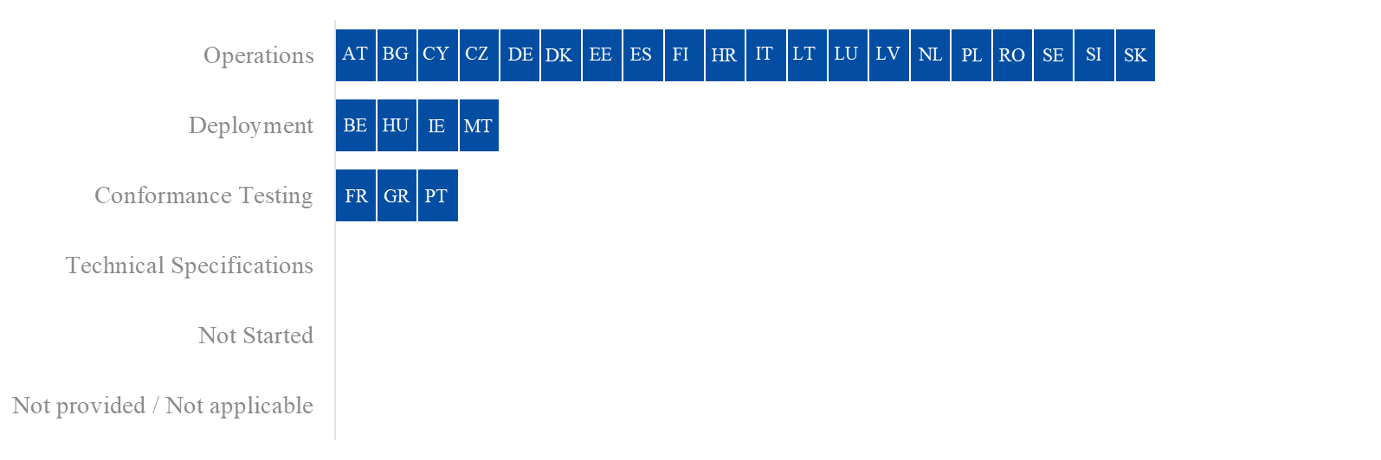
Figure 41: Project progress and status per milestone – AES-C1

AES – Component 2 (AES-C2)
Summary from the Member States:
Please see also the summary from AES-C1.
At the moment of writing, the following Member States have joined operations for AES-C2: BE, BG, CY, CZ, DE, DK, EE, ES, FI, HR, HU, IE, IT, LT, LU, LV, NL, PL, RO, SE, SI and SK. AT, GR, MT and PT are delayed beyond the legal deadline but plan to join operations before the end of 2025. Additionally, FR reported the project as not applicable.
Detailed Responses:
Table 25 provides the individual updates from the Member States on their responses to the survey and the national plans provided in June 2025:
MS | Additional Comments
AT | AT plans for the AES-C2 system to join operations on 30/09/2025.
BE | BE informed that the AES-C2 system joined operations on 18/12/2024.
BG | BG shared that the AES-C2 system started operations on 29/08/2023.
CY | CY reported that the AES-C2 system has been operational since 18/12/2023.
CZ | CZ shared that the AES-C2 system started operations on 01/10/2023.
DE | DE informed that the AES-C2 system has been operational since 29/10/2023.
DK | DK shared that the AES-C2 system started operations on 31/05/2024.
EE | EE reported that the AES-C2 system has been operational since 01/10/2023.
ES | ES informed that the AES-C2 system started operations on 09/05/2023.
FI | FI reported that the AES-C2 system joined operations on 05/11/2024.
FR | FR reported the system as not applicable.
GR | GR plans for the AES-C2 system to join operations on 01/12/2025.
HR | HR shared that the AES-C2 system has been operational since 02/05/2023.
HU | HU reported that the AES-C2 system was deployed and became operational on 06/05/2025, but experienced delays due to dependencies on the delivery of the AES-C1 system.
IE | IE reported that the AES-C2 system started operations on 21/05/2023.
IT | IT shared that the AES-C2 system joined operations on 01/12/2024.
LT | LT informed that the AES-C2 system has been operational since 03/12/2023.
LU | LU reported that the AES-C2 system joined operations on 02/12/2024.
LV | LV shared that the AES-C2 system joined operations on 10/10/2023.
MT | MT plans for AES-C2 to become operational on 21/07/2025.
NL | NL reported that the AES-C2 system has been operational since 01/12/2023. However, NL noted that CCE and the interface between NCTS-P5 and AES have not yet been completed.
PL | PL informed that the AES-C2 system has been operational since 31/10/2024.
PT | PT reported that the AES-C2 project is delayed beyond the legal deadline, with deployment planned for 01/10/2025. PT attributed a high level of risk to the timely delivery of the project, with delays stemming from the strong interdependencies among national systems, which complicated the development of the AES system. PT noted that the project was particularly complex, as it involved creating an entirely new national export system requiring integration with various national and EU systems. To address these challenges, PT adopted Agile development to shorten the implementation timeframe and enhanced its planning processes.
RO | RO shared that the AES-C2 system joined operations on 16/03/2024.
SE | SE reported that the AES-C2 system began operations on 02/12/2024 for all interfaces related to the common domain. Delays were noted for the deployment of EIDR, the Exit Summary Declaration, and the Re-Export Notification, due to the prioritisation of other UCC projects. SE stated that EIDR will be deployed on 01/02/2026, with all EOs expected to be operational by 28/02/2026, noting that it is currently used by only a few EOs, and only for exports to NO. The Exit Summary Declaration and Re-Export Notification are planned for deployment in the second half of 2026, though both involve a very limited number of transactions.
SI | SI informed that the AES-C2 system joined operations on 24/05/2023.
SK | SK reported that AES-C2 has been operational since 01/11/2024.
Table 24: Detailed responses from Member States – AES-C2

Figure 42 provides the progress reported by the Member States through their national project plans, along with the status of the project.
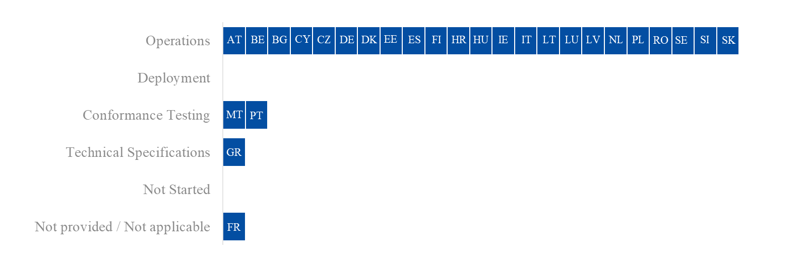Figure 42: Project progress and status per milestone – AES-C2

Overview of Project Progress
Figure 43 for AES-C1 highlights any known divergences in the Member States’ National Planning compared to the dates set in the UCC WP, along with the specific dates of each milestone. As this project has a deployment window, the deployment and operations milestones are shown. Any difference between these dates, indicates that a migration period is planned.
Regarding UCC Automated Export System – Component 1 (AES-C1):
- The Member States that plan to deliver the system in full and have a planned/actual operations date that is later than the single operations deadline in the UCC WP are AT, DK, GR, LU, MT, PL, RO, SE, and SK;
- The Member States that plan to deliver the system by steps and have a planned/actual operations date for the core functionalities (Step 1), interface with Excise (Step 2) and the non-core functionalities (Step 3) that is later than the steps deadline in the UCC WP are BE, CY, FI, FR, HU and PT. Furthermore, IE has a planned/actual operations date for only the non-core functionalities (Step 3) that is later than the step deadline in the UCC WP.

Figure 44 for AES-C2 highlights any known divergences in the Member States’ National Planning compared to the dates set in the UCC WP, along with the specific dates of each milestone. As this project has a deployment window, the deployment and operations milestones are shown. Any difference between these dates, indicates that a migration period is planned.
Regarding UCC Automated Export System – Component 2 (AES-C2), the following Member States have a planned/actual operations date that is later than the deadline in the UCC WP: AT, BE, GR, HU, MT and PT. Additionally, FR indicated the project as not applicable.
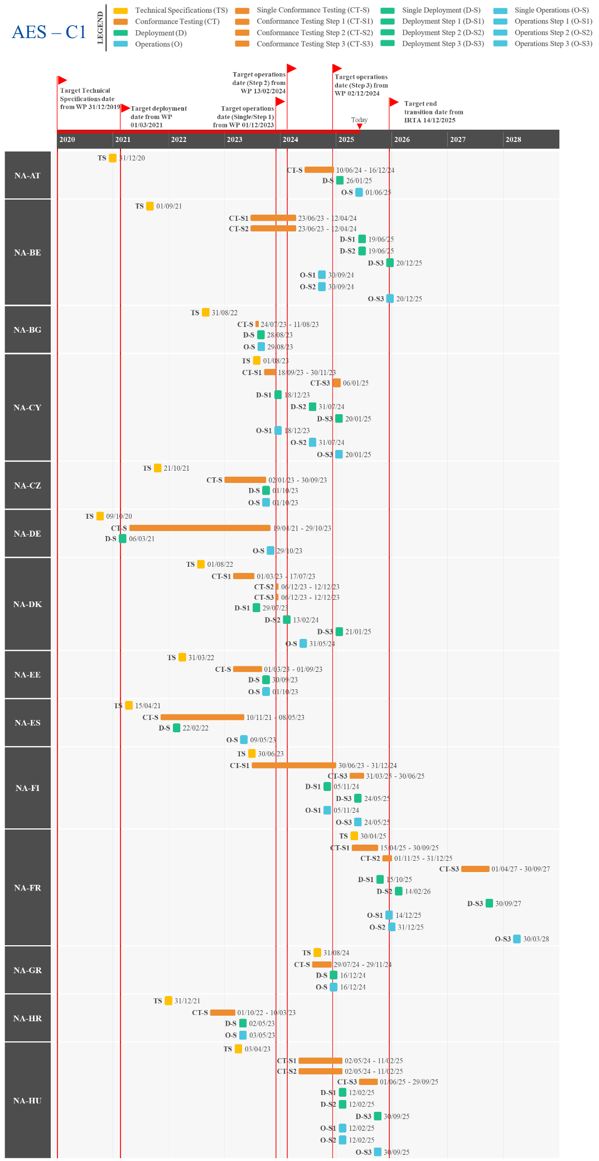
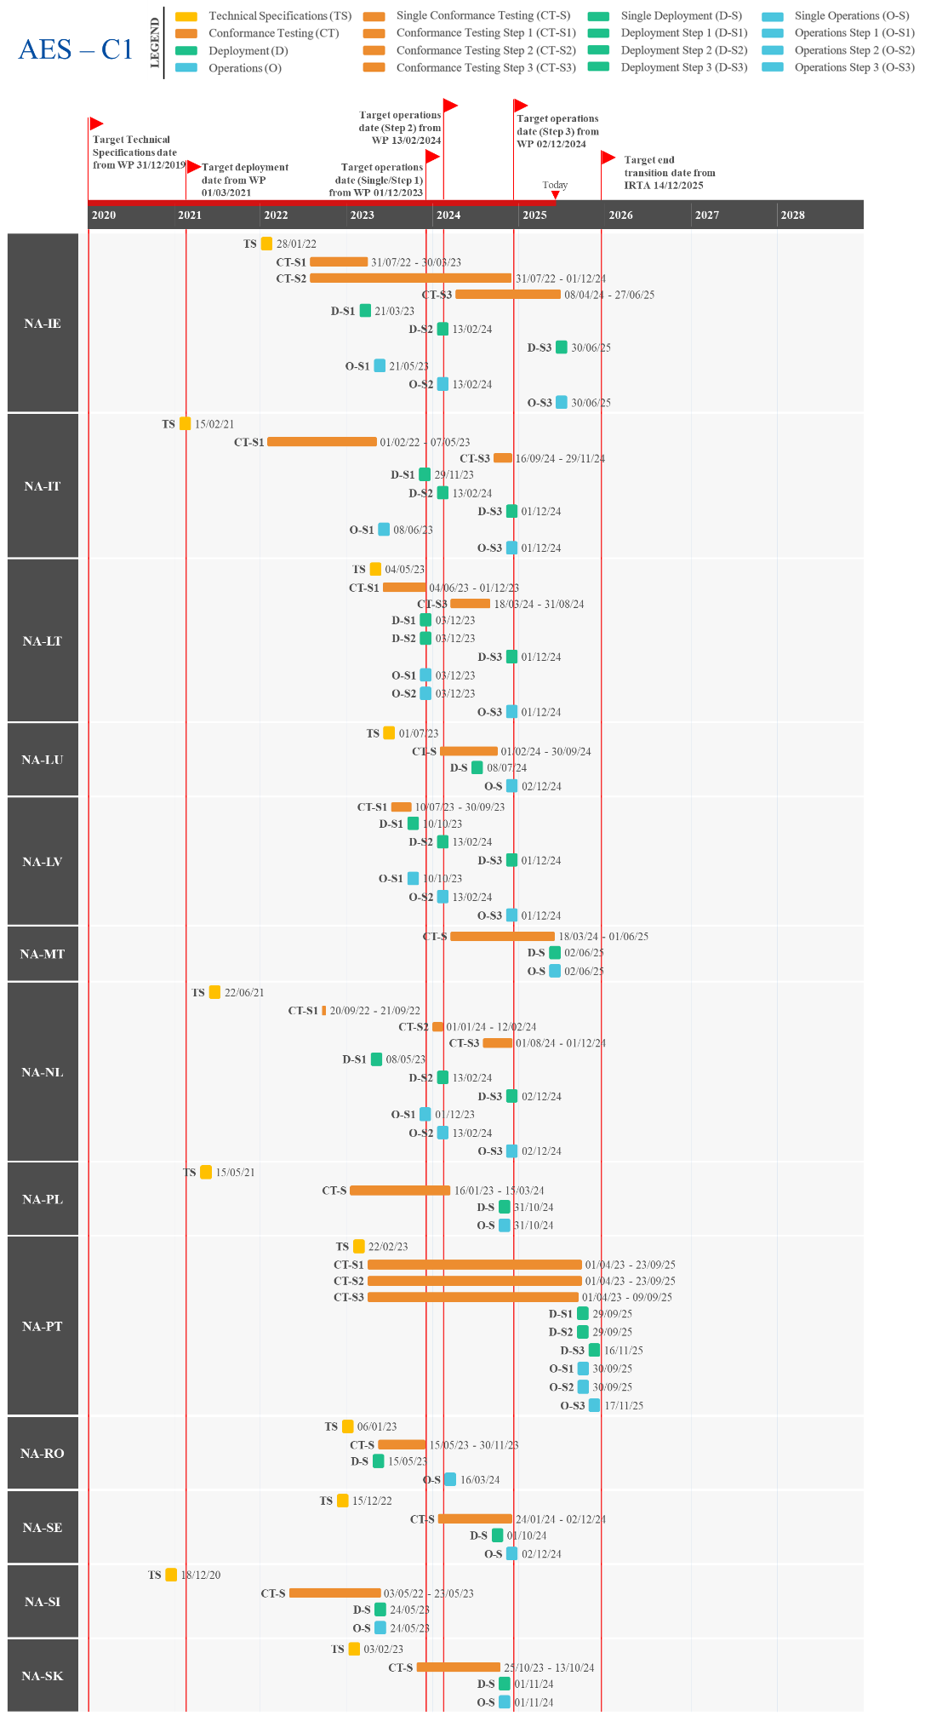
Figure 43: Actual/Planned dates per milestone – AES-C1
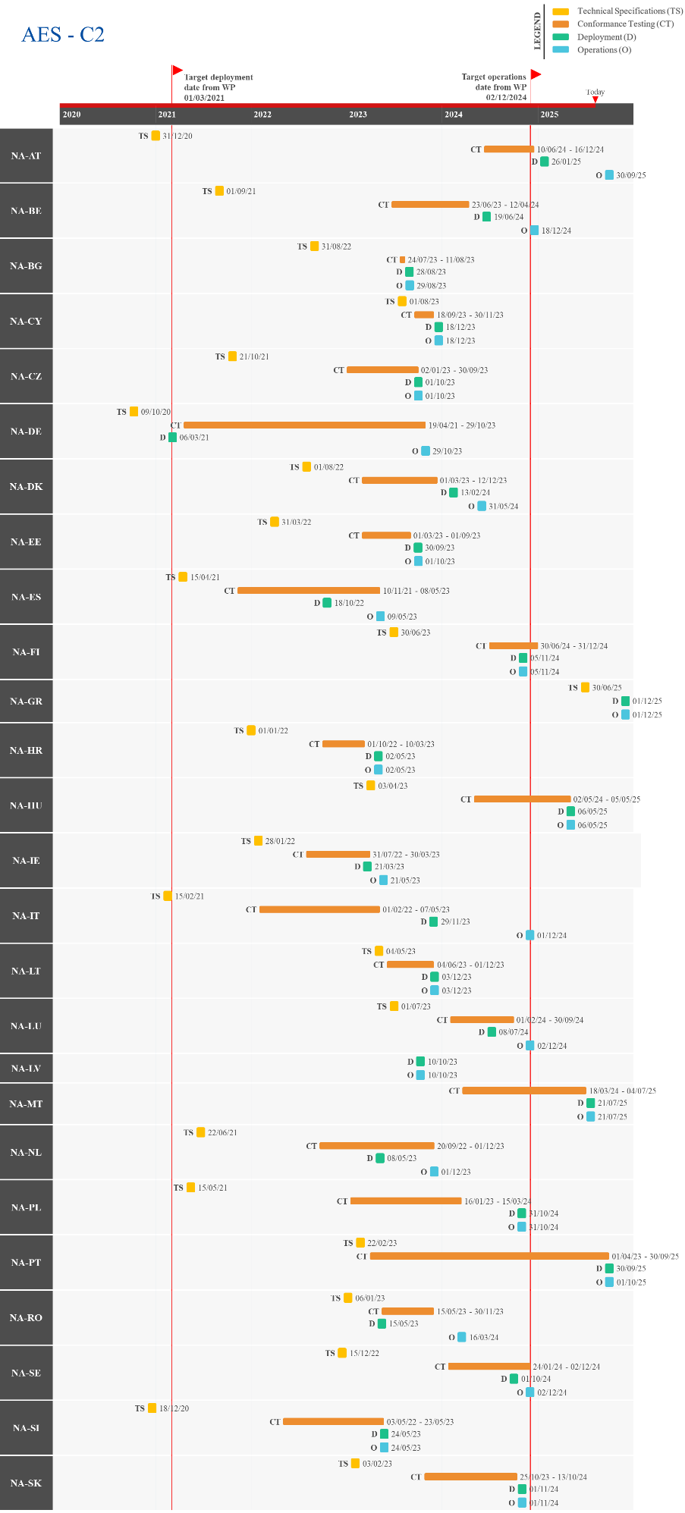
Figure 44: Actual/Planned dates per milestone – AES-C2

UCC Import Control System 2 (ICS2) – Release 3
The goal of the UCC ICS2 programme is to strengthen the Safety and Security of the supply chain for goods moved via all modes of transport. The aim is to do so through better targeted risk-based controls of EU customs authorities on improved ENS data quality, data filing, data availability and data sharing and through real-time collaborative risk analysis and co-ordinated Safety and Security controls at the EU entry points. The main purpose of the system is to implement the requirements resulting from the UCC and strategic objectives endorsed by the Member States in the risk management strategy and action plan of 2014.
In terms of planning, the programme is implemented in three releases.
For Release 1 (ICS2-R1) and Release 2 (ICS2-R2), please refer to Section 2.9.
Release 3 (ICS2-R3) aims to cover the implementation of new ENS obligations, related business, and risk management process for all goods in maritime and inland waterways, road, and rail traffic.
The Member States need to deploy their national ICS2 component by 3 June 2024. Depending on the mode of transport, the EOs shall start using ICS2 within the following deployment windows:
- For maritime and inland waterways carriers, between 3 June 2024 and 4 December 2024;
- For house level filers in the maritime and inland waterways traffics, between 4 December 2024 and 1 April 2025;
- For road and rail carriers, between 1 April 2025 and 1 September 2025.

Summary of Responses
Summary from the Commission:
The trans-European project on UCC ICS2-R3 enhances the functional scope of ICS2 with support for further modes of transport and implements the complete UCC requirements for all ‘entry of goods’ use cases including the existing ones from ICS2-R2.
ICS2-R3 includes further extension for Safety and Security Analytics.
The ICS2-R3 Common Technical System Specifications (CTSS) were initially delivered in February 2022 and subsequently updated in September 2022. For ICS2-R3, the conformance testing activities are exclusively carried out by EOs. The connectivity conformance testing activities are in progress since 1 July 2023 and the conformance testing itself for functional testing started on 11 December 2023. Unlike previous releases, for ICS2-R3 there was no R3 conformance testing campaign for the National Administrations. The National Administrations have already implemented all functionalities for ICS2-R3 within ICS2-R2 and completed the mandatory conformance testing, except for NL.
The development of the central components, namely the Common Repository (CR) and Shared Trader Interface has started and is progressing as planned.
Important remark:
Member States, Common Transit Convention Countries and Trade Associations expressed some concerns in the ECCG/TCG meetings held in February and June 2025 about their readiness with the implementation of the new entry summary declaration requirements underpinned by the ICS2- R3 (Step 3) and NCTS-P6 (opt-in) implementation as of 1 September 2025. The Commission found that the appropriate legal approach was to issue derogation decisions according to the articles 6(4) and 8(2) of the UCC. Seven Member States (ES, FI, FR, HU, IE, IT and LT) and the U.K. in respect of XI requested derogation from the deployment date of ICS2-R3 until 31/12/2025. In addition, seven Member States (BG, HR, GR, LV, PL, RO and SK) requested derogation from the deployment date of ICS2-R3 and NCTS-P6 opt-in version until 01/06/2026. At the moment of writing, the derogation decisions are being prepared. For more information regarding the derogations, please consult the 2025 APR Report from the Commission to the European Parliament and the Council.
Summary from the Member States:
At the time of writing, all Member States have deployed the ICS2-R3 system. In terms of operations, BG, CZ, GR, LU, PT, and SI are fully operational across all modes of transport, having adopted a single-step approach. DK, is also following a single-step approach and is on track to become operational by the UCC WP deadline.
The following Member States have started operations for maritime and inland waterways carriers (Step 1) and house-level filers in these traffic modes (Step 2), and are on target to reach operational status for road and rail carriers (Step 3) by the deadline: AT, BE, CY DE, EE, ES, FI, HR, HU, IE, LT, LV, MT, PL, RO SE, and SK.
In addition, IT has yet to join operations, but is on track to do so with all functionalities before the final deadline. FR and NL joined operations for Step 1 but reported a delay in reaching Step 3 and Step 2 respectively.
Detailed Responses:
Table 26 provides the individual updates from the Member States on their responses to the survey and the national project plans provided in June 2025:
MS | Additional Comments
AT | AT shared that the ICS2-R3 system was deployed on 03/06/2024, with operations for maritime and inland waterways carriers (Step 1) and house level filers in the maritime and inland waterways traffics (Step 2) starting on 04/12/2024 and 01/04/2025 respectively. AT aims to have the system operational for road and rail carriers (Step 3) on 01/09/2025.
BE | BE informed that ICS2-R3 was deployed on 03/06/2024, with maritime and inland waterways carriers (Step 1) in operations since 04/12/2024 and maritime and inland waterways traffics (Step 2) since 01/04/2025. Additionally, BE plans to have road and rail carriers (Step 3) operational on 01/09/2025.
BG | BG reported that the ICS2-R3 system has been operational for all modes of transport since 03/06/2024.
CY | CY shared that the ICS2-R3 system was deployed on 03/06/2024 and is fully operational since 04/12/2024 for maritime and inland waterways carriers (Step 1) and 01/04/2025 for house level filers in the maritime and inland waterways traffics (Step 2).
CZ | CZ shared that the ICS2-R3 system was deployed and started operations on 01/06/2024 for all modes of transport.
DE | DE informed that the ICS2-R3 system was deployed on 03/06/2024, with maritime and inland waterways carriers (Step 1) in operations since 04/12/2024 and maritime and inland waterways traffics (Step 2) since 01/04/2025. Additionally, DE is on target to have road and rail carriers (Step 3) operational on 01/09/2025.
DK | DK reported that the ICS2-R3 system was deployed on 25/05/2024 and is on track to start operations for all modes of transport on 01/09/2025, as only a few EOs remain to be onboarded.
EE | EE informed that the ICS2-R3 system was deployed on 03/06/2024. Operations began with maritime and inland waterways carriers (Step 1) and house level filers in the maritime and inland waterways traffics (Step 2) on 01/04/2025. Road and rail carriers (Step 3) are scheduled to become operational on 01/09/2025.
ES | ES shared that the ICS2-R3 system was deployed on 03/06/2024, with operations for maritime and inland waterways carriers (Step 1) starting on 04/12/2024, house level filers in the maritime and inland waterways traffics (Step 2) on 01/04/2025 and road and rail carriers (Step 3) planned for 01/09/2025.
FI | FI shared that the ICS2-R3 system was deployed during Q2 2025, with operations for maritime and inland waterways carriers (Step 1) and house level filers in the maritime and inland waterways traffics (Step 2) starting on 01/04/2025. FI aims to have the system operational for road and rail carriers (Step 3) on 01/09/2025.
FR | FR informed that ICS2-R3 was deployed on 03/06/2024, with maritime and inland waterways carriers (Step 1) in operations since 04/12/2024. FR aims to have road and rail carriers (Step 3) join operations on 31/12/2025.
GR | GR reported that the ICS2-R3 system was deployed and has been in operations for all modes of transport since 14/06/2024.
HR | HR shared that ICS2-R3 was deployed on 03/06/2024. Operations began with maritime and inland waterways carriers (Step 1) and house level filers in the maritime and inland waterways traffics (Step 2) on 01/04/2025. Road and rail carriers (Step 3) are scheduled to become operational on 01/09/2025.
HU | HU reported that the ICS2-R3 system was deployed on 01/03/2023. Operations were launched for maritime and inland waterways carriers (Step 1) on 04/12/2024, followed by house-level filers in the maritime and inland waterways traffics (Step 2) on 01/04/2025. Road and rail carriers (Step 3) are expected to follow on 01/09/2025.
IE | IE informed that the ICS2-R3 system was deployed on 03/06/2024, and has been operational for maritime and inland waterways carriers (Step 1) since 04/12/2024 and for house level filers in the maritime and inland waterways traffics (Step 2) since 01/04/2025. In addition, IE aims to have road and rail carriers (Step 3) operational on 01/09/2025, but noted that EOs may face challenges meeting the final deadline.
IT | IT shared that ICS2-R3 was deployed on 03/06/2024. IT aims for maritime and inland waterways carriers (Step 1) and house-level filers in the maritime and inland waterways traffics (Step 2) to join operations on 14/07/2025 and for road and rail carriers (Step 3) on 01/09/2025.
LT | LT reported that the ICS2-R3 system was deployed on 01/06/2024. This was followed by operations for maritime and inland waterways carriers (Step 1) on 04/12/2024, house-level filers in the maritime and inland waterways traffics (Step 2) on 01/04/202. It aims for road and rail carriers (Step 3) to become operational on 01/09/2025.
LU | LU shared that the ICS2-R3 system joined operations on 01/07/2024 for all applicable modes of transport. Additionally, LU noted that the impact of ICS2-R3 is limited as it has no land or sea borders with 3rd countries.
LV | LV reported that the ICS2-R3 system was deployed on 01/03/2023. Operations for maritime and inland waterways carriers (Step 1) began on 04/12/2024, followed by house-level filers in these traffic modes (Step 2) on 01/04/2025. LT plans to launch operations for road and rail carriers (Step 3) on 01/09/2025.
MT | MT informed that ICS2-R3 was deployed on 03/12/2024, with maritime and inland waterways carriers (Step 1) in operations since 04/12/2024 and maritime and inland waterways traffics (Step 2) since 01/04/2025. Additionally, MT plans to have road and rail carriers (Step 3) operational on 01/09/2025.
NL | NL shared that the ICS2-R3 system was deployed on 27/05/2024 and has been operational for maritime and inland waterways carriers (Step 1) since 04/12/2024. NL aims to have the system operational for house level filers in the maritime and inland waterways traffics (Step 2) on 01/09/2025.
PL | PL informed that the ICS2-R3 system was deployed on 03/06/20204, with maritime and inland waterways carriers (Step 1) in operations since 04/12/2024 and maritime and inland waterways traffics (Step 2) since 01/04/2025. Additionally, PL is on target to have road and rail carriers (Step 3) operational on 01/09/2025.
PT | PT shared that the ICS2-R3 system joined operations on 03/06/2024 for all modes of transport.
RO | RO reported that ICS2-R3 was deployed on 16/12/2024. Operations for maritime and inland waterways carriers (Step 1) began on 01/05/2024, and house-level filers in these traffic modes (Step 2) on 01/04/2025. RO plans to launch operations for road and rail carriers (Step 3) on 01/09/2025.
SE | SE informed that the ICS2-R3 system was deployed on 03/06/2024. Operations began with maritime and inland waterways carriers (Step 1) on 04/12/2024, followed by house-level filers in the maritime and inland waterways traffics (Step 2) on 01/04/2025. Road and rail carriers (Step 3) are scheduled to become operational on 01/09/2025.
SI | SI reported that ICS2-R3 was deployed on 02/06/2024 and has been operational for all modes of transport since 03/06/2024.
SK | SK shared that the ICS2-R3 system is on target to meet the UCC deadline and was deployed on 03/06/2024. Operations were launched for maritime and inland waterways carriers (Step 1) on 04/12/2024, followed by house-level filers in the maritime and inland waterways traffics (Step 2) on 01/04/2025. Road and rail carriers (Step 3) are planned to follow on 01/09/2025. In regards to Step 3, SK noted that traders might have issues meeting the deadline and has launched a campaign for the trade community to help in this regard.
Table 25: Detailed responses from Member States – ICS2-R3

Figure 45 provides the progress reported by the Member States through their national project plans, along with the status of the project.
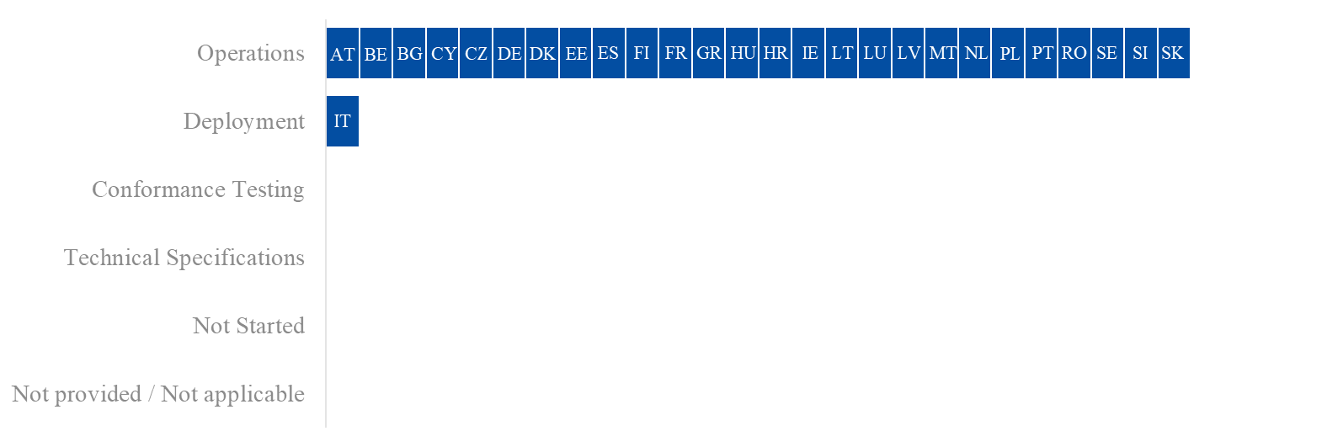
Figure 45: Project progress and status per milestone – ICS2-R3

Overview of Project Progress
Figure 46 highlights any known divergences in the Member States’ National Planning compared to the dates set in the UCC WP, along with the specific dates of each milestone.
Regarding the implementation of UCC Import Control System 2 – Release 3 (ICS2-R3):
- The Member States that plan to deliver the system in full and have a planned/actual operations date that is later than the single operations deadline in the UCC WP: DK;
- The Member States that plan to deliver the system by steps and have a planned/actual operations date for the maritime and inland waterways carriers (Step 1) that is later than the Step 1 operations deadline are: EE, FI, FR and IT. In addition, FR also has a planned/actual operations date for road and rail carriers (Step 3) that is later than the Step 3 operations deadline, while IT does so for house-level filers in the maritime and inland waterways traffics (Step 2).

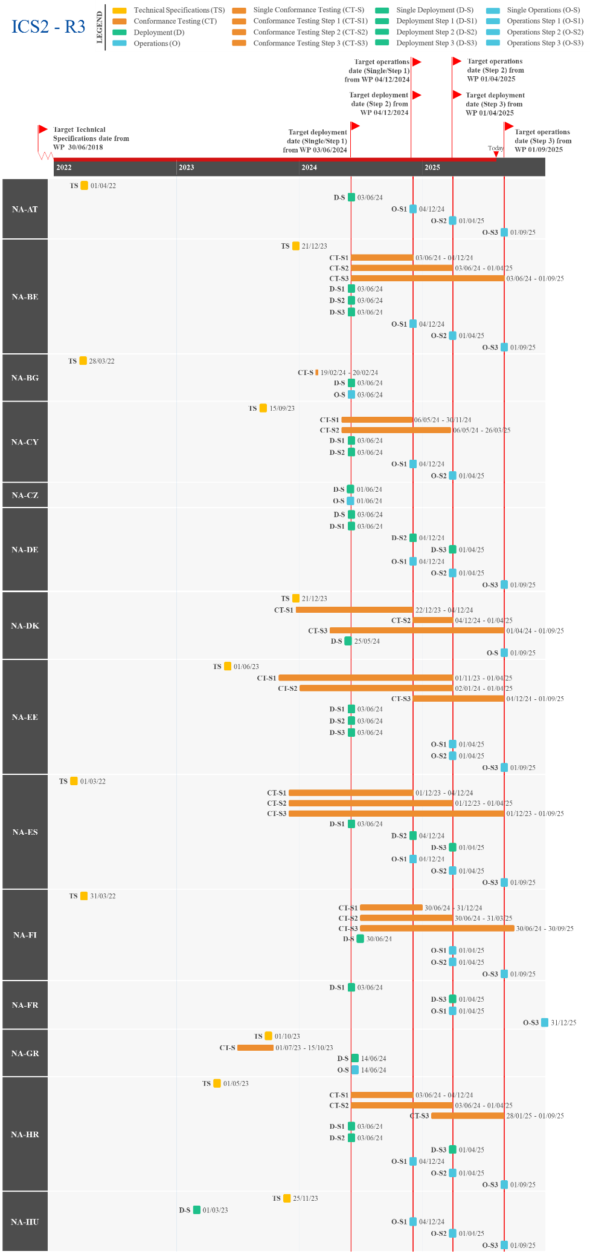
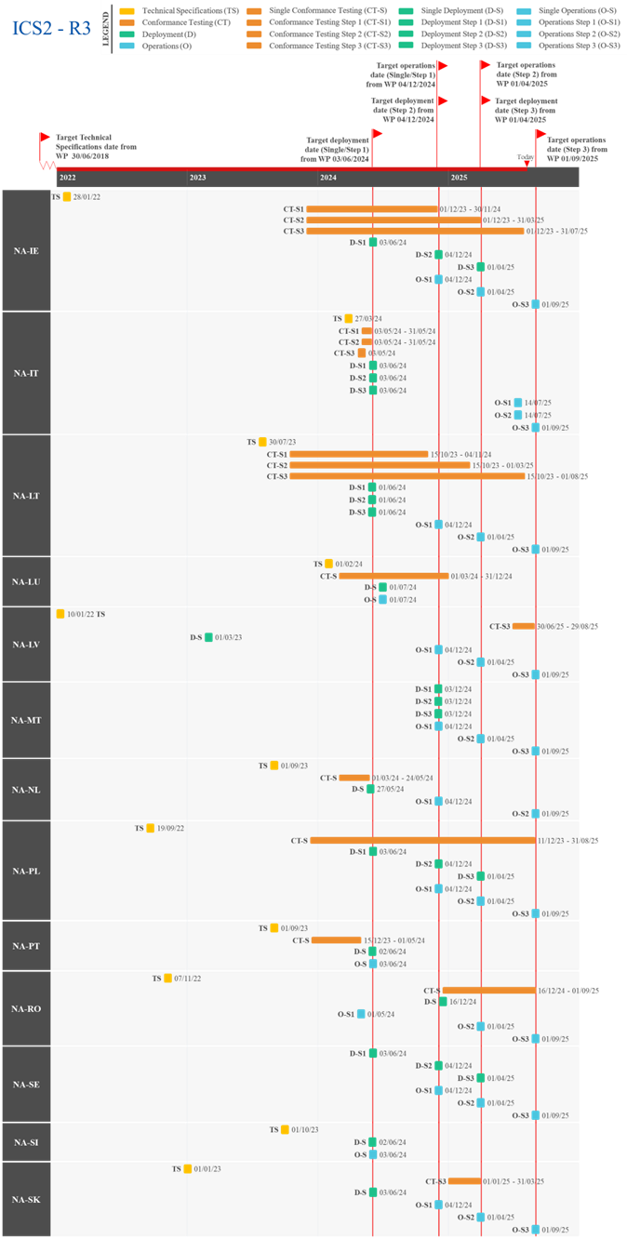
Figure 46: Actual/Planned dates per milestone – ICS2-R3

UCC Proof of Union Status (PoUS) – Phase 2
The UCC PoUS is a trans-European system designed to allow storage, management, and retrieval of certain types of documents (e.g., T2L, T2L/F, CGM, CGMF) that traders provide to prove the Union Status of their goods. The system is meant to improve the uniformity of the procedures across the European Union and contribute to the establishment of a more consistent, harmonised and, thus, simplified process related to customs clearance for Union goods.
A system will be created that will include a central repository for the storage and exchange of data and documents dealing with PoUS between the customs authorities across all the Member States.
The project is divided into two phases.
For Phase 1 (PoUS-P1), please refer to Section 2.11
Phase 2 (PoUS-P2) covers the implementation of the electronic CGM, including the information exchange with the EMSWe.

Summary of Responses
Summary from the Commission:
The TSS were completed by Q2 2023. The conformance testing activities of the PoUS central components (PoUS STP, PoUS BO and web-services used for national PoUS systems (ES and PL)) are anticipated to be concluded by Q3 2025. The system-to-system (S2S) connection for traders is envisaged to occur via the MNSWs and was planned to be deployed at the same date as the central PoUS-P2, namely on 15 August 2025, in order to meet the requirements laid down by Article 26 of Regulation (EU) 2019/1239 establishing a EMSWe. For this S2S part, there is a delay for two different reasons:
- Over the past few months, Member States haves announced delays in the implementation of the MNSWs for up to 18 months following the planned deployment date, which will have a significant impact on the maritime sector. The Commission looked into a potential solution from the legal point-of-view (in order to allow to continue the shipping company’s manifest use until the MNSW is ready).
- In May 2025, the Commission changed the technical strategy below to be used for the S2S in order to simplify the work from the MS side: SPEED2 should be used instead of CCN2. That has introduced yet another cause for a delay in the release into PROD of the S2S communication between the MNSW and the central PoUS system.
Nevertheless, the Phase 2 is envisaged to be deployed according to the UCC WP on 15 August 2025, providing the service of submitting CGM requests without the S2S connection.
Important remark:
The Commission found that the appropriate legal approach to bridge the tie gap between the deployment of PoUS-P2 and the MNSW was to issue derogation decisions according to the articles 6(4) and 8(2) of the UCC. Seventeen Member States requested derogations from the connection between the PoUS and the MNSW, until the latter will be in place individually in each Member State. For more information regarding the derogations, please consult the 2025 APR Report from the Commission to the European Parliament and the Council.

Summary from the Member States:
The Member States have the option of using the central PoUS system or developing their own national application. From all the Member States, only ES and PL conveyed the intention to develop their own national system. ES is on target to deploy the system within the legal deadline, however, PL has reported it will be delayed beyond 2025 and has requested a derogation as described above.
Detailed Responses:
Table 27 provides the individual updates from the Member States on their responses to the survey and the national project plans provided in June 2025:
MS | Additional Comments
ES | ES reported that the PoUS-P2 system is on track to join operations on 15/08/2025.
PL | PL shared that the PoUS-P2 project is delayed beyond 2025, with operations planned for 30/06/2027. A high level of risk was attributed to the timely delivery of the project due to funding shortages under the current contract and a lengthy procurement process. A new contract is under tender, but further delays may occur if a new provider requires time to become familiar with the system. PL aims to sign the new contract and complete at least half of the analysis phase by the end of 2025.
Table 26: Detailed responses from Member States – PoUS-P2

Overview of Project Progress
Figure 47 highlights any known divergences in the Member States’ National Planning compared to the dates set in the UCC WP, along with the specific dates for the central and national system.
Regarding UCC Proof of Union Status – Phase 2 (PoUS-P2), all Member States, except ES and PL, will use the central PoUS system. ES and the Commission indicated to be on target to deploy the system on 15 August 2025, however PL indicated that it will go into operations after the UCC WP deadline.
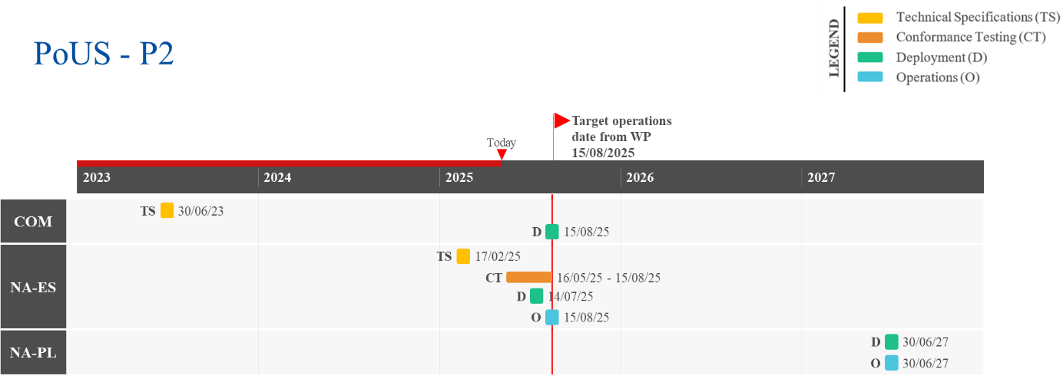
Figure 47: Actual/Planned dates per milestone – PoUS-P2

Annex 1 – Planning Overview – UCC Work Programme Projects
Figure 48 reflects the state of play at the end of 2025, corresponding to the legal deadline established in the revised 2023 UCC Work Programme. The projects marked in green are fully completed, while the projects marked in orange indicate the areas where less than 90% of the Member States are ready, and the ones marked in yellow indicate where between 90% and 99% of the Member States are ready.

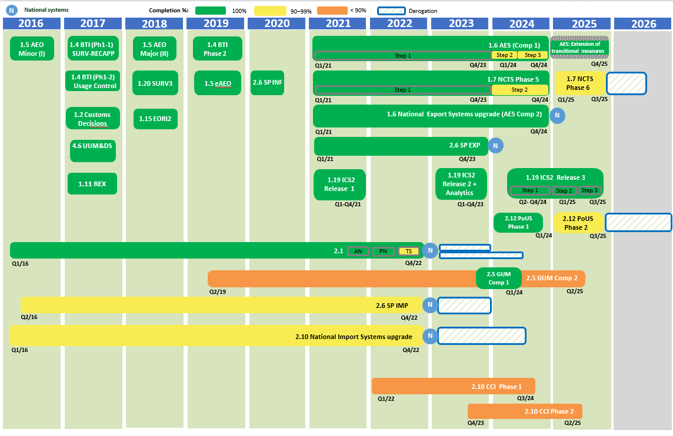
Figure 48: Planning Overview – UCC WP Projects

Annex 2 – Acronyms, Abbreviations & Key Terms
Acronym | Description
AEO | Authorised Economic Operator
AES | Automated Export System
AN | Notification of Arrival
ATLAS | Automated Customs Tariff and Local Processing Application System
BTI | Binding Tariff Information
CCE | Centralised Clearance for Export
CCI | Centralised Clearance for Import
CDS | Customs Decisions System
CGM | Customs Goods Manifest
CRS | Customer Reference Services
CTC | Common Transit Convention
DG TAXUD | Directorate-General for Taxation and Customs Union
EBTI/EBTI-3 | trans-European Binding Tariff Information
ECCG | Electronic Customs Coordination Group
EIDR | Entry In the Declarant’s Records
EMCS | Excise Movement and Control System
EMSW | European Maritime Single Window
EMSWe | European Maritime Single Window environment
ENS | Entry Summary Declaration
EO | Economic Operator
EORI2 | Economic Operator Registration and Identification upgrade
EUCDM | European Union Customs Data Model
EU CTP | European Union Customs Trader Portal
GSP | Generalised Scheme of Preferences
GUM | Guarantee Management
ICS2 | Import Control System 2
ieCA | Information Exchange Conversion Application
INF | Information Sheet
IRTA | UCC Implementing Regulation on Technical Arrangements
MASP-C | Multi-Annual Strategic Plan for Customs
MNSW | Maritime National Single Window
MSW | Maritime Single Window
NCTS | New Computerised Transit System
NES | National Export System
NIS | National Import System
PN | Presentation Notification
PoUS | Proof of Union Status
Q1/2/3/4 | Quarter 1/2/3/4
REX | Registered Exporter System
RfC | Request for Change
SP | Special Procedures
SP EXP | Special Procedures – Component 1
SP IMP | Special Procedures – Component 2
SURV3 | Surveillance 3
TP | Trader Portal
TS | Temporary Storage
TSS | Technical System Specifications
UCC | Union Customs Code
UCC WP | Union Customs Code Work Programme
UUM&DS | Uniform User Management and Digital Signature
VIS | Vision Document
Table 27: Abbreviations and Acronyms

Annex 3 – Definition of formats, legal base and legal deadline for Surveillance3
SDR Format | Details | Validity
SDR Format | Details | Import | Export
CCIP  Annex 21-02, of the UCC IA  (16 data elements) | Format according to CCIP legislation, which is the format accepted before UCC entered into force with the addition of the Data Elements required for VAT legislation. | Will be discontinued for imports not later than 1st July 2025 (legal date) | Will be discontinued for exports as of 2nd December 2024 (legal date)
Reduced UCC  Annex 21-02, of the UCC IA  (16 data elements) | This format is put in place to cover the case for those Member States who cannot provide the 41 data elements but want to align with the UCC format for the data elements available. | Will be discontinued for imports not later than 1st July 2025 (legal date) | Will be discontinued for exports as of 2nd December 2024 (legal date)
Full UCC - current Annex B  Annex 21-01, of the UCC IA  (41 data elements) | This format supports national declaration systems complying with the UCC legislation and following the data formats as set out in the current Annex B UCC DA¹⁹ | This queue will be discontinued for imports as of 1st July 2025 (legal date) | This queue will be discontinued for exports as of 2nd December 2024 (legal date)
Full UCC – new Annex B  Annex 21-03, of the UCC IA  (57 data elements) | The format will support national declaration systems complying with the UCC legislation and following the data formats as set out in in the NEW Annex B UCC DA²⁰ | MS may switch to the “Full UCC – new Annex B” format as of 1st March 2022
 |  | MS must switch to “Full UCC – new Annex B” format for imports at the latest by 1st July 2025 (legal date) | MS must switch to “Full UCC – new Annex B” for exports at the latest by 2nd December 2024 (legal date)
Postal  Annex 21-03, of the UCC IA | The format will support postal declarations for national declaration systems complying with the UCC legislation | MS may transmit data this format as of 1st March 2022 | Not applicable
Table 28: Definition of formats, legal base and legal deadline – SURV3

In the context of this report, ‘the Commission’ refers to the European Commission.
External communication with the EOs.
Commission Implementing Decision (EU) 2023/2879 of 15 December 2023 establishing the Work Programme relating to the development and deployment for the electronic systems provided for in the Union Customs Code, OJ L, 2023/8568, 22.12.2023, https://eur-lex.europa.eu/legal-content/en/TXT/?uri=CELEX%3A32023D2879.
Electronic Customs Multi-Annual Strategic Plan for Customs 2023 Revision, Ref. Ares(2023)8102089, 28.11.2023, https://taxation-customs.ec.europa.eu/system/files/2023-12/000.%20MASP-C_Rev.%202023_Main%20Body_v1.0.pdf.
Report from the Commission to the European Parliament and the Council: 2019:https://eur-lex.europa.eu/legal-content/EN/TXT/?uri=CELEX%3A52019DC0629&qid=1747132035353; 2020: https://eur-lex.europa.eu/legal-content/en/ALL/?uri=CELEX:52020DC0806; 2021: https://eur-lex.europa.eu/legal-content/EN/ALL/?uri=CELEX:52021DC0791; 2022: https://eur-lex.europa.eu/legal-content/EN/TXT/?uri=CELEX:52023DC0068; 2023: https://eur-lex.europa.eu/legal-content/EN/TXT/?uri=CELEX:52024DC0395; 2024: https://eur-lex.europa.eu/legal-content/EN/TXT/?uri=CELEX:52025DC0579
The information was collected between February 2025 and May 2025.
Countries benefiting from the EU GSP that provides preferential access to the EU market.
For the scope of EU GSP, in parallel with the GSP scheme for of CH, and NO as partner countries.
Aggregated information from 01/01/2017 until 01/05/2025.
It includes 993 registrations from Partner Countries CH, NO, and TR, as well as AD and SM.
Beneficiary countries of the EU, Overseas Countries and Territories, as well as CH GSPs, NO GSPs, TR GSPs.
Information from 01/01/2025 to 15/05/2025.
All information in the figure below is from May 2024 until March 2025.
Please refer to section 3 for more detailed information.
See Annexe 3 Definition of formats, legal base and legal deadline for a more detailed description.
0.00% represent numbers bellow two decimal point but with reception of data
Aggregated information from 01/10/2019 until 19/05/2025.
Aggregated information from 01/10/2019 until 19/05/2025.
Aggregated information from June 2020 until May 2025.
Aggregated information from June 2020 until May 2025.
Information from 16/05/2024 until 15/05/2025.
Total number of Registered Proofs per Member State from 01/03/2024 to 28/02/2025.
Total number of Presented Proofs per Member State from 01/03/2024 to 28/02/2025.
For NIS upgrade and SP IMP projects, where Article 2(4a) of Commission Delegated Regulation (EU) 2015/2446 applies, Member States had until 01/07/2024 to deploy the system.
The end of the deployment window for AES-C1 is 02/12/2024, however the end of transition deadline was changed from 11/02/2025 to 14/12/2025, under Article 56 of the revised IRTA.
Commission Implementing Decision (EU) 2023/235 of 1 February 2023 granting a derogation requested by certain Member States pursuant to Regulation (EU) No 952/2013 of the European Parliament and of the Council to use means other than electronic data-processing techniques for the exchange and storage of information for the Notification of Arrival of a sea-going vessel or of an aircraft (OJ L 32, 3.2.2023, p. 220-222).
Considering the link with ICS2-R3 for maritime transport, the Member States that were granted a derogation had the possibility to deploy the system until 03/06/2024.
Fields marked in grey mean no information was provided.
The progress shown in the figure considers all modes of transport. Additionally, ‘Deployment’ encompasses both deployment and operations milestones.
Commission Implementing Decision (EU) 2023/234 of 1 February 2023 granting a derogation requested by certain Member States pursuant to Regulation (EU) No 952/2013 of the European Parliament and of the Council to use means other than electronic data-processing techniques for the exchange and storage of information for the Presentation Notification related to goods brought into the customs territory of the Union (OJ L 32, 3.2.2023, p. 217-219).
Considering the link with ICS2-R3 for maritime transport, inland waterways, road and rail transport, the Member States that were granted a derogation had the possibility to deploy the system until 03/06/2024.
The progress shown in the figure considers all modes transport. Additionally, ‘Deployment’ encompasses both deployment and operations milestones.
Commission Implementing Decision (EU) 2023/236 of 1 February 2023 granting a derogation requested by certain Member States pursuant to Regulation (EU) No 952/2013 of the European Parliament and of the Council to use means other than electronic data-processing techniques for the exchange and storage of information for the Temporary Storage declaration related to non-Union goods presented to customs (OJ L 32, 3.2.2023, p. 223-225).
Considering the link with ICS2-R3 for maritime transport, inland waterways, road and rail transport, the Member States that were granted a derogation had the possibility to deploy the system until 03/06/2024.
The progress shown in the figure considers both the air and other modes transport. Additionally, ‘Deployment’ encompasses both deployment and operations milestones.
The Commission adopted on 1 February 2023 an Implementing Decision (EU) 2023/235, granting a derogation to AT, BE, BG, CY, CZ, DK, EE, ES, FR, GR, HU, HR, LU, MT, NL, PL, PT, RO, SE, SI, and SK from 01/01/2023 until the deployment of the AN system, but not later than 31/12/2023, for Air transport and 29/02/2024 for maritime transport or inland waterways, whichever date is sooner. Additionally, considering the link with ICS2-R3 for maritime transport, the Member States that were granted a derogation had the possibility to deploy the system until 03/06/2024.
The Commission adopted on 1 February 2023 an Implementing Decision (EU) 2023/234, granting a derogation to AT, BE, CY, CZ, DK, EE, ES, FR, GR, HU, HR, LU, MT, NL, PL, PT, RO, SE, SI, and SK from 01/01/2023 until the deployment of the PN system, but not later than 31/12/2023, for Air transport and 29/02/2024 for maritime transport, inland waterways, road or rail transport, whichever date is sooner. Additionally, considering the link with ICS2-R3 for maritime transport, inland waterways, road or rail transport, the Member States that were granted a derogation had the possibility to deploy the system until 03/06/2024.
The Commission adopted on 1 February 2023 an Implementing Decision (EU) 2023/236, granting a derogation to AT, BE, CY, CZ, DK, EE, ES, FR, GR, HU, HR, LT, LU, MT, NL, PL, PT, RO, SE, SI, and SK from 01/01/2023 until the deployment of the TS system, but not later than 31/12/2023, for Air transport and 29/02/2024 for maritime transport, inland waterways, road or rail transport, whichever date is sooner. Additionally, considering the link with ICS2-R3 for maritime transport, inland waterways, road or rail transport, the Member States that were granted a derogation had the possibility to deploy the system until 03/06/2024.
In all projects, for the Member States that provided dates in quarters or months, the project is considered on target if the UCC WP deadline falls within the quarter or month indicated.
Commission Implementing Decision (EU) 2023/237 of 1 February 2023 granting a derogation requested by certain Member States to use means other than electronic data-processing techniques for the exchange and storage of information related to the customs declaration for goods brought into the customs territory of the Union laid down in Articles 158, 162, 163, 167, 170 to 174, 201, 240, 250, 254 and 256 of the Regulation (EU) No 952/2013 of the European Parliament and the Council laying down the Union Customs Code (OJ L 32, 3.2.2023, p. 226-228).
The information shared by IE, PL, and SK corresponds to a further upgrade of NIS, but the system is already deployed. Additionally, ‘Deployment’ encompasses both deployment and operations milestones.
The Commission adopted on 1 February 2023 an Implementing Decision (EU) 2023/237, granting a derogation to AT, BE, CY, CZ, DK, ES, FR, GR, HU, LT, LU, MT, NL, PT, RO, and SE from 01/01/2023 until the deployment of the NIS system, but not later than 31/12/2023. Additionally, where Article 2(4a) of Commission Delegated Regulation (EU) 2015/2446 applies, Member States had until 01/07/2024 to deploy the system.
Commission Implementing Decision (EU) 2023/237 of 1 February 2023 granting a derogation requested by certain Member States to use means other than electronic data-processing techniques for the exchange and storage of information related to the customs declaration for goods brought into the customs territory of the Union laid down in Articles 158, 162, 163, 167, 170 to 174, 201, 240, 250, 254 and 256 of the Regulation (EU) No 952/2013 of the European Parliament and the Council laying down the Union Customs Code (OJ L 32, 3.2.2023, p. 226-228).
‘Deployment’ encompasses both deployment and operations milestones.
The Commission adopted on 1 February 2023 an Implementing Decision (EU) 2023/237, granting a derogation to AT, BG, CY, CZ, DK, ES, FR, GR, HU, LT, LU, MT, NL, PT, RO, and SE from 01/01/2023 until the deployment of the SP IMP system, but not later than 31/12/2023. Additionally, where Article 2(4a) of Commission Delegated Regulation (EU) 2015/2446 applies, Member States had until 01/07/2024 to deploy the system.
Information provided from a bilateral meeting between SK and DG TAXUD held on 06/03/2025.
Information provided from a bilateral meeting between SK and DG TAXUD held on 06/03/2025.
Commission Implementing Regulation (EU) 2025/512 of 13 March 2025 on technical arrangements for developing, maintaining and employing electronic systems for the exchange and storage of information under Regulation (EU) No 952/2013 of the European Parliament and of the Council: https://eur-lex.europa.eu/legal-content/EN/TXT/?uri=OJ:L_202500512
The functional and technical specifications include Service Management, Service Level Agreements, Terms of Reference, Crisis Management, Capacity Plans and Security Plans.
The information shared by AT in the survey has been updated based on a bilateral meeting between AT and DG TAXUD held on 24/04/2024.
Information provided from a bilateral meeting between SK and DG TAXUD held on 06/03/2025.
The deployment is planned for 15/08/2025.

